# Yet Another BAC Organizer v0.1.7

This tool helps with editing BAC files for Xenoverse 2, which are responsible for various actions in a moveset and skill, such as animations, hitboxes, effects, sound, and more.

This is not a guide on what each entry means. This is just a tool to make editing them easier. For a more comprehensive guide to that, please refer to the [Skill/Moveset Editing Manual](https://docs.google.com/document/d/18gaAbNCeJyTgizz5IvvXzjWcH9K5Q1wvUHTeWnp8M-E/edit#heading=h.v77lp7pp65pd)

Features include:

* Copying/Pasting/Adding/Deleting entries
* Smart pasting for items like EAN Indexes that are not the same between two movesets/skills
* Find/Replace entries by value
* Shared clipboard between different instances of the BAC organizer
* Convert Skills for use with the XV2 Skill Creator by Eternity easily

## Getting Started

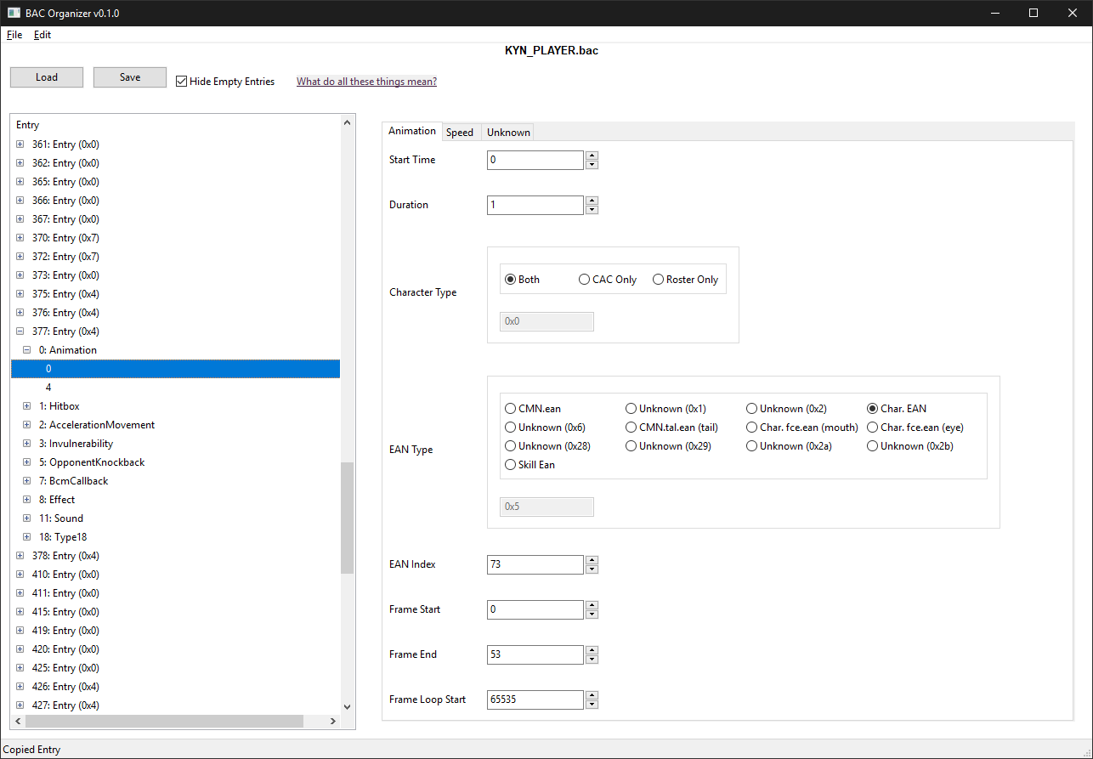

To load a BAC, just click on the **Load** button or drag a file onto the window

To save a BAC, just click on the **Save** button

To hide/unhide empty Entries, toggle the **Hide Empty Entries** checkbox.

### BAC Tree

The left side is the tree view of the BAC. It consists of many entries, each with groupings of similar type sub-entries such as Animation ands and Hitboxes.

**377**: **Entry** (**0x4**)

* **Index** - Used in BCM’s to refer to an entry.
* **Flag** - Entry flags, which can be edited. See moveset guide for more details. Generally you don’t want to change these

**0**: **Animation**

**0**

**4**

* **BAC Type**
* **Sub-Entry Start Time** - When this particular sub-entry starts. Always ordered.

### Entry Panel

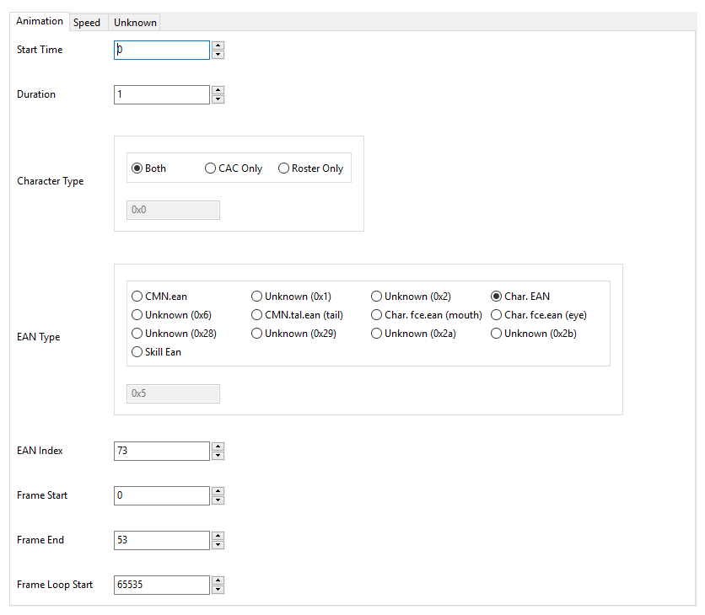

Each different sub-entry has its own panel with multiple pages of info. Please refer to the [Skill/Moveset Editing Manual](https://docs.google.com/document/d/18gaAbNCeJyTgizz5IvvXzjWcH9K5Q1wvUHTeWnp8M-E/edit#heading=h.v77lp7pp65pd) for an explanation of these. Changing these values is straightforward. The Radioboxes/Checkboxes have a hex entry below thats useful for cross referencing XML entries from other tools.

## Convert for Skill Editor

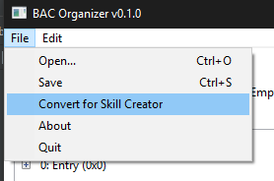

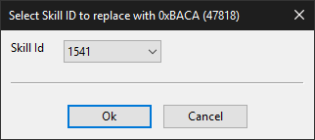

Replaces the selected **Skill ID** with **0xBACA**, which is required for creating new Skills with Eternity’s XV2 Skill Creator

## Adding

Can only do this from a parent BAC Entry

### Adding/Inserting Entry

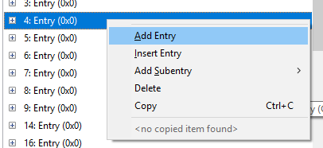

Adding will create an empty BAC Entry after the selected Entry, Inserting will create an empty one before

### Adding Subentry

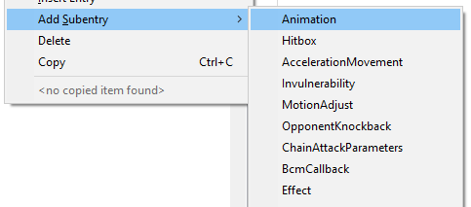

Adds an empty sub-entry of the specified type to the selected BAC

## Deleting

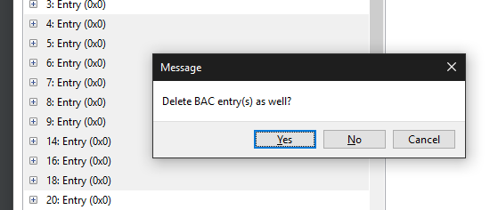

You’ll be asked whether or not you want to delete BAC entries as well, useful if you just want to empty entries and not delete them to preserve the BAC Entry order.

## Copying Items

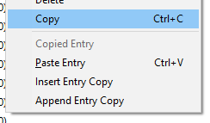

Any BAC Tree item can be copied. When pasting, it must be pasted over the same class of item, ex: Entry over Entry, Animation group over Animation Group, Hitbox sub-entry over Hitbox sub-entry.

Copied items can also be added as a copy as well. Entries can be added to or before the current entry, while subentries can be added alongside existing ones.

### Smart Pasting

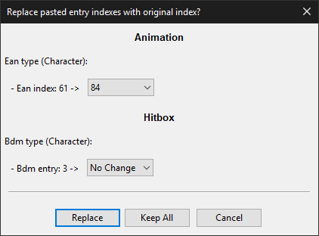

When pasting certain items, sometimes you may wish to use the existing EAN/Skill/BDM entry of a Character/Skill EAN/Skill/BDM, in which case this window pops up and asks whether you want to replace the copied entry indexes with the original, or keep them the same and overwrite them.

The second handy feature of this, is this allows you to figure out what entries to replace in the corresponding files.

In the above example, I am copying over one of Goku’s moves to my character’s. Using an EAN organizer, I would copy Goku’s #61 EAN entry to replace my characters #84 EAN Entry. The BDM entry here says that its using the same value, so I copy Goku’s #3 BDM entry over my character’s #3 BDM entry.



If the original index is used in other places in the BAC, it will say **Conflict Found**, meaning you’ll need to create a new entry in the relevant file. Here, EAN #56 is used elsewhere, so I would need to create a new EAN animation and set it to that after pasting.

## Find/Replace

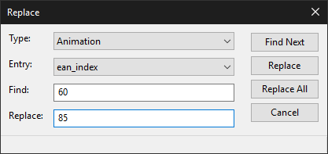

Open either in the **Edit Menu** or **Ctrl+F** for find and **Ctrl+H** for replace. Replace is shown here (Find is identical except no option to replace)

**Type**: BAC Type

**Entry**: BAC Entry

Example of usage: Replacing EAN Indexes in Animations that are 60 with 85

## Credits

* Eternity - Genser source code helped with the nitty gritty technical bits of the BAC file structure.
* Smithers,LazyBones, & Jackal - For the Skill/Moveset guide and the research into what each BAC entry field does.
* SK for the BAC Moveset Info file

## Changelog

0.1.0 - Initial Release

0.1.1 - Fixed bug saving after changing Projectile data, Fixed bug loading Transparency data. Fixed bug with Smart Paste not showing enough changes sometimes.

0.1.2 - Fixed floating point entries not being able to go negative

0.1.3 - Fixed bug on certain BAC files where when they don't have a BAC Entry 0, would not be able to read the file.

0.1.4 - Fixed visual bug with deleting BAC entries

0.1.5 - Fixed paste being broken.

0.1.6 - Fixed Part Invisibility not working

0.1.7 - Fixed deleting the wrong entries, fixed pasting entries with projectiles, fixed error when changing entry flags