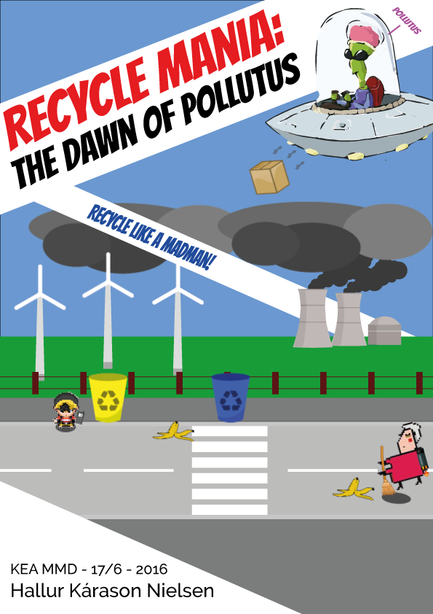

Recycle Mania – The Dawn of Pollutus

by Hallur Kárason Nielsen

# Introduction & problem area

Recycle Mania is a game where you have to recycle garbage in order to complete levels and gain money in order to defeat the evil villain known as “Pollutus”.

Recycle Mania was originally an idea aspired from a mini project. The main focus of the mini project was to come up with a game that would get kids/teenagers more engaged in the preservation of our environment.

I came up with a game where you are a kid that has to recycle garbage into the right bins. Knowing that it can be hard for children to grasp the idea of recycling properly, I wanted to make a game that was fun and interactive, while also educating them and getting them interested in recycling. With the given timeframe for the mini project, I wasn’t able to implement all the things I had in mind, which is why I decided to stick to working with it for the exam project.

In this report I will explain how and what I implemented into the new version of Recycle Mania, using MDA frameworks, object oriented programming, IEZA frameworks and more. In the end of the report you will find two separate links, one linking to the old version, and one to the new one.

MDA framework

One of the absolute keys to my game design is the **MDA framework**. My game relies heavily on mechanics in order to function properly, which in correlation with the dynamics and aesthetics make the game interesting.

## Mechanics

### Levels

The game is set up into levels. Each level has three rounds, where the villain throws garbage down to you. He throws it around to a random position, one by one. You have to sort the garbage into the right bins as soon as they hit the ground. If you fail to do so, they will disappear after a certain amount of time, and you will have a smaller chance of winning the level. After each round the amount of garbage, that is thrown down, increases. After you complete a level, the settings that make the game challenging are incremented. Also new elements are introduced, such as new garbage bins, new types of garbage and cars driving.

If you don’t complete the level, you will have the option to enter a power-up shop or try again. You cannot fully lose this game. Just by playing long enough, anyone should be able to complete it.

### Missions

In every level you have to sort a certain percentage of all the garbage in their rightful bin, in order to go on to the next level. If you fail to do so, you will have to play the same level again. This engages the player to focus on doing the right.

### Money

When you sort out the garbage correctly, you are rewarded with 5 dollars from your grandmother. If you either put the garbage in the wrong bin, or wait until the timer on the garbage runs out, you will gain no money, and have a smaller chance of completing the level. Even if you fail the level, you will still have the money earned.

### Power-ups

If you have a hard time playing the game, this will be the key factor to keep playing in order to complete it, because the money you gain will stick with you even if you lose the game. Then you can spend it on power-ups in order to have a better chance of winning the game the next time.

Dynamics

### Rewards

The game has a very simple rewarding schedule. Whenever you sort something correctly you are rewarded with 5 dollars, which is the driving force in the game. These money rewards ultimately result in more rewards, when you can spend the money in the power-up shop.

Other rewards include small snippets of texts every time you complete a level as well as small narration in between the things you buy and levels you complete.

Progressive gameplay

Every time we complete a level, the next level will be more challenging. At first it’s simple challenges, but with time the user needs to stay 100% in focus in order to complete the levels. When you get to higher levels, 100% focus is not enough; you need to specifically think about which power-ups to invest in, if you want to complete the game.

## Aesthetics

Sounds

The sounds of the game were carefully chosen to relate to the dynamics and mechanics. They are all set up with the IEZA framework in mind.   
In order to create the best whole experience possible it was very important to give sounds to all aspects of the game. That being environmental/affective/effective and interface sounds. The sounds are all simple and have a sort of cartoonish/silly feel about them. They evoke emotions, and make the game fun to play and a more interactive experience for the user. I wanted to make the sounds as fitting as possible for my target audience, which is also why the visual design is the way it is.  
  
Visual design

I chose to make the visual design cartoonish yet simplistic, due to the fact that my target audience could vary a bit in age, and I wanted to make it appealing for as many as possible. It’s set up with many colors, illustrations and small icons in your informative canvas. I decided to go with “Bangers” as a font, which is a font much used throughout the history of comic books.   
When interacting with the user and sending messages, I’ve used a plugin called “sweetAlert”. I used this because it is visually pleasing and easily evokes emotions in the user. Below you can see a snippet of “sweetAlert”, alerted after a completed level.

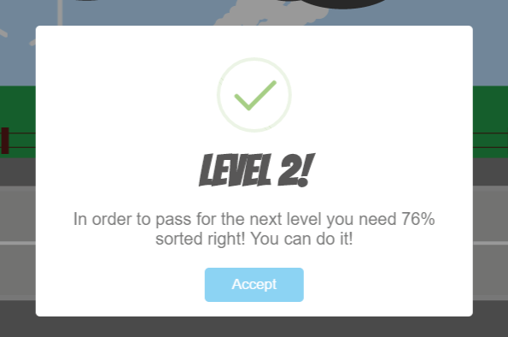

## Target Audience description and expected Player Types

### The idea

The original idea of Recycle Mania had a target audience around the age of 8-10. It was made to be a purely educational game, due to the short amount of time I had to create the game. The game did not have an ending, and the gameplay didn’t really make any sense. It was merely an idea.

I added a lot of different elements to the game, and restructured it to be more challenging and interactive. This led me to believe that my former target audience is no longer purely around the age of 8-10. The design is still fun and childish, but with a little more challenge to it. Since the game has many different elements to it now, my target audience is at a higher age. The average user of my target audience is expected to be around the age of 12-14. It can still be played by younger people; it requires however that they can grasp the mechanics of the game.

The main idea is still to make a game that teaches young people to recycle. The only difference is that with implementing the MDA framework I gave the game a new purpose that’s not only related to educating kids.

Expected Player Types  
Like stated before, my game has a lot of various elements that make it appeal to different audiences, which also will result in different player types. I will however only talk about the achiever.

My main focus for the creation of the game was set on the achievers and explorers. However it turned out to be mainly for the achievers for now, since it still lacks a better story/explorative values.

The whole game concept is built around completing levels and challenges, which makes it appealing for the achiever. The mechanics are built around power-ups and settings, and the achiever will want to complete them in the utmost fashion. Every time you do something positive or negative you are rewarded with some kind of interactive element, and the idea was to spark some types of competitiveness in order to make people want to complete it in the fewest amount of tries or in the least amount of time.

# Object oriented design and programming

When I started working with my exam assignment, the initial code was not very clustered or hard to grasp. However as things moved a long I realized that in order to keep my code structured, I had to approach it in a different way, which is why I started working with OOP.  
I decided to group the variables into objects, so I had a better understanding of what I was working with. My main objects settings, assets, booleans and more. See picture below for reference.

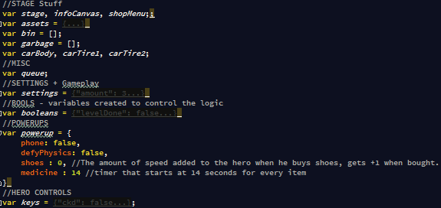

# Product documentation and perspectives

## Product documentation

Grasping the whole solution for the game is a very broad topic, so I will focus on the gameplay elements that make it challenging.

The game starts off with the villain throwing garbage. Each piece of garbage has an individual timer on it, which is its’ lifespan. The timer counts down from a number, and when the timer reaches below 5 seconds, the item will start flashing until it reaches 0, when it disappears and counts as a missed item. If the item is picked up before the time is up, the hero is allowed to sort it.

In order to complete a level you must sort at least 70% of all the garbage from the level correctly. Fail to do so, and you will not proceed. If you do however proceed, a number of settings that control the difficulty of the game are increased relating to the level. These include the boss throw speed, amount of garbage boss throws, boss speed, percentage needed to complete next level etc.

When a level is done, you have the option to buy items in the shop. As for now, they are four in number. One is defy physics, which gives you the ability to exit the canvas and enter on the opposite side, which can save you a lot of time.   
The second one is charge your phone, so you can call your grandma for help. This is very powerful in stressful situations, but you do not however gain money from the garbage that your grandma collects, so it needs to be used wisely.  
The third and fourth power-up have the same functionality. One of them is buy new shoes, which increases the hero speed. The other one is to buy medicine for you old grandpa. This one increases the lifespan of every piece of garbage by 3 seconds. The initial idea was that the reason the garbage disappears, is because the hero’s grandpa is old and has trouble remembering which bin to put which piece of garbage in.

## Perspectives **Current solution**

The current solution for my project was a huge step from the initial game. The game was given an identity, a purpose, proper MDA framework and is more relatable to by the target audience.

### Future solution

One main thing the game is missing now is a better story. I wanted to give the villain a more concrete reason to why he suddenly ended up littering the earth. It would add to the narrative and explorative elements in the game, and could potentially lure in some new player types.

Other things include more elements, more power-ups, more types of garbage to every bin, and more bins. Another idea I want to implement, is a visual representation of the grandpa, who is old and keeps putting the garbage in the wrong bins when the garbage’s timer is up.

# Links to the finished game

### Old version http://hallurkn.com/javascript/recycle/

### New version http://hallurkn.com/javascript/recycle_mania/