Bruce Holway Portal Page Site Plan

Bruce Holway

WDD 130

Overview

Purpose
To present my work for the semester in WDD130.

Audience
Brother Alvey.

Branding

Website Logo
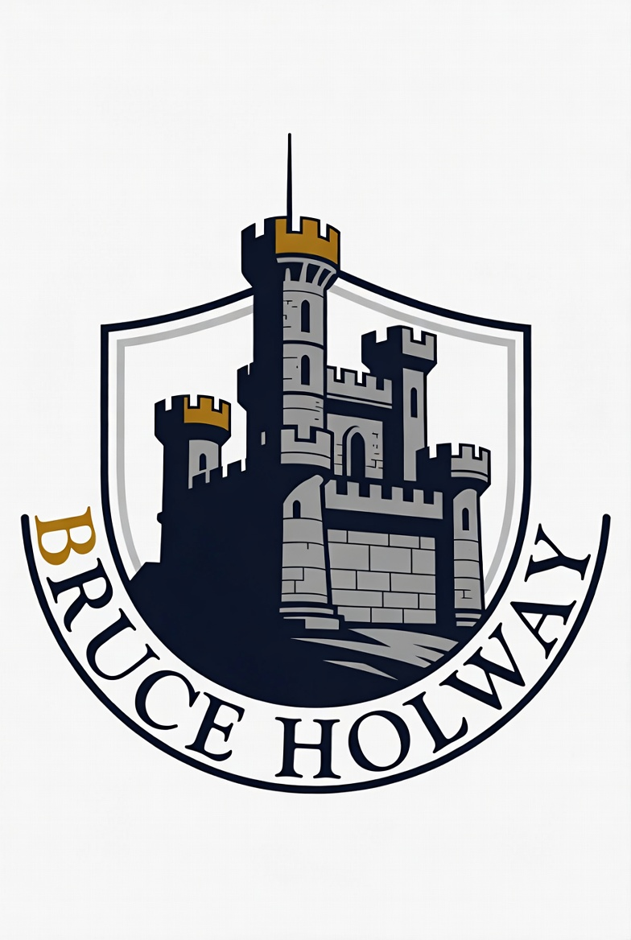

Style Guide

Color Palette
Primary | Secondary | Accent 1 | Accent 2 | Accent 3
#FEFED7 | #C09269 | #000000 | #334934 | 5482BE

Typography

Heading Font: Euphemia

Paragraph Font: Claibri

Navigation
Home WWR ICE About Me

Content

Home Page:
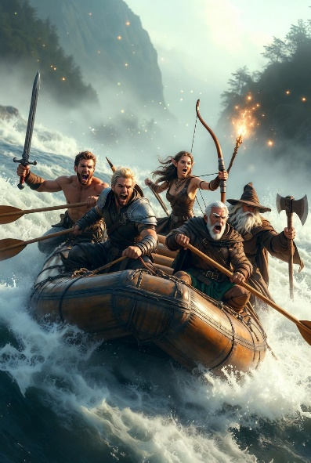
White Water Rafting
-Tutorial Site
-Planning
-Wireframe
-Structure with HTML
-Style with CSS

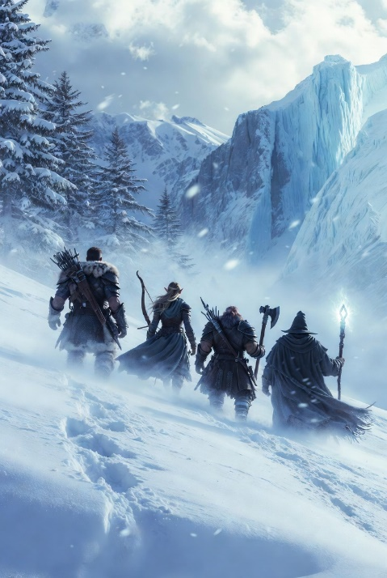
In Class Exercises (ICE)
-Practice in Class
-45 minutes to complete tasks
-Challenges in HTML and CSS
-Focus on Grid practice
-Help and encourage classmates

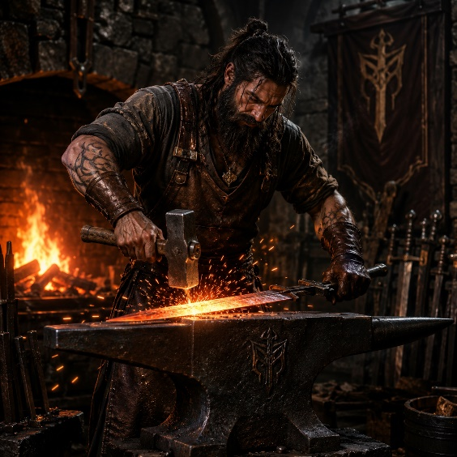
Web Development Projects (table)
Role Website Link About
Client preston553.github.io/wdd130-holway/ Art Portfolio Website
Lead D eveloper https://hallway5.github.io/wdd130-velasquez/ Law School Info
Junior Developer 1
Junior Developer 2 https://hoo25012.github.io/wdd130-commins/ How to Pick Up an Apple

Contact Me
Email:
Comments:

ICE Challenges:
Here are the different in class exercises completed throughout the semester:
Prophet Card
Apostle Spotlight
Favorite Devo
Father’s Day
Grid Flags
Grid Positioning Practice
Fixed Gallery
Signup Form

About Me:
Bruce Holway was raised in Pasco, Washington, one of the three Tri-Cities in Southeast Washington. He spent most of his time reading speculative fiction novels, playing RPG video games, and drawing out his wild ideas.
Bruce’s formal art education includes a concentration in illustration from Brigham Young University-Idaho in Rexburg, Idaho and a certificate in video game design from Tri-Tech Skills Center in Richland, Washington. Bruce has created illustrations for video games and entertainment media, such as character designs, setting layouts, and concept art.
Aditionally, Bruce has studied computer programming at BYU-I and can program in Python, C#, HTML, and CSS. Bruce has also studied creative writing and is currently working on finding a publisher for his pulp adventure short stories.

Wireframes

Home
[hero image]

Home WWR ICE About Me
logo

White Water Rafting
ICE Challenges

Contact Me:
Web Development Projects table

ICE Page/About Me
Same Header as Home Page
logo

Ice Challenges
-links

