|  |  |  |  |  |
| --- | --- | --- | --- | --- |
| Has the student created a GET method that gets the orders based on a CustomerID being parsed in? In Readme    Order Controller line 96 - 105    OrderService Line 162 - 172 | 1.25 | 0 | 0 | No reference made to customer in the orders controller |

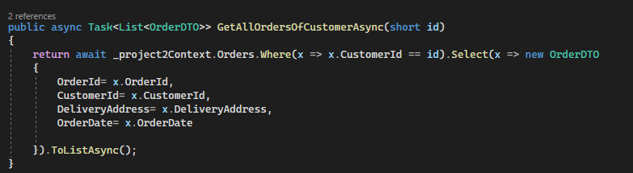

Placed Function and endpoint in Order for it fit better with OrderService because it is interlinked with orders not customers also there was no specification that is has to be in customersService.  
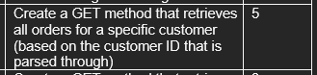

|  |  |  |  |  |
| --- | --- | --- | --- | --- |
| Has the student created a GET method that will return all products that are associated with a specific order? In Readme    OrderDetailsController Line 96 - 111 | 1.25 | 0 | 0 | No reference made to customer in the orders controller |

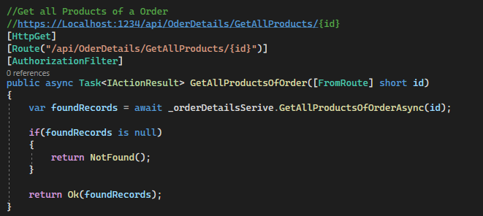

Order Detail Service Line 160 – 176

Placed the function of getting all products of a order in the orderdetails service for it wants detail about a order there was also no reverence to where it should be so the orderdetails service was deemed the most fitting.

|  |  |  |  |
| --- | --- | --- | --- |
| Has the student created a method that checks if an item exists before trying  to edit or delete the item (applied to Customers, Orders and Products)? | 1.25 | 0 | 0 |

CustomerService Line 28 – 39

Used in CustomerService Line 154

Line 112

OrderServicve Line 27 – 37  
Line 107

Line 142

ProductService Line 29 - 39

Line 109  
  
Line 144

Has the student linked their repository, specific to this project, to their board?  
<https://github.com/users/HaloBoss777/projects/10>  


According to the student's board, is it clear that the student used roughly 11 hours on the project?  


Has the student added a ReadME.md file in the repository that describes how the API should be used by users?  
  
There was no specification of who the user is, so I presumed that it would be the businesses that use the Api so all that was needed is the description of each endpoint.  
  
The readme is a complete guide of what every endpoint does and what is needed to work with the endpoint, all needed info was provided to work with the API through the endpoints if something else was needed to be described it should have been stated clearer.

## [Bonus Mark] Has the student applied authentication on the API?

Authentication has been implemented you cannot use the API endpoints unless you are logged in or have registered and have a JWT bearer token!

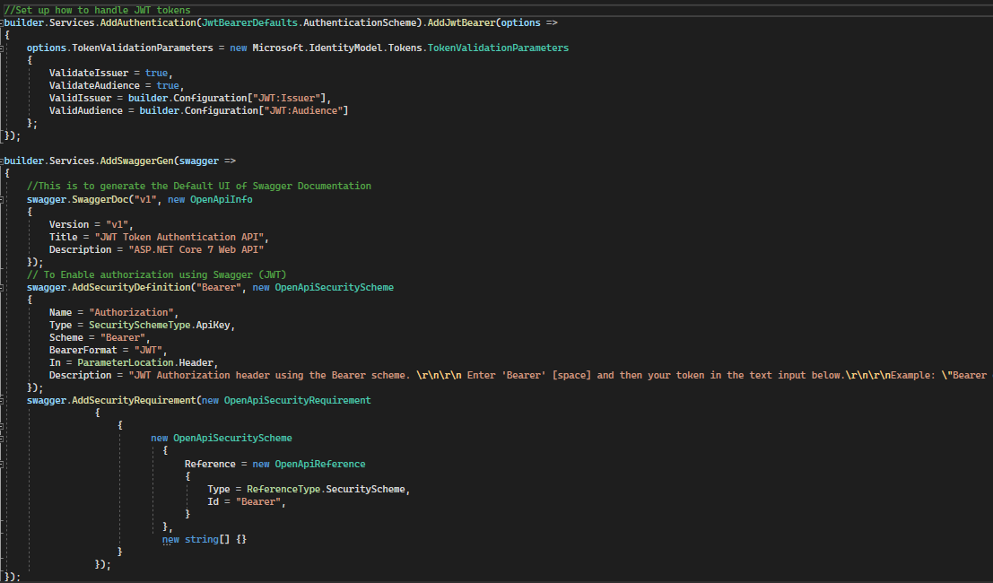

You cannot use the Other API endpoints without a valid token, therefore you cannot use the API. If the Register and Login where to be put behind the Authentication there would be no why to start using the api.