Deploying a Predictive Model with KServe on Minikube
1. Experiment Objective
The objective of this experiment is to deploy and test a predictive model using KServe on a local Kubernetes cluster (Minikube).
The lab covers:
Installing and configuring KServe
Deploying a predictive model using InferenceService
Monitoring service status and debugging
Exposing the service outside the cluster
Sending inference requests and interpreting results

- Experiment Environment
Item | Description
OS | Windows 10
Shell | PowerShell (black background)
Kubernetes | Minikube
Container Runtime | Docker
Serving Framework | KServe
Model | Sklearn Iris Classifier

3. Start Minikube Cluster
3.1 Start Minikube
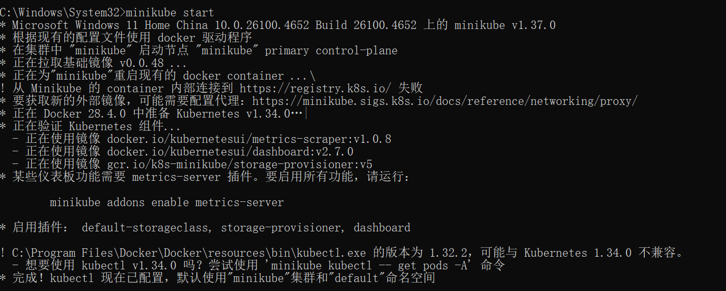

4. Install KServe
4.1 Install Cert-Manager
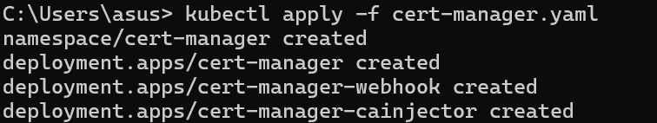
4.2 Install KServe Core Components
Command:
kubectl apply -f https://github.com/kserve/kserve/releases/latest/download/kserve.yaml
4.3 Verify KServe Pods
Command:
kubectl get pods -n kserve

5. Deploy Predictive Model (InferenceService)
5.1 Create Sklearn Iris InferenceService
apiVersion: serving.kserve.io/v1beta1
kind: InferenceService
metadata:
name: iris-model
spec:
predictor:
sklearn:
storageUri: gs://kfserving-examples/models/sklearn/iris

5.2 Apply InferenceService
Command:
kubectl apply -f iris-isvc.yaml

6. Monitor InferenceService Status
6.1 Check InferenceService
Command:
kubectl get inferenceservice
6.2 Debugging (Describe InferenceService)
Command:
kubectl describe inferenceservice iris-model
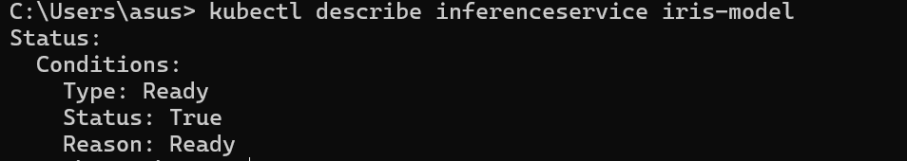
7. Access InferenceService from Outside Cluster
7.1 Get Minikube IP
Command:
minikube ip

7.2 Port Forwarding (Alternative Access)

8. Send Inference Request
8.1 Send Prediction Request
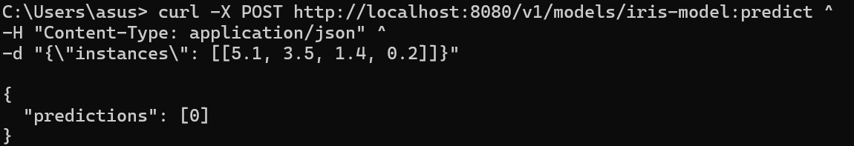
9. Interpret Results
The model returns a prediction label:
0 → Iris-setosa
1 → Iris-versicolor
2 → Iris-virginica
In this example, the input corresponds to Iris-setosa.

10. Conclusion
In this experiment:
KServe was successfully installed on a Minikube cluster
A Sklearn predictive model was deployed using InferenceService
The service status was monitored and debugged
The model was exposed outside the cluster
Inference requests were sent and predictions were interpreted
This demonstrates how KServe enables scalable and standardized model serving on Kubernetes.

