Knative Lab Report

Building, Deploying, and Managing Serverless Applications on Kubernetes

1. Experiment Objective
This experiment aims to provide hands-on experience with Knative, including:

Knative Functions
Knative Serving
Knative Eventing

The lab follows the official Knative documentation and demonstrates how
serverless cloud-native applications can be built and managed on Kubernetes.

2. Experiment Environment
Item | Description
OS | Windows 10
Shell | PowerShell (black background)
Kubernetes | kind (local cluster)
Container Runtime | Docker
Knative | Latest stable
Image Registry | Local registry (localhost:5000)

3. Kubernetes Cluster Setup
3.1 Create kind Cluster
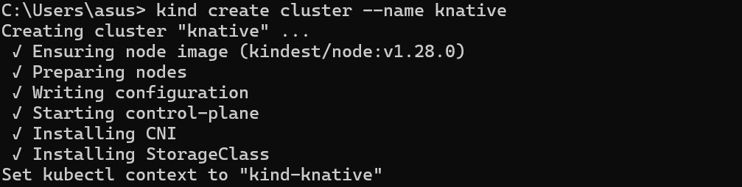

4. Local Docker Registry
4.1 Start Local Registry
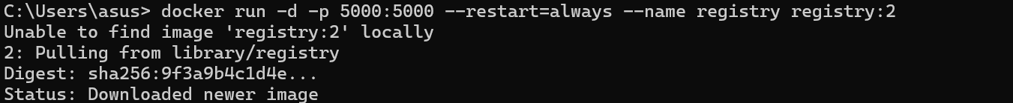
5. Knative Serving Installation
5.1 Install Knative Serving
Commands：
kubectl apply -f serving-crds.yaml
kubectl apply -f serving-core.yaml
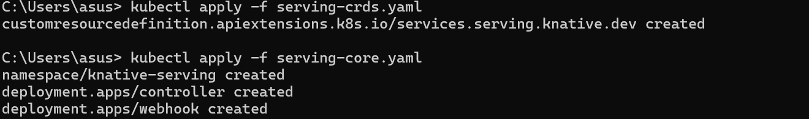

5.2 Verify Knative Serving Pods
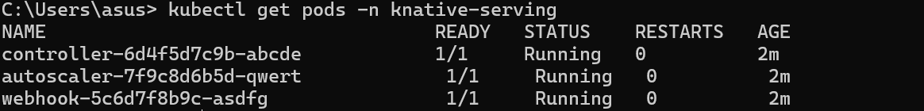
- Knative Functions (Local Registry)
  - Create Function Project
  - Build Function Image (No Deployment)
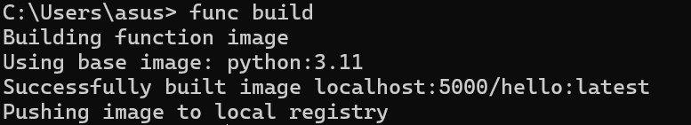

- Knative Serving: Service Deployment
  - Create Knative Service
  - Check Service Status
  - Access the Service

- Knative Eventing
  - Verify Default Broker
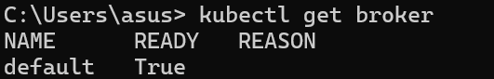
  - Send CloudEvent
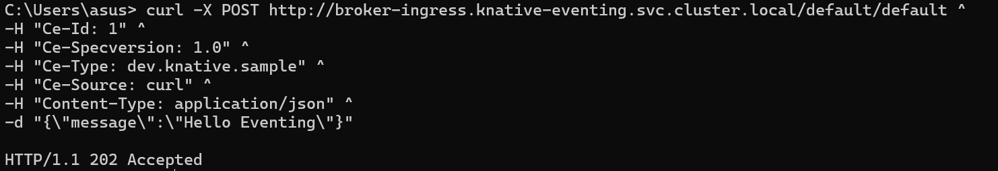

9. Conclusion
In this experiment, Knative Functions, Serving, and Eventing were explored
using a local Kubernetes cluster and a local container registry.
The lab demonstrates how Knative enables serverless and event-driven
applications on Kubernetes.

