1.install wsl

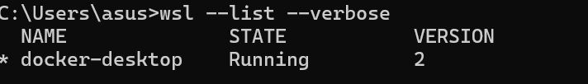

2.install docker

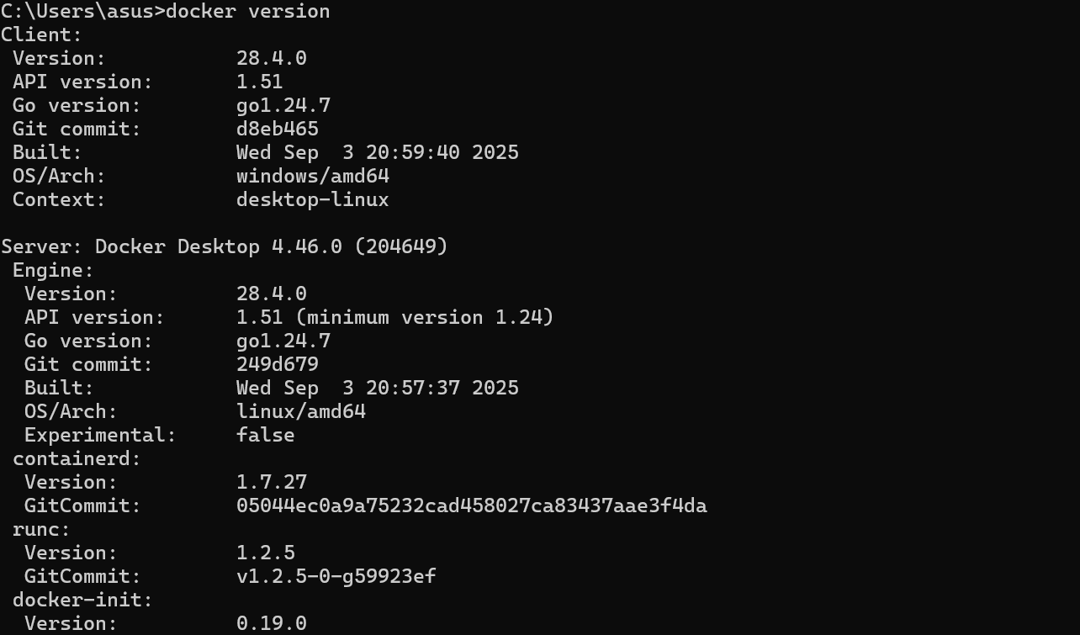

1. install Gitea

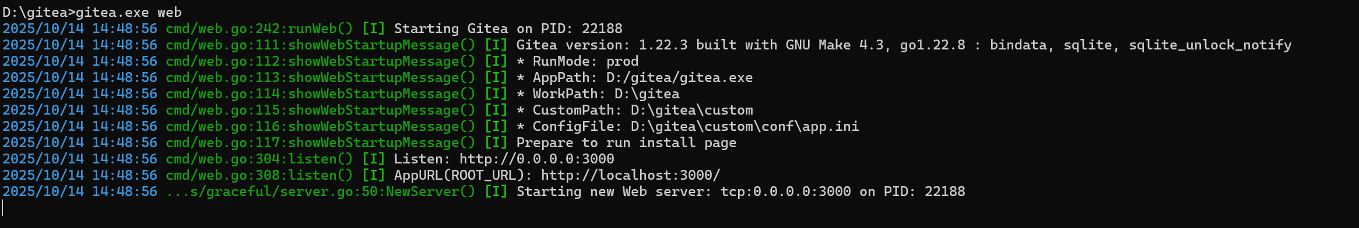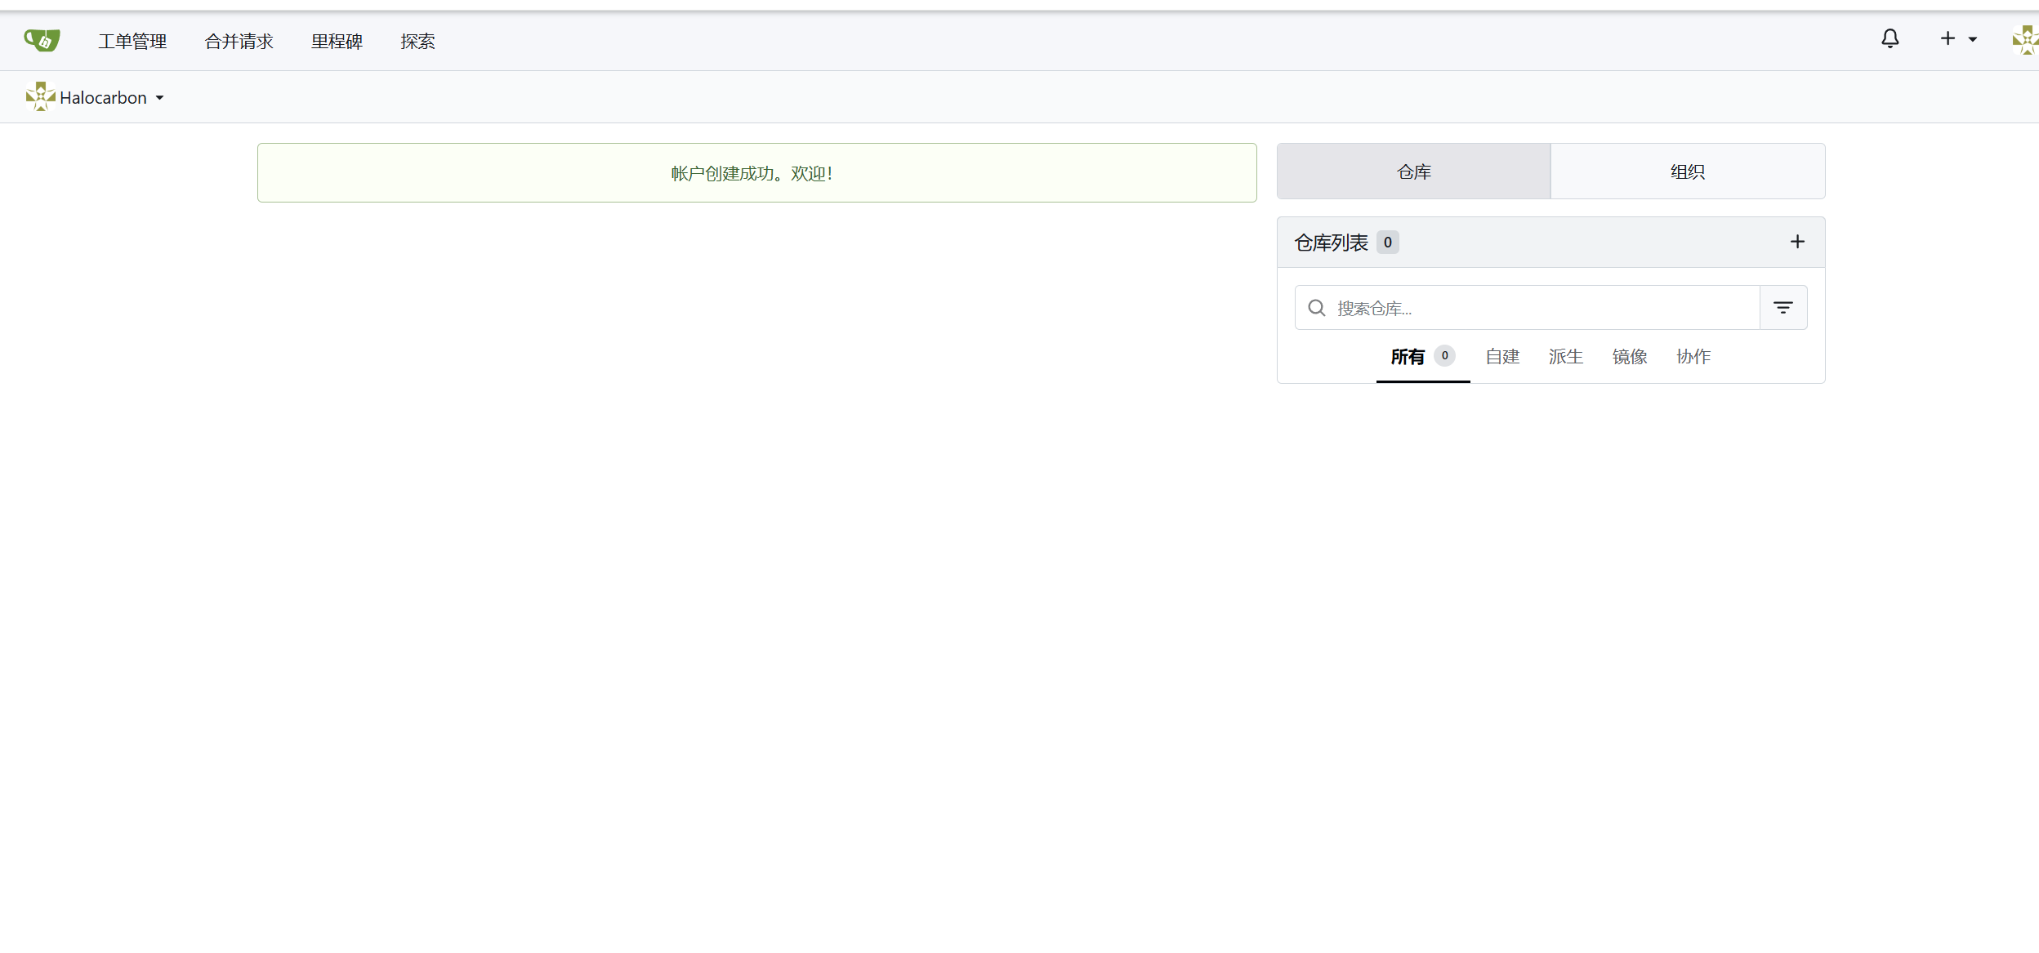

4.create repository and verify LFS

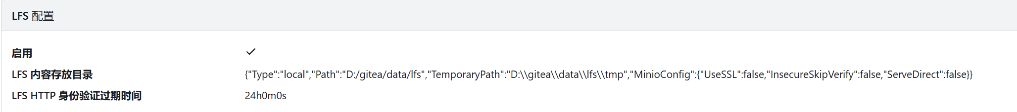



5.load 1GB file

