1. Download and install Istio

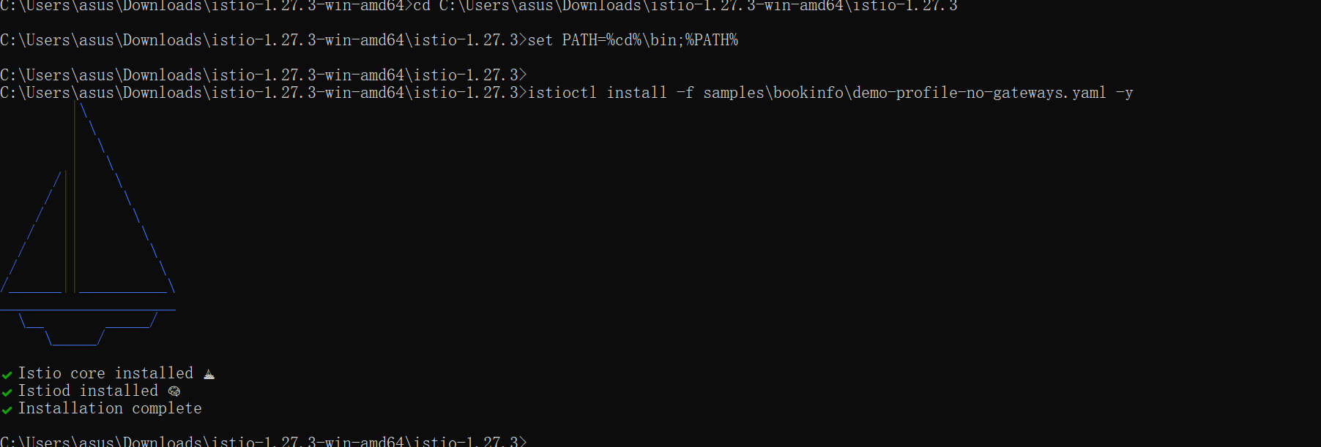

1. Install the Kubernetes Gateway API CRDs

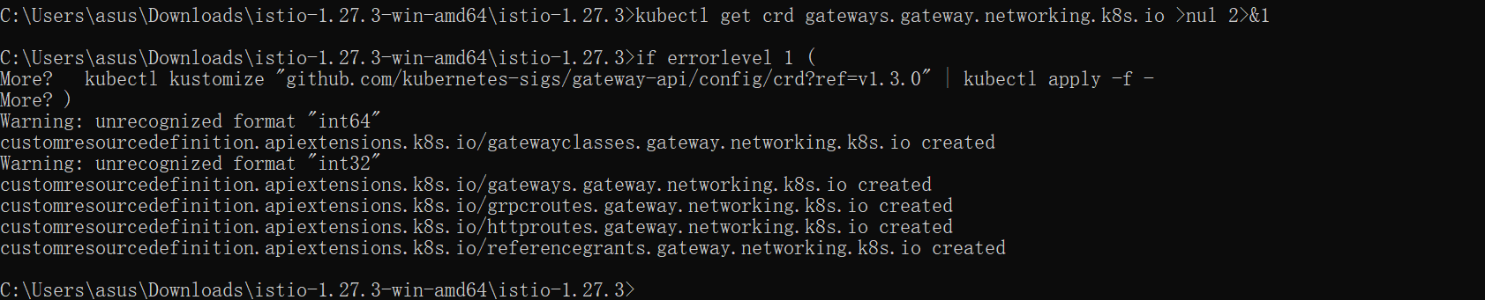

1. Deploy the sample application

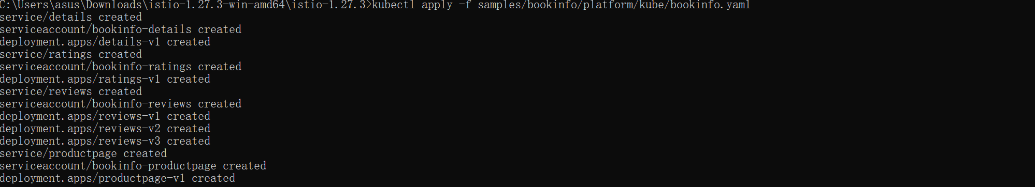

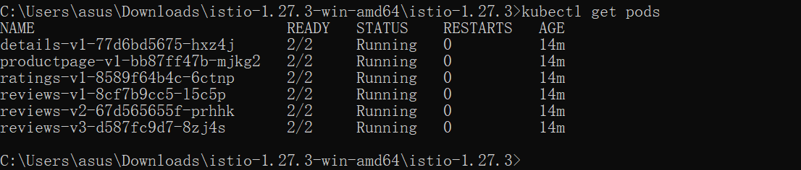



1. Open the application to outside traffic

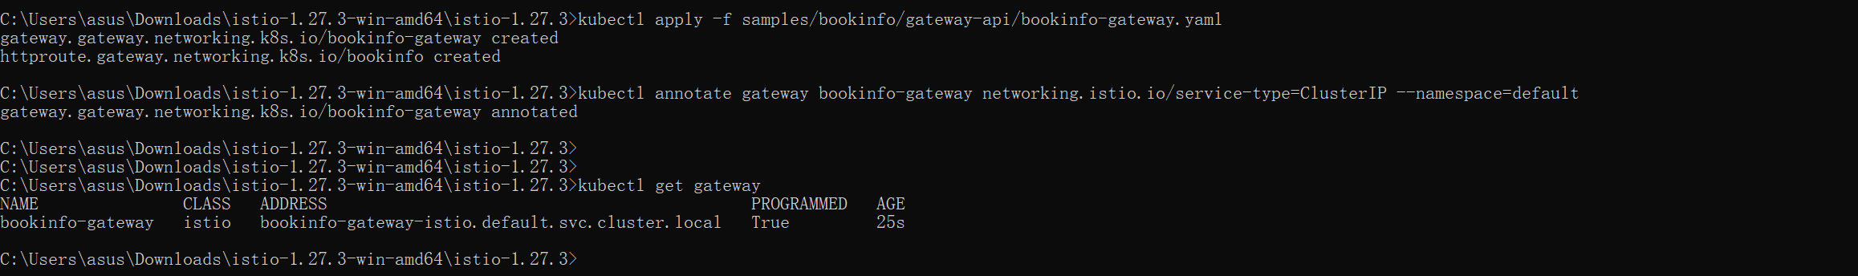

1. Access the application

