Apply weight-based routing

1. To get started, run this command to route all traffic to the v1 version:

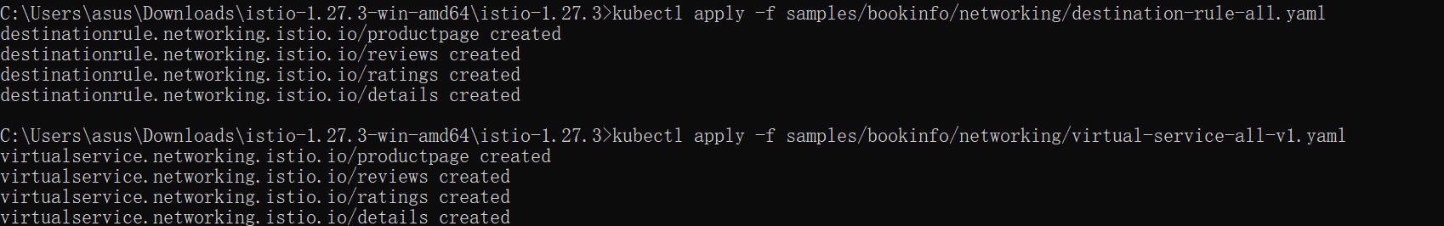

1. Transfer 50% of the traffic from reviews:v1 to reviews:v3 with the following command:



1. Wait a few seconds for the new rules to propagate and then confirm the rule was replaced:

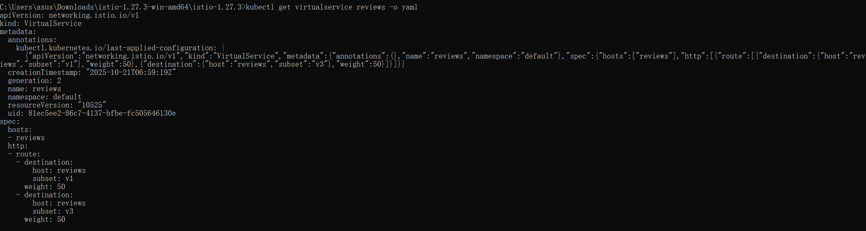

1. Assuming you decide that the reviews:v3 microservice is stable, you can route 100% of the traffic to reviews:v3 by applying this virtual service:



屏幕截图 2025-10-21 150600

1. clean up

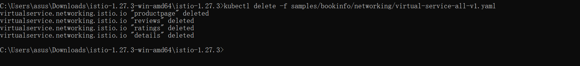

# **Request Routing**

1.Istio uses virtual services to define route rules. Run the following command to apply virtual services that will route all traffic to v1 of each microservice:



1. Display the defined routes with the following command:

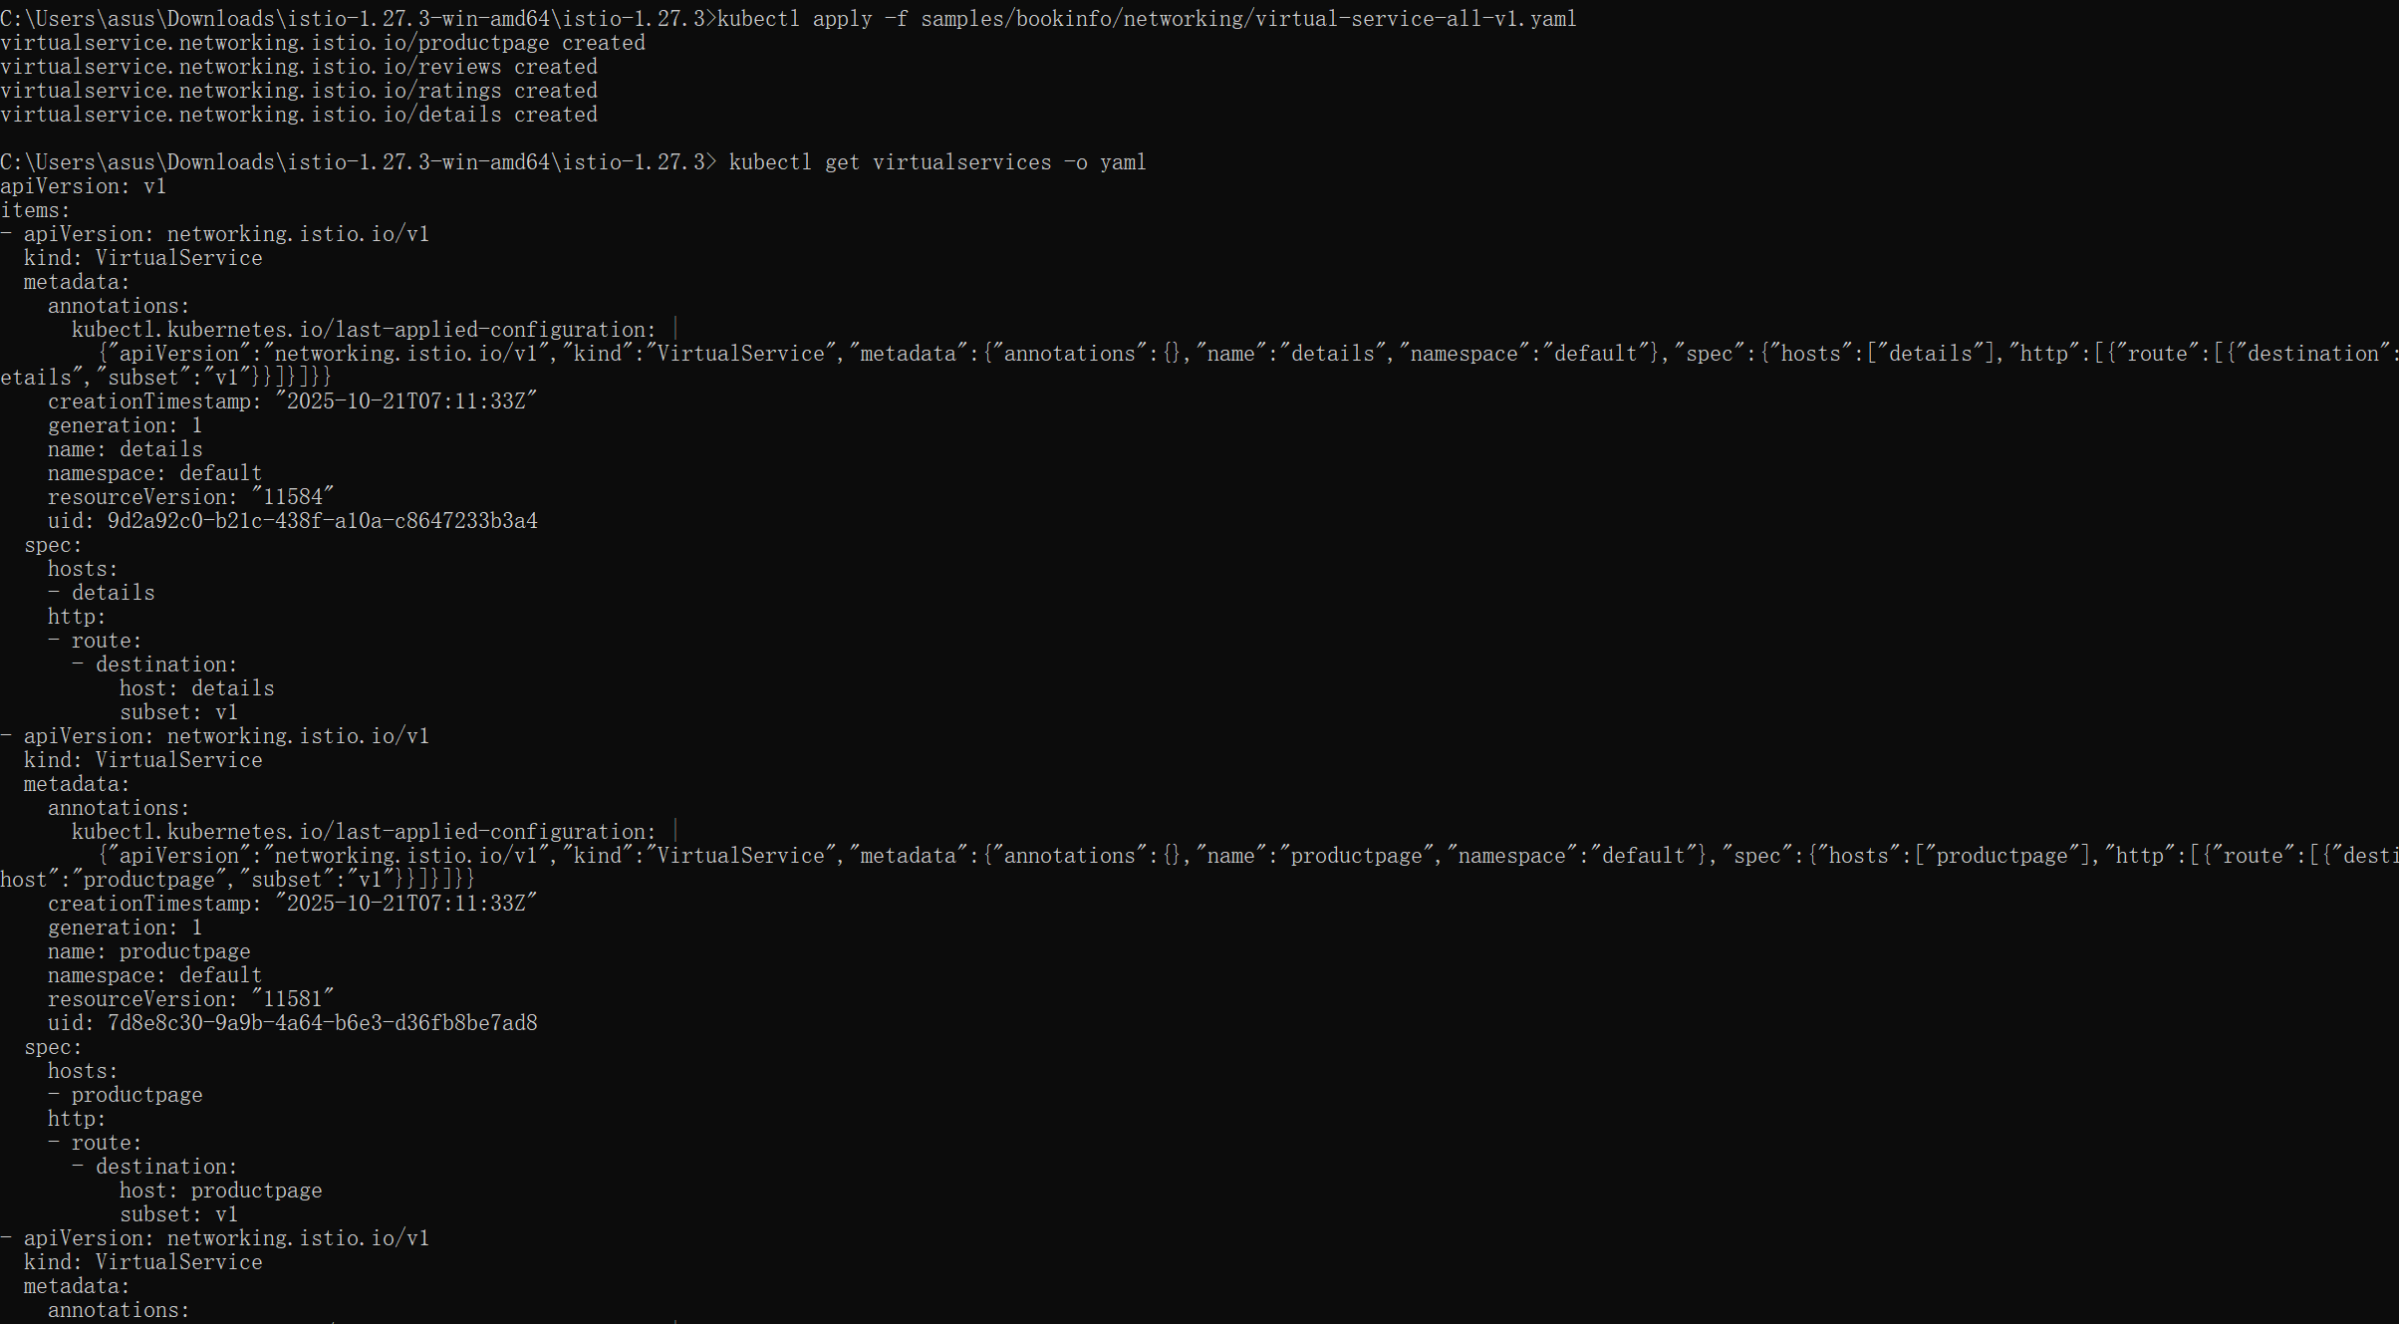

Route based on user identity

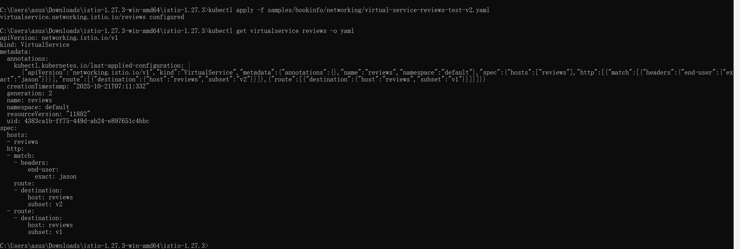

# **Fault Injection**

1. Injecting an HTTP delay fault
2. Testing the delay configuration
3. Injecting an HTTP abort fault
4. Cleanup

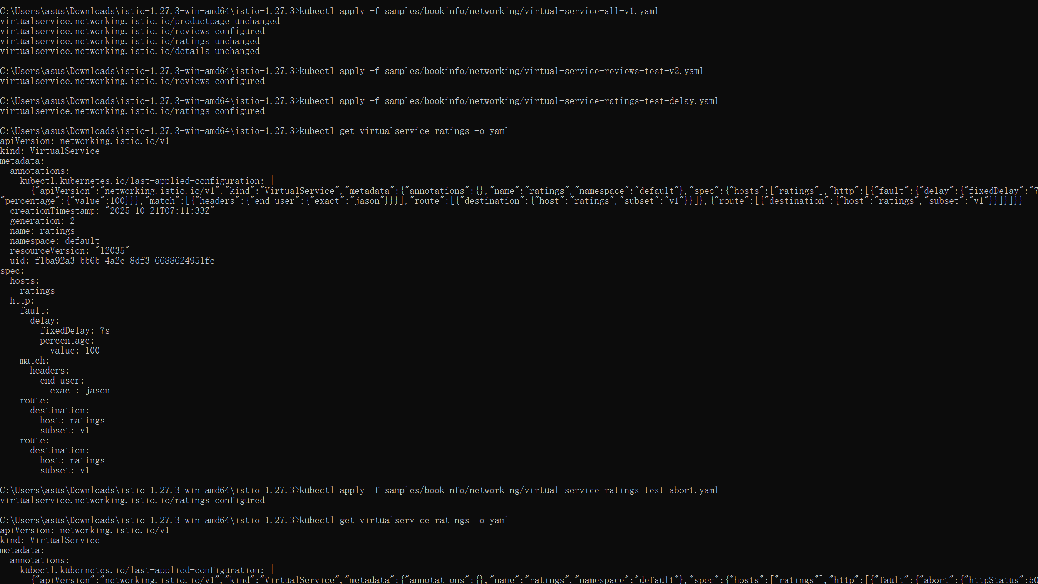

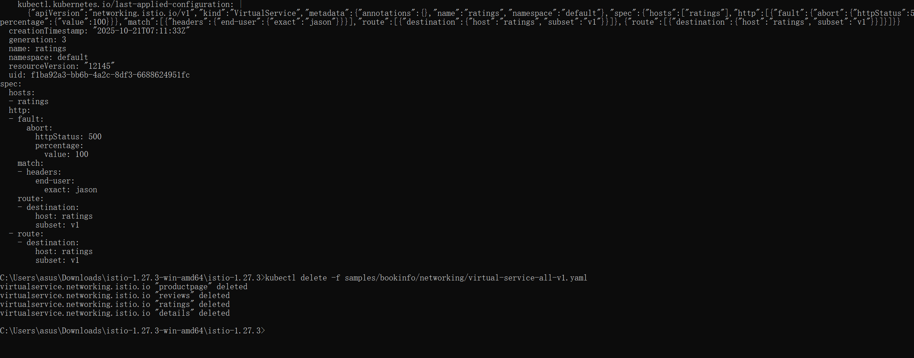

# **Circuit Breaking**

1. Configuring the circuit breaker
2. Adding a client
3. Tripping the circuit breaker
4. Cleaning up

