Plan of Gemini Web Terminal Browser
A general layout of what has to be built, and how it fits together.

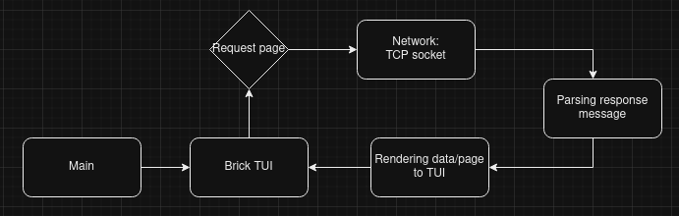

Nuts & bolts

Parts
Brick TUI interface.
Network: TCP sockets, etc.
Parsing Gemini response messages.
Rendering information to TUI.

Actions
User sends request.
Communicating with Gemini servers.
Display response messages to user.
Allow user to interact with page – by link, ...

Plan to create:
- Start working the the assumption that the Network part will work.
  - First find some (2-5) Gemini Responses that can be used as reference.
  - Create a parser for the Response messages
  - Simple rendering in the Terminal
- Network: Build a working TCP socket
  - Simple method for getting URL from user
- Build a more decent interface in Brick
- Other features
  - Logging & Error logging?

Parsing & creating requests
Absolute URI; Max 1024 bytes. Then CR LF.
Add ‘/’ if missing to path.

Parsing Response message:
https://geminiprotocol.net/docs/specification.gmi#31-response-headers
Header: 2-digit status code, a space, “meta field”, CRLF-termination.
Upon successful file retrieval (at server): “meta field” is the MIME type of the returned file.

Network
https://geminiprotocol.net/docs/specification.gmi#2-gemini-requests

Port: 1965
Only allow SO many requests (max 6?)

