**Book My Beauty**

HALYNA YEZERSKA

2023

**Product description**

The product is a web service for online booking in a beauty salon that allows users to create accounts and book specific procedures with specific employees.

**Non-functional requirements**

**Productivity**

* Download free hours to a specific employee for up to 3 seconds
* Simultaneous viewing by at least 20 users
* Response to data change up to 500 ms

**Reliability**

* If an error occurs, the system should report it, not reject it
* Restarting the service after a critical failure within an hour
* Availability 90% of the time

**Ease of use**

* Users can see the changes made in relation to free hours for specific employees
* The system works as a built-in application without complete page reloads
* Intuitive interface

**Maintainability**

It works stably in all the most popular browsers: Chrome, Safari, Mozilla Firefox, Edge and Opera.

**Product features**

1. Registration and login to an account.

2. Viewing the employees providing services.

3. Viewing the list of procedures offered in the salon.

4. Choosing a specific employee and procedure.

5. Selecting available dates and times for booking.

6. Confirmation of booking by the user.

**Technical requirements for the product**

Web server with the ability to use Python (Django, DRF, Flask) and PostgreSQL.

Access to a database with the ability to store information about users, employees, procedures, and appointments.

Graphic design and user interface for interacting with the product.

**Description of the process of user interaction with the product**

The user registers on the website and creates their account.

The user views a list of employees and a list of procedures.

The user selects an employee and procedure they want to book.

The user views available dates and times for booking and chooses a convenient time.

The user confirms the booking and receives confirmation of successful registration.

**Data model**

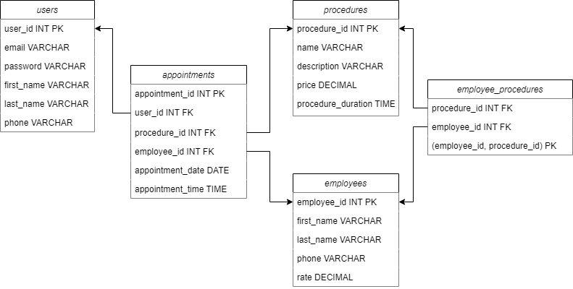

**Users**

This table contains information about the users of the web service. Each user has a unique identifier, name, email, phone number and password for login.

**Procedures**

This table contains a list of available procedures at the beauty salon, their names, price and duration in minutes.

**Employees**

The table store information about the employees of the beauty salon who provide services to clients. It contains a unique identifier for each employee, as well as their first name, last name, phone number and a rating of their work.

**Employees Procedures**

This table associates procedures with employees who provide them. Each record contains a unique identifier of an employee and a procedure they perform.

**Appointments**

This table contains information about appointments for procedures. Each record contains a unique identifier of the user who made the appointment, a unique identifier of the employee who will perform the procedure, the date, and time of the appointment.

**UI Design**

**Sing in**

**Sing up**

**Home**

**Procedures**

**Employees**

**My procedures**

