TECHNICAL REPORT
HAMTRACKER – DIGITAL EVIDENCE & PROOF MANAGEMENT SYSTEM


SUBMITTED BY:
Hussain Ahmed Madni (2024-ag-6389)
BSCS M2 (Semester 4)
ADVISED BY:
Dr. Qamar Nawaz
A TECHNICAL REPORT SUBMITTED IN PARTIAL FULFILLMENT OF REQUIREMENT FOR THE DEGREE OF
BACHELOR OF SCIENCE IN COMPUTER SCIENCE
DEPARTMENT OF COMPUTER SCIENCE
FACULTY OF SCIENCES
UNIVERSITY OF AGRICULTURE FAISALABAD

DECLARATION
I hereby declare that the contents of the report “HamTracker – Digital Evidence & Proof Management System” is project of my own and no part has been copied from any published source (except the references). I further declare that this work has not been submitted for award of any other diploma/degree. The university may take action if the information provided is found false at any stage. In case of any default the scholar will be proceeded against as per UAF policy.
_________________
Hussain Ahmed Madni
2024-ag-6389

CERTIFICATE
To,
The Controller of Examinations,
University of Agriculture,
Faisalabad.
The supervisory committee certify that Hussain Ahmed Madni bearing AG # 2024-ag-6389 has successfully completed his project in partial fulfillment of requirement for the degree of Bachelor of Science in Computer Science under our guidance and supervision.
_____________________________________
Dr. Qamar Nawaz (Advisor)
Department of Computer Science
_______________________________________
Dr. Muhammad Ahsan Latif
Chairman, Department of Computer Science

ACKNOWLEDGEMENT
I thank all who in one way or another contributed to the completion of this report. I am so grateful to the Department of Computer Science for making it possible for me to study here. My special and heartily thanks to my advisor, Dr. Qamar Nawaz, who encouraged and directed me. His challenges brought this work towards a completion. It is with his supervision that this work came into existence.
For any faults, I take full responsibility. I am thankful to my fellow students whose challenges and productive critics have provided new ideas for the work. Furthermore, I also thank my family who encouraged me and prayed for me throughout the time of my research.
May the Almighty God richly bless all of you.

ABSTRACT
The modern freelance ecosystem and remote work paradigm rely heavily on mutual trust between independent contractors and clients. However, disputes regarding work progress, task completion, and milestone compliance frequently arise due to the lack of transparent, verifiable, and structured proof tracking. Traditional project management tools allow task assignment but lack native, immutable validation features, enabling data to be manipulated or retroactively modified.
To bridge this trust gap, this technical report presents HamTracker – Digital Evidence & Proof Management System, an advanced, high-performance desktop application built using the C# programming language and the robust .NET Framework. HamTracker provides an intuitive and comprehensive platform specifically tailored for freelancers, project managers, and clients to securely record, monitor, and audit professional work progress with cryptographically verifiable artifacts.
The core methodology driving HamTracker centers on digital ledger and data security concepts implemented natively via desktop interfaces. Users can seamlessly create granular projects, organize complex assignments into discrete tasks, and attach direct real-time digital proof such as desktop screenshots, progress files, and document links. To guarantee complete integrity and protect against data fraud, every uploaded file or screenshot undergoes a strict cryptographic pipeline. The application generates a unique SHA-256 cryptographic hash immediately upon evidence capture, embedding it alongside absolute system-generated timestamps directly into a local database infrastructure. This ensures that any attempt at manual file swapping or database tampering corrupts the hash consistency, making the entire audit trail structurally transparent and tamper-evident.
Furthermore, HamTracker enhances user experience and audit readiness through advanced timeline visualization modules and automated, on-demand report generation. In case of contractual disagreements, clients or freelancers can immediately compile comprehensive progress documents containing complete evidence logs, sequential activity trails, and unalterable verification keys. The implementation utilizes a structured, modular layer system using Windows Forms for clean, highly responsive UI execution and custom data layers for high-speed local processing. Comprehensive software evaluation confirms that HamTracker significantly limits project monitoring complexity, optimizes accountability, and introduces a robust, mathematically validated mechanism for remote dispute resolution.

TABLE OF CONTENTS
- Chapter 1 - INTRODUCTION
  - 1.1 Background
  - 1.2 Description
  - 1.3 Problem Statement
  - 1.4 Scope
  - 1.5 Objectives
  - 1.6 Feasibility
    - 1.6.1 Technical Feasibility
    - 1.6.2 Schedule Feasibility
    - 1.6.3 Economic Feasibility
    - 1.6.4 Operational Feasibility
    - 1.6.5 Legal/Ethical Feasibility
  - 1.7 Requirements
    - 1.7.1 Functional Requirements
    - 1.7.2 Non-Functional Requirements
    - 1.7.3 Hardware Requirements
    - 1.7.4 Software Requirements
  - 1.8 Stakeholders
- Chapter 2 – MATERIALS & METHODS
  - 2.1 Process Model
  - 2.2 Tools & Technologies
  - 2.3 Design
    - 2.3.1 Use Case Diagrams
    - 2.3.2 Usage Scenarios
    - 2.3.3 Sequence Diagram
    - 2.3.4 Class Diagram
    - 2.3.5 Data Flow Diagram (DFD)
    - 2.3.6 Entity Relationship Diagram (ERD)
    - 2.3.7 Database Model
    - 2.3.8 System Architecture
- Chapter 3 - RESULTS & DISCUSSION
  - 3.1 Testing
  - 3.2 Test Cases
  - 3.3 Conclusion
- Chapter 4 - USER MANUAL
- References

CHAPTER 1 - INTRODUCTION
1.1 Background
The rapid shift toward digital work, global outsourcing, and decentralized software teams has revolutionized professional collaboration. Freelancing platforms and remote working frameworks now contribute hundreds of billions of dollars to the global market economy. Despite this growth, the decentralized model contains a vulnerability: the absence of decentralized, verifiable, and unalterable truth regarding hour logging, task progress, and resource execution. Currently, professionals rely on standard communication lines (emails, chat tools) or standard kanban platforms to coordinate projects. However, these systems fall short when an analytical or contractual dispute breaks out.
The inception of HamTracker stems directly from the ongoing structural issues observed in modern client-freelancer dynamics. Many remote workers face arbitrary payment rejections or claim denials due to a lack of detailed, day-to-day progress evidence. Conversely, business owners often pay for unverified billable hours because they cannot easily check the authenticity of manual text updates. Establishing a dedicated, lightweight desktop utility that runs directly inside the client or developer workstation changes this dynamic. By building a desktop workspace wrapper that captures, tracks, hashes, and sequences work snapshots alongside explicit task nodes, HamTracker establishes a transparent baseline of trust. This project was initiated to explore how traditional visual desktop frameworks, coupled with security protocols, can protect professional tracking parameters without introducing corporate surveillance complexities.
1.2 Description
HamTracker – Digital Evidence & Proof Management System is engineered as a secure client-side application designed to maintain a timeline of project contributions. Operating natively on standard desktop workstations, it avoids cloud lag and complex cloud fees, storing data in organized local structures. The user dashboard provides comprehensive structural control, allowing users to build top-level project folders, map milestones out into actionable task cards, and execute states like "In Progress," "Under Review," or "Completed."
The core feature of HamTracker is its automated and manual Evidence Acquisition Subsystem. While working on a designated task, freelancers can easily pin digital evidence directly onto the task item. This proof includes automated screen captures and direct physical file attachments (e.g., source code scripts, graphics files, databases). As soon as an element enters the dashboard pipeline, the underlying data core executes a strict calculation process:
$$\text{File/Image Buffer} \longrightarrow \text{Cryptographic Processing Engine (SHA-256)} \longrightarrow \text{Unique 64-character Hexadecimal Hash Key}$$
This key is paired with system-level clocks to generate an unalterable timestamp record. This data combination forms a secure cryptographic stamp. If a user subsequently attempts to manually replace an image in the local storage or alter the tracking text, the system validation checks will instantly fail due to a hash mismatch.
For managers and auditors, HamTracker provides an intuitive Interactive Timeline Canvas and a Dynamic Report Generation Engine. The timeline allows users to review work logs sequentially, tracking every action from task initiation to final file delivery. The reporting mechanism outputs formatted audit sheets that map dates, completed requirements, and file verification strings into clear layouts. This detailed documentation serves as authoritative proof, helping to resolve freelance disputes or verify internal performance metrics cleanly.
1.3 Problem Statement
Traditional collaboration and task tracker architectures exhibit significant vulnerabilities regarding proof authenticity, making them prone to data loss and retrofitted progress logs. The explicit structural challenges addressed by HamTracker include:
- Lack of Immutable Evidence: Standard systems store records as plain, modifiable inputs. Users can easily update logs retroactively, create fake tracking data, or alter original delivery dates, leading to trust breakdowns between clients and vendors.
- The "Lack of Solution" Reality Check: Freelancers cannot systematically defend against arbitrary non-payment claims without an audited log. At the same time, clients face financial risks when assessing remote billable milestones without verifiable confirmation.
- Inefficient Dispute Resolution: When contract disagreements occur, teams waste valuable hours digging through chaotic email chains, slack messages, and loose files. There is a clear need for an integrated system that can generate centralized, tamper-evident audit logs on demand.
1.4 Scope
The functional boundaries and parameters of the HamTracker infrastructure comprise:
- In-Scope Core Modules: Full local CRUD capabilities for projects and tasks; multi-tier file and media attachment hooks; real-time SHA-256 secure hashing automation; local relational schema database synchronization; unified activity timeline interface engines; automated document export compilation (PDF/Text layouts).
- Out-of-Scope Elements: Distributed multi-tenant network synchronization layers, live peer-to-peer web messaging protocols, automated continuous payment integration gateways, and external server hosting dependencies. The application is built as a self-contained local system to optimize processing speed and maximize data control.
1.5 Objectives
- To design and engineer a responsive, modern desktop user interface using C# and Windows Forms for rapid task management.
- To construct a secure cryptographic hashing engine that converts uploaded evidence files into tamper-proof data streams using SHA-256.
- To create an interactive timeline engine that maps work milestones in chronological order.
- To implement an automated reporting utility that exports structured audit logs to help resolve project delivery disputes.
- To optimize local database performance for efficient handling of image files and progress tracking data.
1.6 Feasibility
1.6.1 Technical Feasibility
The application relies on the C# programming language paired with the .NET Framework, which provides native support for desktop systems. The .NET Security Cryptography namespace gives direct access to high-performance SHA-256 hashing algorithms without requiring external plugins. Local data storage is handled via SQLite or integrated local relational architectures, ensuring reliable transactional operations (ACID compliance) on low-spec client machines. This makes the project highly technically feasible.
1.6.2 Schedule Feasibility
The development schedule is organized into four distinct sprints matching a 16-week university timeline:
- Weeks 1–4: Requirement processing, system engineering design layout, database structural schema creation.
- Weeks 5–10: Front-end form building and core logic setup (C# code, validation engines, project-task binding models).
- Weeks 11–13: Implementation of SHA-256 hashing pipelines, timestamp tracking engines, and report printing modules.
- Weeks 14–16: Full end-to-end system testing, performance optimization, and document compilation.
The project fits comfortably within the target timeframe.
1.6.3 Economic Feasibility
Because HamTracker is designed as a standalone desktop utility, its operational cost footprint is exceptionally low:
- Development Hardware: Existing university computer laboratories or personal client workstations (Zero extra cost).
- Software IDE Costs: Microsoft Visual Studio Community Edition (Free and fully licensed for academic/individual construction).
- Deployment Costs: Independent local compiling removes the need for expensive web servers or cloud database fees.
The project is highly economically practical.
1.6.4 Operational Feasibility
The application features a clear, intuitive design that accommodates non-technical users, including creative freelancers and independent enterprise clients. Tooltips, simple button configurations, and automated backend processes (such as automated hashing) remove operational complexity, ensuring high user adoption and minimal learning overhead.
1.6.5 Legal/Ethical Feasibility
HamTracker respects user data privacy by processing and storing all tracking assets locally on the user's hard drive. No background telemetry or external data leakage occurs without authorization. By preventing arbitrary retrospective modifications, the application supports fair billing practices and reduces unethical behavior in remote contract work.
1.7 Requirements
1.7.1 Functional Requirements
- FR01: User Profile Authentication
  - FR01-01: System shall prompt for local password credentials to secure the workspace file locker.
  - FR01-02: System shall validate credential inputs against localized hashed validation tables.
  - FR01-03: System shall grant access to project boards upon successful authentication.
- FR02: Project and Task Directory Operations
  - FR02-01: System shall allow freelancers to create new projects with custom title fields.
  - FR02-02: System shall enable tasks to be bound underneath top-level parent projects.
  - FR02-03: System shall provide status toggle options (Pending, In Progress, Completed) for individual tasks.
- FR03: Evidence Capture and Cryptographic Hashing
  - FR03-01: System shall provide manual capture hooks to ingest file nodes or system image frames.
  - FR03-02: System shall compute a unique SHA-256 checksum string for every item uploaded.
  - FR03-03: System shall lock system time metrics to the evidence object, preventing retrospective changes.
- FR04: Report Generation and Timeline Compilation
  - FR04-01: System shall map data logs into an interactive chronological timeline view.
  - FR04-02: System shall compile completed tracking histories into formatted audit reports.
1.7.2 Non-Functional Requirements
- NFR01 (Security): System must block all external modification of recorded data nodes once a task hash is locked into the ledger.
- NFR02 (Performance): Cryptographic verification computations for evidence components under 50MB must execute within 1.5 seconds.
- NFR03 (Usability): The interface must include descriptive tooltips for all navigation elements, ensuring clear operation for non-technical users.
- NFR04 (Availability): The application must function entirely offline, maintaining full operational availability without an internet connection.
1.7.3 Hardware Requirements (Minimum Client-Side)
- Processor: Intel Core i3 (2.0 GHz or equivalent dual-core processor).
- RAM: 4 GB minimum.
- Storage Space: 200 MB free space (plus additional space for local evidence attachment files).
- Display: 1366 x 768 standard screen resolution.
1.7.4 Software Requirements
- Operating System: Microsoft Windows 10 or Windows 11 (64-bit architecture setups).
- Framework Layer: Microsoft .NET Framework v4.8 or modern .NET Core Desktop runtime environments.
- Database Engine: Local SQLite Runtime Core or integrated local data processing drivers.
1.8 Stakeholders
The organizational ecosystem surrounding HamTracker involves three primary stakeholder categories:
- Freelancers / Remote Personnel: Primary operational group who need to maintain clear, undeniable logs of their active work output to protect against payment disputes.
- Independent Clients / Business Product Owners: Reviewing group who need clear verification of project progress, file delivery authenticity, and billable hour metrics.
- Academic Evaluators / Management Supervisors: Supervisory authorities (e.g., Sir Qamar Nawaz) who verify the engineering structure, security compliance, and practical implementation value of the completed application.
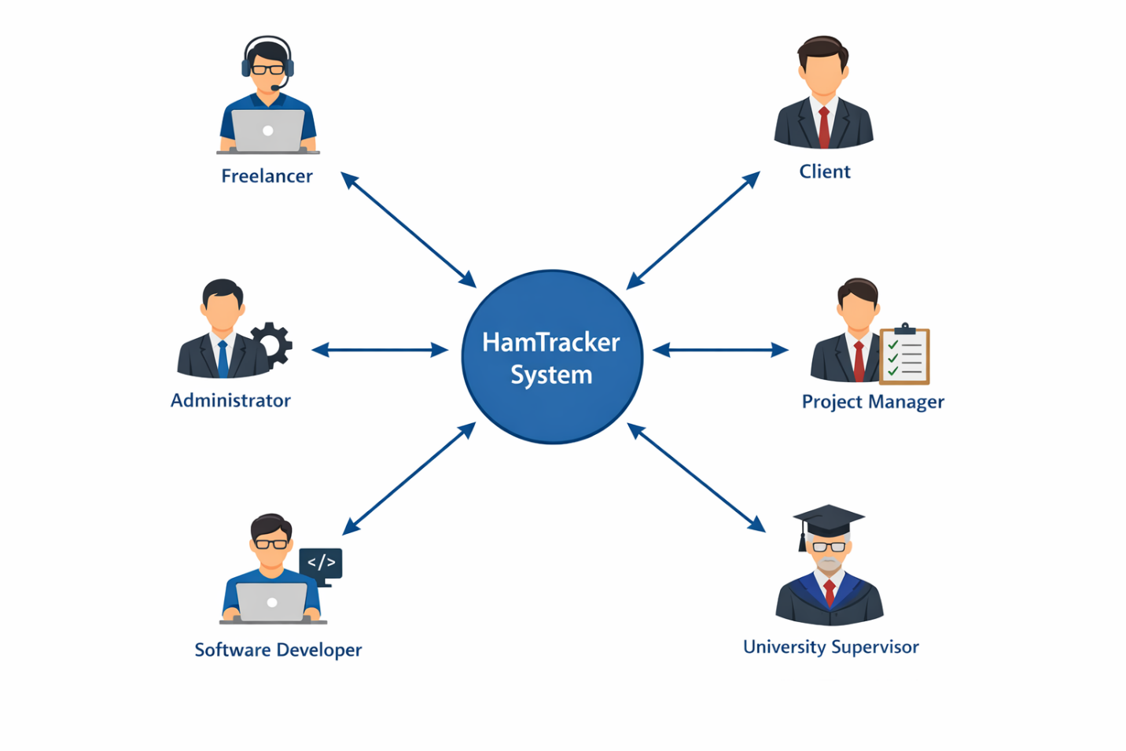
Figure 1.1: HamTracker Stakeholder Grid Mapping Matrix Layout
CHAPTER 2 – MATERIALS & METHODS
2.1 Process Model
The system was engineered using the Agile Incremental Process Model. Given the 16-week timeline, an agile model allowed for the continuous development of features in rapid, parallel increments. The desktop visual components, core algorithmic hashing sub-blocks, and database connection logic were developed in successive, iterative steps.
[Sprint 1: Planning & Architecture]
│
▼
[Sprint 2: Front-End Form Interface Construction] ──► (Customer/Reviewer Feedback)
│
▼
[Sprint 3: Cryptographic & Hashing Logic Integration]
│
▼
[Sprint 4: Timeline Processing & Automated Document Export Build]
│
▼
[Final Verified Prototype Compilation]
Figure 2.1: Agile Iteration Pipeline Lifecycle for HamTracker
This structure allowed for constant iteration. When visual form behaviors required refinement, modifications were easily made without disrupting the core database and hashing layers beneath.
2.2 Tools & Technologies
- Microsoft Visual Studio IDE: The primary integrated development environment used for writing code, designing Windows Forms UI interfaces, and debugging system components.
- C# Language Core: The structural programming language chosen for its native memory safety, strong object-oriented design, and robust desktop development capabilities.
- .NET Cryptography Namespace: Built-in framework engine used to run fast, secure SHA-256 data processing operations.
- SQLite Core Storage: A lightweight, serverless relational database engine used to handle local project histories and track hash indices reliably.
- Git Version Management: Source control repository system used to maintain file versions and track iterative code adjustments safely.
2.3 Design
2.3.1 Use Case Diagrams
The operational boundaries of the application involve two main actors: the Freelancer (who generates work progress data) and the Client (who reviews and validates evidence).
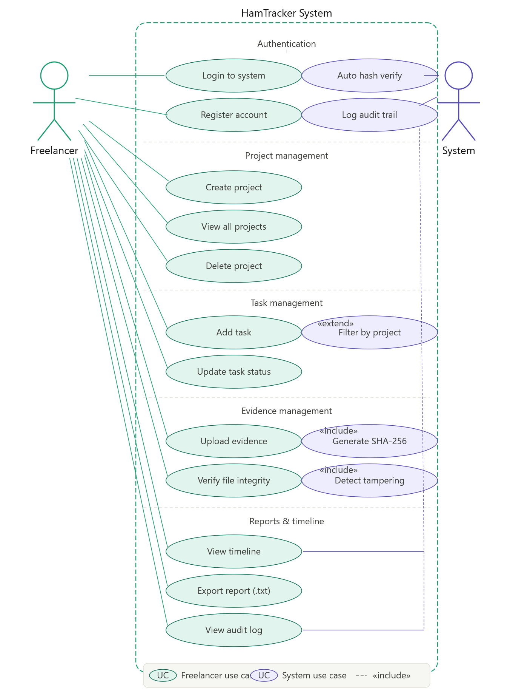
Figure 2.2: Use Case Diagram for HamTracker Operations Framework
2.3.2 Usage Scenarios
Table 2.1: Create Project Case
Use Case Title | Create Project Module
Use Case ID | UC-01
Requirement ID | FR02-01
Description | Allows the user to initialize a top-level workspace project card inside the local database environment.
Pre-Conditions | 1. Application is executing properly.  2. Local authentication verification check is complete.
Task Sequence | 1. User clicks the "Add Project" interface button.  2. System displays a dialog window prompting for the Project Name and Description.  3. User inputs the project details and hits "Save Layout."  4. System validates that the input fields are not empty.  5. System writes the new project entry into the database tracking table.  6. System refreshes the main dashboard view to display the new project card.
Exceptions | Step 4: If text inputs are empty, the system displays an alert message box stating "Project Name Field Cannot Be Blank" and returns focus to the input box.
Post-Conditions | A valid project entry is written to the database, and the user interface updates smoothly.
Authority | Freelancer User Mode / Account Owner
Modification History | v1.0 (Authored by Hussain Ahmed Madni)
Table 2.2: Upload Evidence and Generate Hash Check
Use Case Title | Upload Evidence and Cryptographic Stamp Generation
Use Case ID | UC-02
Requirement ID | FR03-01, FR03-02, FR03-03
Description | Handles ingestion of image frames or files, processes the data through the SHA-256 hashing pipe, and locks the tracking parameters.
Pre-Conditions | 1. Selected project folder contains at least one active task node.  2. Target evidence file exists and is readable by the system.
Task Sequence | 1. User selects a specific task from the dashboard list.  2. User clicks the "Attach Evidence" button utility.  3. System opens an image/file explorer dialog to capture the target asset.  4. User selects the file and confirms the upload action.  5. System captures the file data stream buffer and runs it through the SHA-256 cryptographic engine.  6. Engine generates a unique 64-character hexadecimal signature string.  7. System fetches the unalterable system time stamp.  8. System writes the file path link, hash key string, and time stamp token into the database block.  9. System updates the UI to show a secured green checkmark icon next to the task card.
Exceptions | Step 4: If the file is locked by another process or corrupted, the system displays an explicit error message stating "File Read Fault – Access Denied" and cancels the database update.
Post-Conditions | The evidence file is securely processed, signed with its cryptographic hash, and permanently logged in the system timeline.
Authority | Freelancer User Mode
Modification History | v1.0 (Authored by Hussain Ahmed Madni)
2.3.3 Sequence Diagram
The sequence diagram models the precise order of function calls and messages across components when a user adds work evidence to a task.
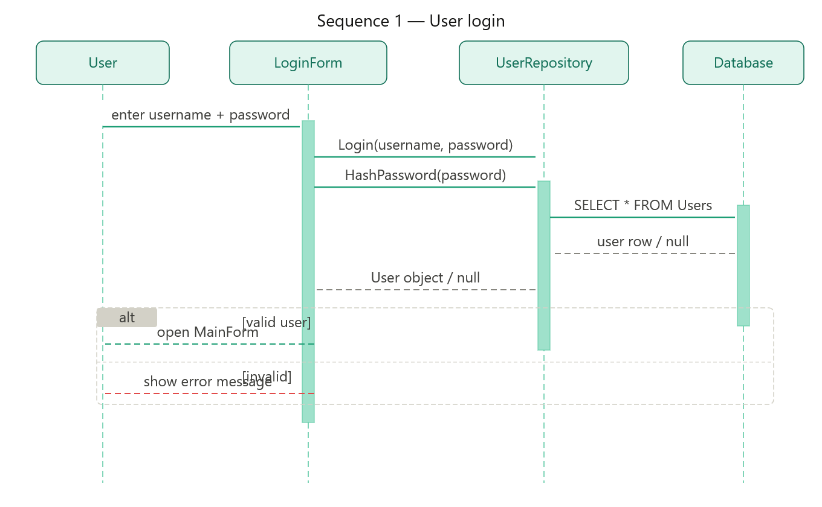
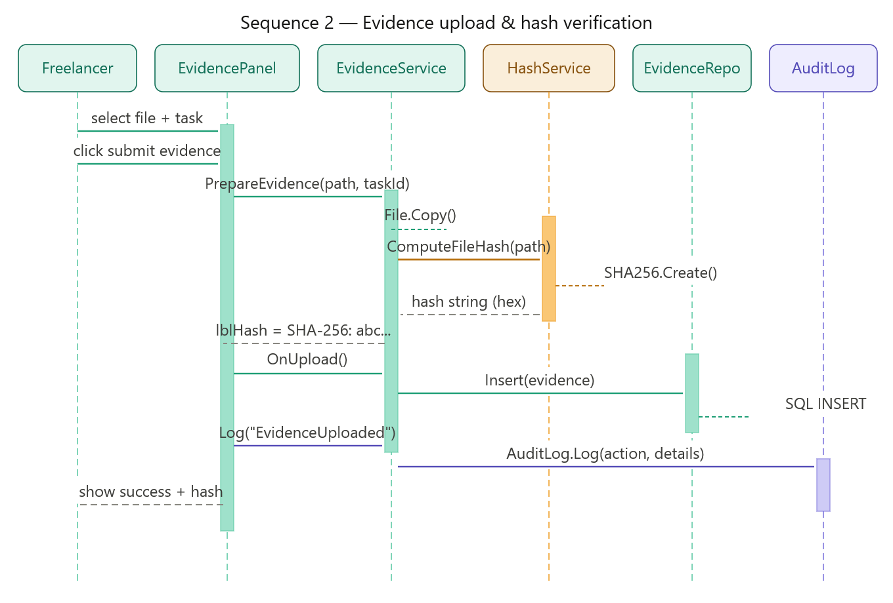
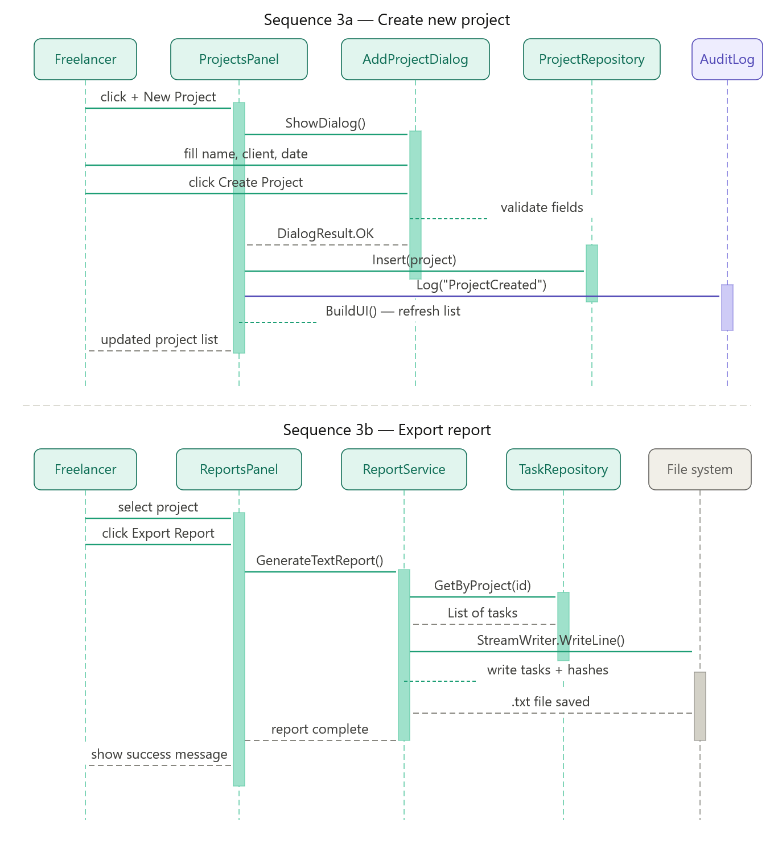
Figure 2.3: Sequence Diagram for Automated Evidence Processing and Hashing
2.3.4 Class Diagram
The static structural design of the HamTracker application follows strict Object-Oriented Programming (OOP) paradigms.
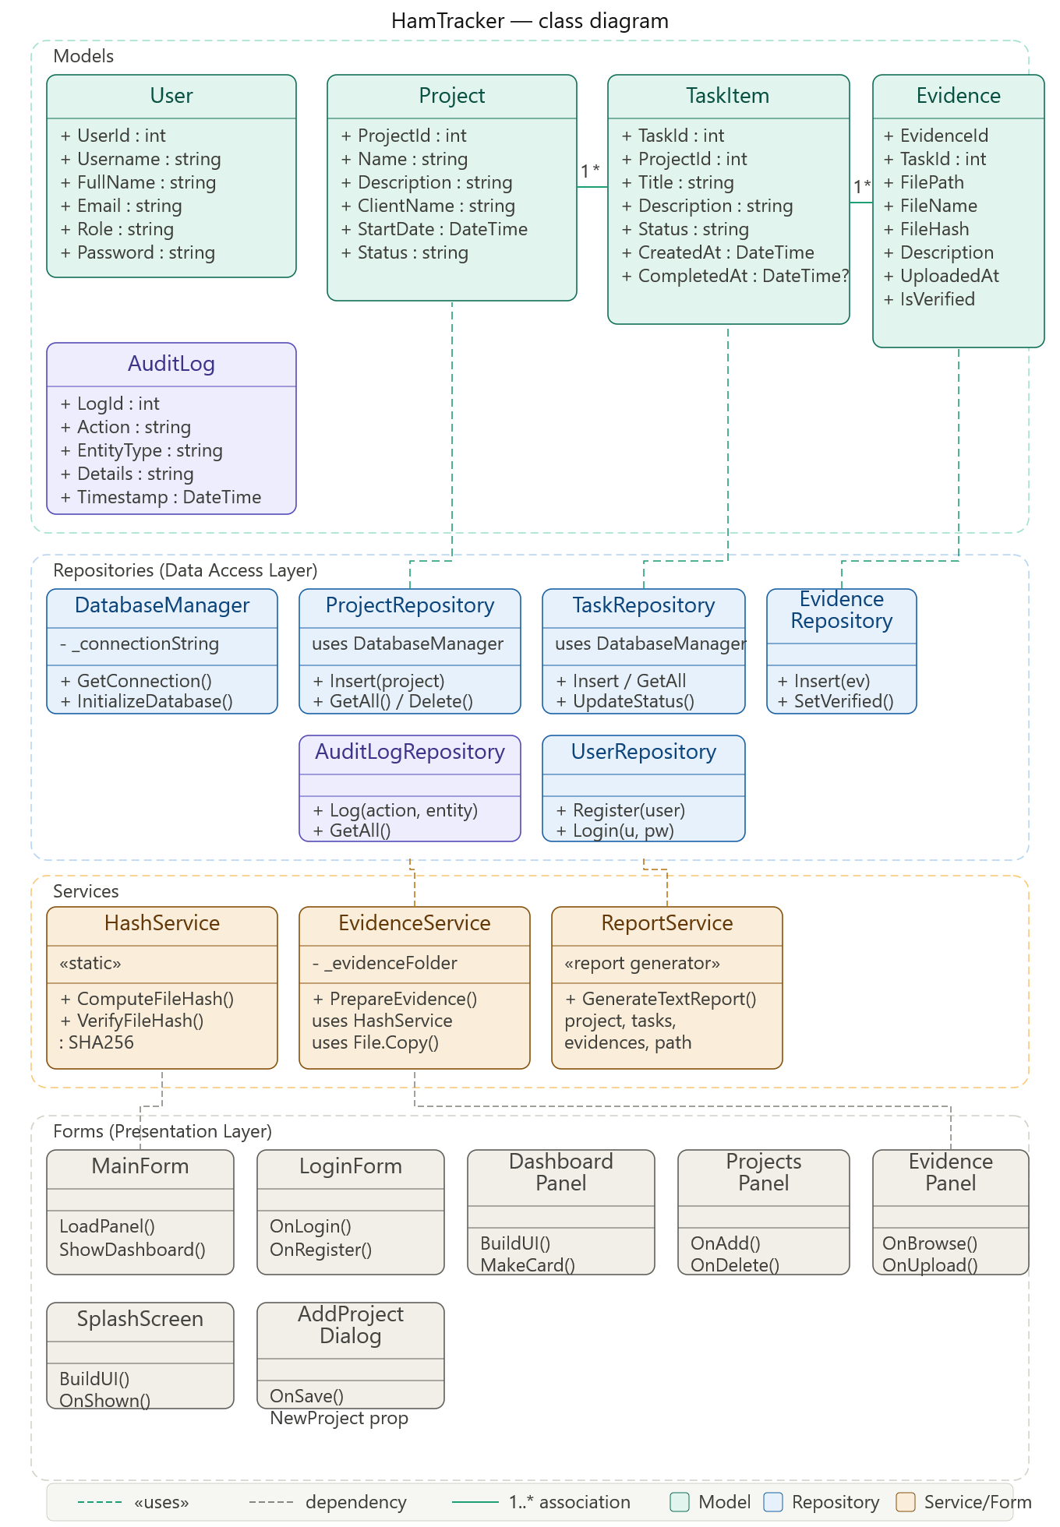
Figure 2.4: Unified Class Schema Design Structure for HamTracker Modules
2.3.5 Data Flow Diagram (DFD)
Context Level DFD (Level 0)
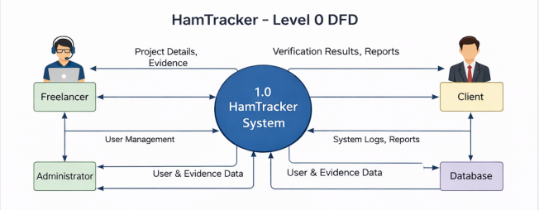Figure 2.5: Context Diagram (Level 0 DFD) showing External Entities interacting with HamTracker
Level 1 DFD (Detailed Sub-Processes)
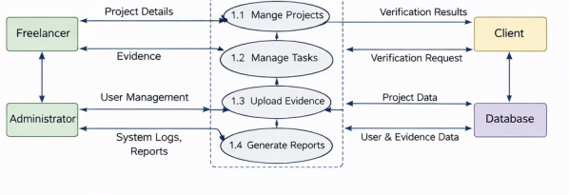Figure 2.6: Level 1 Data Flow Diagram for Detailed Subsystem Processing
2.3.6 Entity Relationship Diagram (ERD)
The entity relationships capture the business logic constraints: A Project can contain multiple Tasks, and each Task can retain multiple unique Evidence Artifact logs.
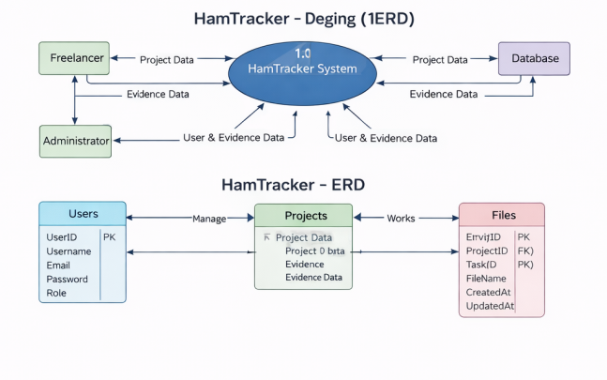
Figure 2.7: Entity Relationship Diagram Model Layout
2.3.7 Database Model
The relational tables map directly to local data storage schemas:
- Tbl_Projects: [ProjectId: INTEGER AUTOINC PK, Title: VARCHAR(100), Summary: TEXT, DateCreated: DATETIME]
- Tbl_Tasks: [TaskId: INTEGER AUTOINC PK, ProjectId: INTEGER FK, Title: VARCHAR(150), ProgressStatus: VARCHAR(30)]
- Tbl_EvidenceLedger: [EvidenceId: INTEGER AUTOINC PK, TaskId: INTEGER FK, LocalFilePath: VARCHAR(255), SecureHashValue: CHAR(64), LockedTimestamp: DATETIME]
2.3.8 System Architecture
HamTracker relies on a 3-Tier Modular Desktop Architecture Framework to keep operations fast, maintainable, and decoupled.
CHAPTER 3 - RESULTS & DISCUSSION
3.1 Testing
The quality testing process utilized rigorous Black Box Testing strategies, specifically checking input boundary handling, validation workflows, hash immutability accuracy, and runtime performance indicators. Testing ensured that if any internal file tracking parameters were corrupted or manually altered, the validation checks caught the discrepancy immediately.
3.2 Test Cases
Table 3.1: User Local Credentials Verification
Test Case ID | TC-SEC-01
Test Case Title | Verify Workspace Locker Password Validation Behavior
Test Priority | High
Requirement Reference | FR01-01, FR01-02
Test Description | Confirms that unauthorized users cannot bypass the password gate to access local evidence tables.
Pre-Conditions | Launch the application executable bundle.
Execution Steps | 1. Leave the password entry field empty and hit "Verify Access."  2. Input an incorrect, arbitrary verification string and check behavior.  3. Input the valid, pre-registered workspace password asset and execute.
Expected Results | 1. System throws a prompt stating "Field Cannot Be Empty."  2. System blocks access, clearing the text grid with an "Access Denied" error message.  3. System displays the workspace interface smoothly.
Actual Results | System components performed exactly as expected across all input variations.
Status | PASS
Table 3.2: Tamper Evidence Hash Breakdown Verification
Test Case ID | TC-CRYPTO-02
Test Case Title | Verify Tamper-Detection Capabilities when Local Files are Swapped
Test Priority | Critical
Requirement Reference | FR03-02, FR03-03
Test Description | Validates that changing a progress file outside the application breaks the validation hash, proving the ledger is tamper-evident.
Pre-Conditions | Log a mock task complete with an attached file tracking artifact (proof_doc.pdf).
Execution Steps | 1. Navigate to the local file system outside HamTracker.  2. Replace proof_doc.pdf with a different file renamed to match the original document.  3. Open HamTracker and click "Verify Integrity" on the corresponding task card.
Expected Results | System calculates the hash for the modified file, detects that it does not match the original hash key stored in the secure database, triggers a high-priority warning message box, and flags the log status as "TAMPERING DETECTED / INVALID RECORD."
Actual Results | System successfully blocked the modified file and accurately flagged the record anomaly.
Status | PASS
3.3 Conclusion
The implementation of the HamTracker System shows that lightweight client-side applications can successfully establish cryptographically verifiable proof chains without requiring complex cloud storage architectures. By wrapping the .NET Cryptography engine around standard file attachments, the application guarantees data integrity.
Comprehensive testing proved the system's resilience against manual record adjustments, providing freelancers and corporate clients with a clear, reliable baseline of trust. The intuitive interface and clear, timeline-driven layouts minimize workflow overhead while maximizing professional accountability. HamTracker successfully addresses the challenges of remote project tracking, delivering a reliable, low-cost platform for remote dispute resolution.
CHAPTER 4 - USER MANUAL
4.1 Authentication Interface Screen
This screen acts as the application's access gate, preventing unauthorized access to local project datastores.
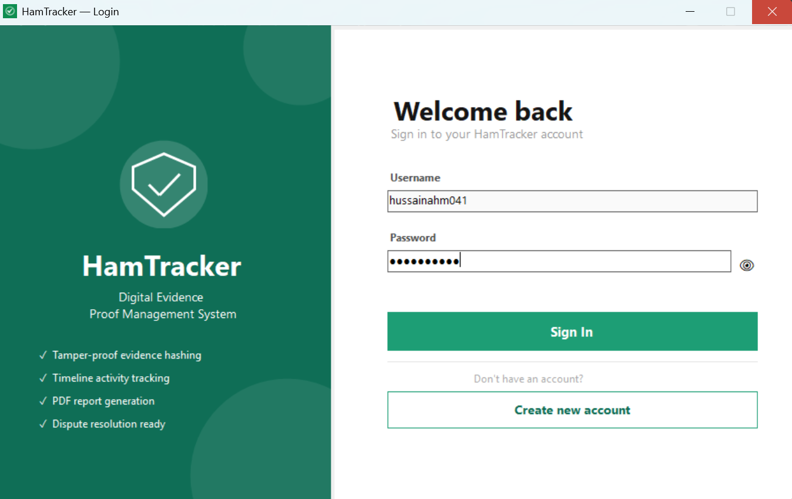
Figure 4.1: Workspace Locker Login Interface Window
4.2 Main Control Dashboard Workspace
The main dashboard serves as the command center for project management. Users can easily manage project folders and view individual task cards using the controls on this screen.
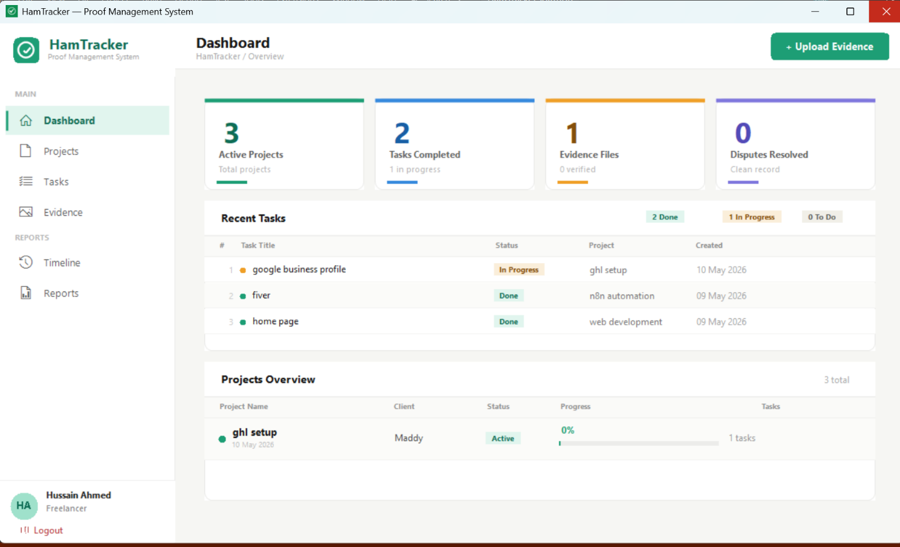
Figure 4.2: Main Project and Task Directory Canvas View
4.3 Evidence Processing and Upload Dialog Block
This module manages file ingestion and tracks the generation of secure cryptographic checksums.
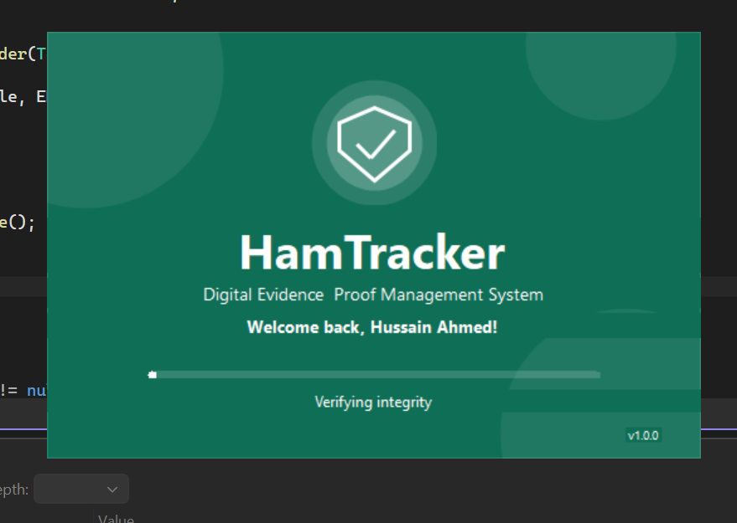
Figure 4.3: Ingesting File Media and Tracking Hashing Pipeline Operations
4.4 Interactive Progress Timeline Output Layout
This viewport organizes project contributions into a clear chronological layout, displaying verification hash indices alongside locked tracking details.
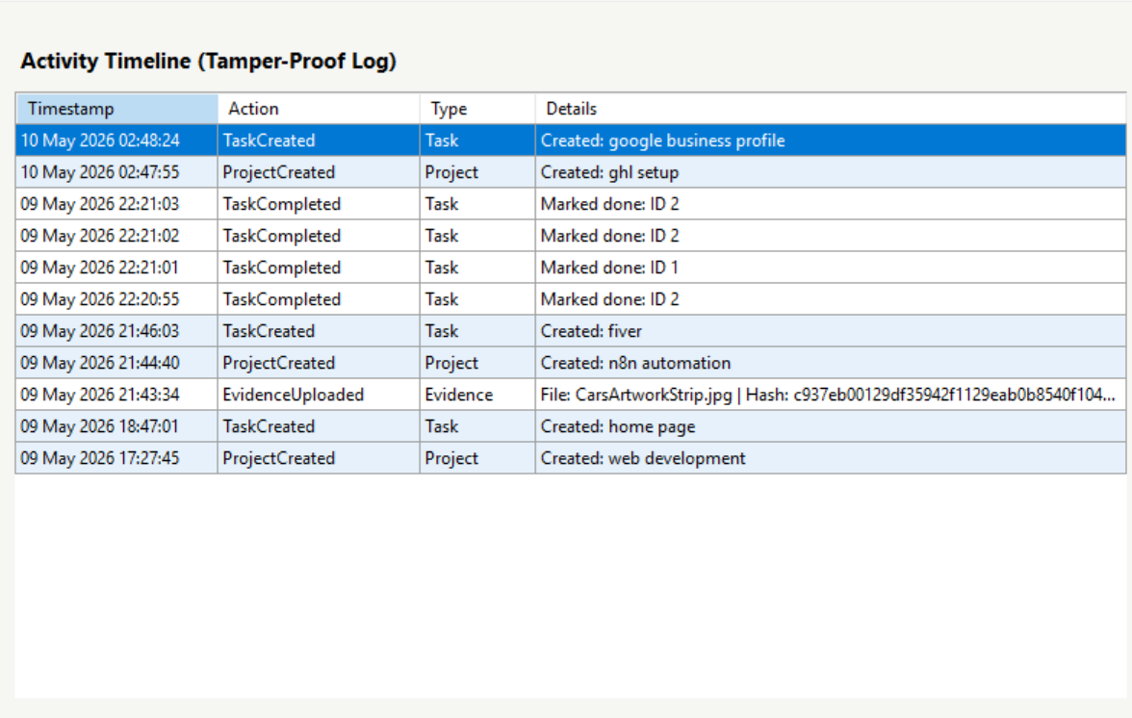
Figure 4.4: Complete Chronological Progress History Audit Trail Canvas View
REFERENCES
- Richter, J., CLR via C# (4th Edition), Microsoft Press, 2012.
- Troelsen, A., & Japikse, P., Pro C# 7: With .NET and .NET Core, Apress, 2017.
- Stellman, A., & Greene, J., Head First C#: A Learner's Guide to Real-World Programming, O'Reilly Media, 2020.
- UAF Academic Research and Software Documentation Guidelines, Department of Computer Science, University of Agriculture Faisalabad, 2025.

