The Python Users Group
is meeting in TX4 tonight:

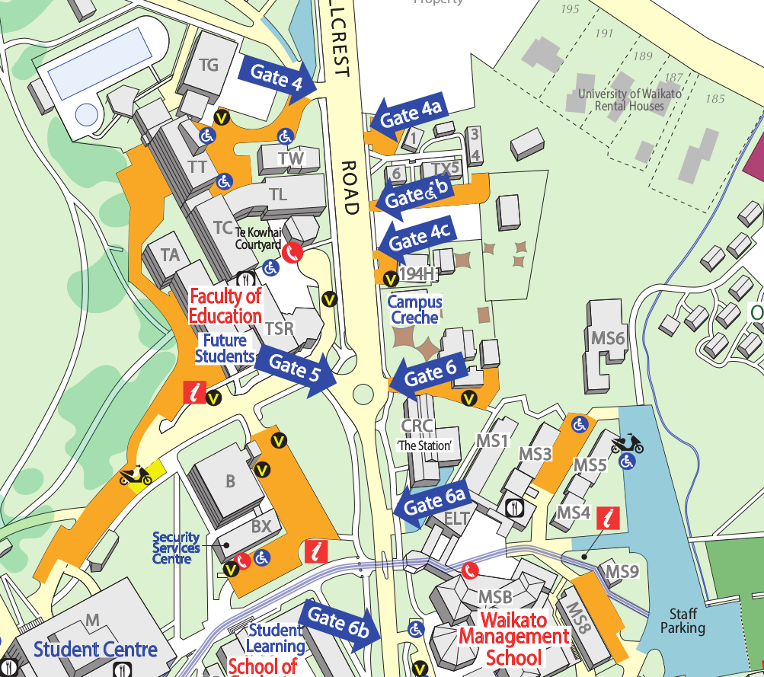
TX4
MS4

You are here

