Modeling and Simulation

of the Meteor Burst Channel
XIA Bing, LI Linlin, ZHENG Yanshan
Rocket Force University of Engineering, Xi'an 710025, China
Source: Telecommunications Science, 2016, No. 9. DOI: 10.11959/j.issn.1000-0801.2016206

Abstract
To evaluate the effectiveness of meteor-burst communication equipment and software under operational conditions, a simulation model of the meteor-burst communication channel is established to address the complex characteristics of the channel and the high cost of obtaining measurement data. Based on an
in-depth study of representative mathematical models, models for underdense and overdense meteor-trail channels are developed. Two special cases-underdense meteor clusters and multipath channels-are incorporated to construct a hybrid meteor-burst channel model according to probability theory. Combined with a meteor-trail arrival-interval model, the hybrid channel model is implemented in C++. The simulation can generate several types of complex channels, including single underdense trails, single overdense trails, underdense meteor clusters, and multipath channels. The simulation results show that the characteristics of the generated meteor-burst channel are broadly consistent with those of actual channels, demonstrating the model's usability and validity.
Keywords: meteor burst communication; channel modeling; underdense; overdense; hybrid model; arrival interval

Introduction
Meteor burst communication refers to long-distance communication using the reflection and scattering of radio waves by meteor trails. It is characterized by strong burstiness, long communication distance, and low transmission rate. During communication, it is difficult to intercept and therefore provides a high degree of concealment. In complex electromagnetic environments, including those associated with nuclear explosions, it can still provide relatively reliable communication, making it an important means of minimum emergency communication support.
The physical phenomena involved in meteor burst communication are complex and variable. In addition, constraints on wireless resources and the threat of electromagnetic leakage make long-distance experiments based on actual channels expensive, requiring substantial human and material resources. Consequently, communication experiments and training based on meteor trails have been limited, and the actual effectiveness of communication equipment and software under operational conditions cannot be adequately evaluated. Establishing a meteor burst channel simulation model is therefore important for research on meteor burst communication.
Simulation research on meteor burst channels in China and abroad has been relatively inactive, and earlier simulation results are not well suited to the background considered in this paper. References [3,4] established parameter models for meteor burst channels and analyzed important indicators such as average communication time, trail arrival intervals, and the probability of multipath interference, but these were not channel models in the practical sense and lacked systematic treatment. References [5-7] analyzed mathematical models and established underdense and overdense meteor-trail channel models, obtaining useful conclusions; however, the simulated channel types were too limited and could not represent the meteor-trail occurrence process. Reference [8] used a design approach combining partial implementation with overall integration and implemented meteor-trail channel simulation using SPW, but the

implementation was heavily constrained by the software, lacked flexibility, and the simulation results were inconvenient to transfer to other simulation studies.
Based on an analysis of meteor-trail channel characteristics, this paper derives and optimizes the mathematical models discussed in References [3-8] to obtain expressions for underdense and overdense meteor-trail channel models. Underdense meteor clusters and multipath channels are incorporated into the channel-modeling process. Based on statistical results from actual observations, a hybrid meteor-trail channel model is established, and the hybrid model is finally simulated using a program-design approach.

Characteristics and Basic Models of the Meteor Burst Channel
A meteor burst channel is the physical channel through which radio signals are scattered or reflected by electrons within a meteor trail. According to the average number of free electrons per meter in a meteor trail (electron line density, in $e/m$), meteor trails can be classified as underdense or overdense. A trail with an electron line density below ${10}^{14}e/m$ is classified as underdense, whereas one above ${10}^{14}e/m$ is classified as overdense. Signal transmission through a channel normally causes power attenuation. In a meteor burst channel, attenuation is most closely related to changes in the electron line density within the trail and is therefore one of the parameters that most clearly reflects channel characteristics. This paper primarily characterizes the channel through variations in received signal power.

Basic Characteristics
An underdense meteor trail is produced by friction between a relatively small meteoroid and the atmosphere. Its characteristics are a low electron line density and a very short duration, normally from several hundred milliseconds to about 1 s. At the beginning of trail formation, the signal rapidly reaches a peak; as the trail continues to diffuse and expand, signal strength gradually decreases, with an approximately exponential decay. Figure 1 shows the received-power waveform for a single underdense trail from formation to disappearance.
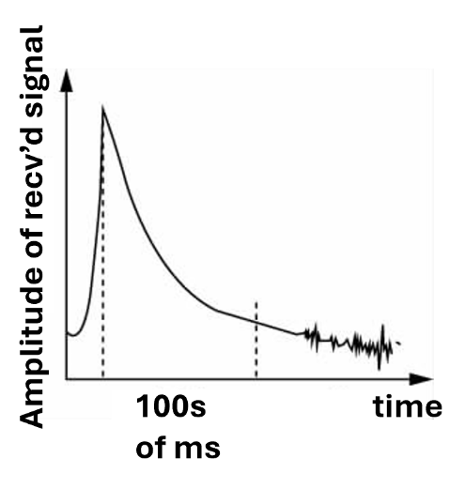
Figure 1 Received-power curve of an underdense meteor trail.

An overdense meteor trail is produced by friction between a relatively large meteoroid and the atmosphere. Its electron line density is greater, and its duration is relatively longer, approximately several hundred milliseconds to several seconds. At formation, the signal rises suddenly. As the trail diffuses and expands, its equivalent radius increases, and the received signal strength initially shows an increasing trend before gradually becoming stable. As diffusion continues, electron line density decreases further; the overdense trail then becomes an underdense trail and signal strength rapidly decreases. Figure 2 shows the corresponding received-power waveform.

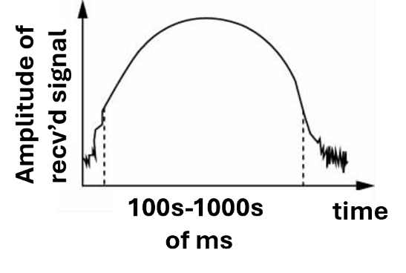
Figure 2 Received-power curve of an overdense meteor trail.

Basic Model of an Underdense Meteor-Trail Channel
The most commonly used mathematical model for an underdense meteor-trail channel [6] was proposed by Eshleman et al. in the early 1950s:
 | $$P_{R}\left(t\right)=P_{R}(0)e^{{-t}/τ}$$ | (1)
where $P_{R}(t)$ is the received signal power, $P_{R}\left(0\right)$ is the initial power of the reflected trail signal, and $τ$ is the received-power decay factor. $P_{R}(0)$ and $τ$ are given by Eqs. (2) and (3), respectively.

 | $$P_{R}\left(0\right)=\frac{P_τG_{T}G_{R}λ^{3}q^{2}r_{e}^{2}{\text{sin}}^{2}α}{16π^{2}R_τR_{R}(R_{τ}+R_{R})(1-{\text{cos}}^{2}β{\text{sin}}^{2}ϕ)}$$ | (2)
 | $$τ=λ^{2}{\text{sec}}^{2}ϕ/32π^{2}D$$ | (3)
Substitution of Eqs. (2) and (3) into Eq. (1) gives the received signal power of an underdense meteor trail as Eq. (4).

 | $$P_{R}\left(t\right)=\frac{P_{T}{G_{T}G_{R}λ}^{3}q^{2}r_{e}^{2}{\text{sin}}^{2}α}{16π^{2}R_τR_{R}(R_{τ}+R_{R})(1-{\text{cos}}^{2}β{\text{sin}}^{2}ϕ)}\text{exp}\left(-\frac{32π^{2}D}{λ^{2}{\text{sec}}^{2}ϕ}t\right)$$ | (4)
Here $P_{T}$ is transmitted signal power, $G_{T}$ and $G_{R}$ are the transmitting and receiving antenna gains, $λ$ is wavelength, $q$ is electron line density, $D$ is the diffusion coefficient of the meteor column, $R_{T}$ and $R_{R}$ are the respective distances from the transmitter and receiver to the tangent points on the meteor-trail plane, $β$ is the angle between the trail electric-field vector and the plane, $α$ is the angle between the trail electric-field vector and the incident-wave electric-field vector, $2ϕ$ is the angle between the incident and reflected waves, and $t$ is time. The constant $r_{e}$ is taken as $0.8852\text{×}{10}^{-14}$.

Basic Model of an Overdense Meteor-Trail Channel
For an overdense meteor trail, Hines and Forsythe proposed a typical mathematical model for received signal power [7]. The paper gives the model in Eq. (5),
 | $$P_{R}\left(t\right)=P_{R}(0){\left[Dt\ln{\frac{r_{e}qλ^{2}{\text{sec}}^{2}ϕ }{4π^{3}Dt}}\right]}^{1/2}$$ | (5)
the initial received power in Eq. (6),

 | $$P_{R}\left(0\right)=\frac{P_{T}G_{T}G_{R}λ^{3}q^{\frac{1}{2}}r_{e}^{\frac{1}{2}}{\text{sin}}^{2}α}{16π^{2}R_{T}R_{R}(R_{T}+R_{R})\left(1-{\text{cos}}^{2}β{\text{sin}}^{2}ϕ\right)}$$ | (6)
and the resulting expression in Eq. (7).
 | $$P_{R}\left(t\right)=\frac{P_{T}G_{T}G_{R}λ^{3}q^{\frac{1}{2}}r_{e}^{\frac{1}{2}}{\text{sin}}^{2}α}{16π^{2}R_{T}R_{R}(R_{T}+R_{R})\left(1-{\text{cos}}^{2}β{\text{sin}}^{2}ϕ\right)}{\left[Dt\ln{\frac{r_{e}qλ^{2}{\text{sec}}^{2}ϕ }{4π^{3}Dt}}\right]}^{1/2}$$ | (7)
According to Reference [9], the relevant term in Eq. (5) corresponds to the received-power decay factor $τ$ in Eq. (1). The parameters in Eq. (7) are the same as those in Eq. (4).

Analysis of the Basic Models

Underdense Meteor-Trail Channel Model
    - Assumptions
- The meteor trail occurs within the first Fresnel zone.
- The trail provides reflection only when the angle between the incident and reflected waves is approximately ${90}^{°}$.
- Horizontal polarization is used during transmission, i.e., $α={90}^{°}$.
- The meteor's direction of incidence is isotropically random, and the average value of $\text{cosβ=2/π}$.
- Antenna gains are isotropic, i.e., $G_{T}G_{R}=1$.
- The distance from the transmitting station to the trail, $R_{T}$, is equal to the distance from the receiving station to the trail, $R_{R}$.

Model Analysis
Using Assumptions 1-5, substituting the corresponding values of $α,β,ϕ$ into Eq. (3), and letting $λ=\frac{c}{f}$, where $f$ is the signal frequency, the initial received power can be simplified to Eq. (8):
 | $$P_{R}\left(0\right)=\frac{P_{T}q^{2}}{R_{T}R_{R}\left(R_{T}+R_{R}\right)f^{3}}$$ | (8)
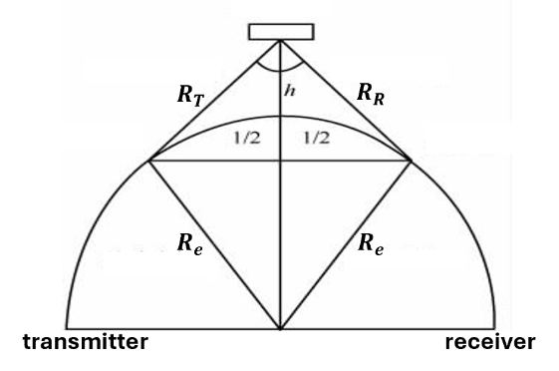
Under Assumption 6, the meteor-trail communication link has the geometry shown in Figure (3).
Figure 3 Meteor burst communication link.
From the geometric relationships, $R_{T}=R_{R}=R$ with $R$ determined by Eq. (9).
 | $$R=\sqrt{{\left(R_{e}-R_{e}\text{cos}\left(\frac{l}{2R_{e}}\right)+h^{2}\right)+R_{e}^{2}{\text{sin}}^{2}\left(l/2R_{e}\right)}_{}}$$ | (9)
The corresponding ${\text{sec}}^{2}ϕ$ relationship is given by Eq. (10).

 | $${\text{sec}}^{2}ϕ=1+\frac{R_{e}^{2}{\text{sin}}^{2}\left(l/2R_{e}\right)}{{\left(R_{e}-R_{e}\text{cos}\left(\frac{l}{2R_{e}}\right)+h\right)}^{2}}$$ | (10)

According to empirical relation (1), the diffusion coefficient satisfies $\log_{10}{D}=0.67h-5.6$, giving equation (11)

 | $$D={10}^{0.067h-5.6}$$ | (11)

The resulting decay factor is given by Eq. (12).

 | $$τ=\frac{c^{2}\left[1+{\left(R_{e}+h\right)}^{2}-2\left(R_{e}+h\right)R_{e}\text{cos}\left(l/2R_{e}\right)\right]r_{e}}{32π^{2}{10}^{0.067h-5.6}f^{2}{\left(R_{e}-R_{e}\text{cos}\left(\frac{l}{2R_{e}}\right)+h\right)}^{2}}$$ | (12)
Equation (12) shows that received signal power for an underdense trail depends on transmitted power $P_{T}$, signal frequency $f$, electron line density $q$, Earth's radius $R_{e}$, trail altitude $h$, and ground communication distance $l$. Normally, the meteor-trail occurrence altitude satisfies $h=124-17\log_{10}{f}$, where $h$ is in km and $f$ is in MHz. This simplifies the model calculation.

Model Simulation
Based on the preceding analysis, the channel model is simulated by setting parameter values. Following Reference [1], the simulation parameters are: transmitted power of 1,000 W; signal frequency of 30-60 MHz; electron line density within the underdense range, ${10}^{12}<q<{10}^{14}e/m$; Earth radius of 6,400 km; and ground communication distance of 400-1,500 km.
The simulation result is shown in Figure 4.
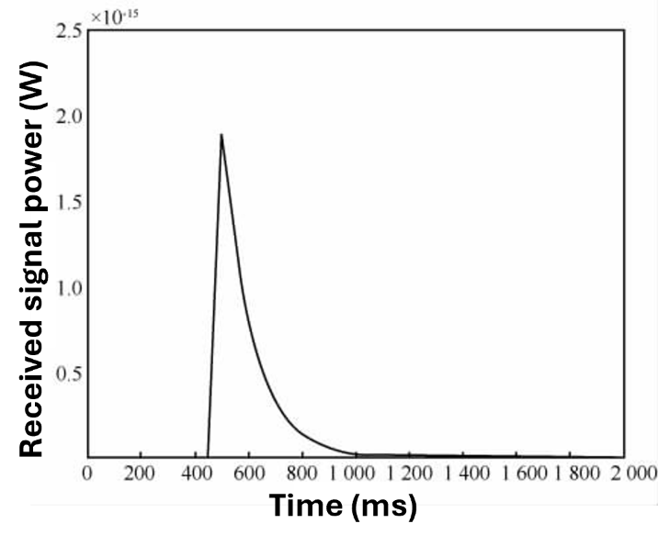
Figure 4 Simulation of an underdense meteor-trail channel.

The signal rapidly reaches a peak at the beginning and then exhibits approximately exponential decay as the trail diffuses, consistent with Figure 1. The entire process lasts approximately several hundred milliseconds, and the signal peak is close to measured values. This indicates that the model represents the power-attenuation characteristics of the underdense meteor-trail channel reasonably well.

Overdense Meteor-Trail Channel Model
    - Model Analysis
Using the assumptions and analytical method of Section 3.1, the model in Section 2.3 yields the initial received signal power and decay factor of the overdense meteor-trail channel in Eqs. (13) and (14). As with the underdense case, received signal power depends on $P_{T}, f, q, R_{e},h, \text{and }l$. Unlike the underdense case, the time-varying component is strongly affected by electron line density q.

Model Simulation
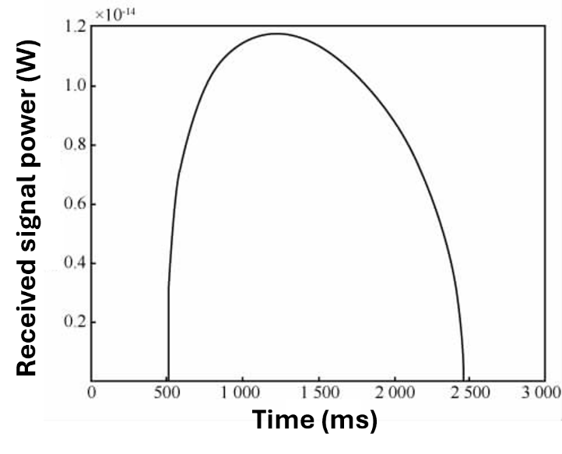
The simulation method is the same as that used for the underdense meteor-trail channel, except that electron line density is restricted to the overdense range, $q>{10}^{14} e/m$. The resulting simulation is shown in Figure 5.
Figure 5 Simulation of an overdense meteor-trail channel.
The signal initially rises for a short period, then becomes stable, and subsequently decays, consistent with Figure 2. The entire process lasts approximately several seconds, and the peak signal is close to measured values. Thus, the model also represents the power-attenuation characteristics of the overdense channel reasonably well.

Probability-Based Hybrid Channel Modeling
Actual observations show that meteor trails most often occur as single underdense or single overdense trails, which can be described by the two models above. However, two special phenomena can occur: multiple underdense meteor trails may arrive consecutively, producing an underdense meteor-cluster channel; and electromagnetic waves may be reflected at two or more locations within the same trail, or two or more usable meteor trails may occur in the same region, producing a multipath channel.
Thus, meteor-trail occurrences can be divided into four cases: single underdense, single overdense, underdense meteor cluster, and multipath channel. To simulate the burst process realistically, the two special channel cases are first analyzed, after which the four models are combined using
probability-distribution methods.
The underdense meteor-cluster and multipath cases can effectively be treated as a single underdense meteor trail occurring repeatedly or simultaneously. They can therefore be modeled by adding appropriately delayed copies of a single-meteor response.
Table 1. Meteor burst channel probabilities.

Channel type | Underdense | Overdense | Multipath | Meteor cluster
Occurrence probability | 85% | 10% | 3% | 2%

For an underdense meteor cluster, if $n$ underdense meteors arrive consecutively and the delay of the $m\text{th}$
meteor is $Δt$, the cluster channel is represented by Eq. (15):

 | $$P_{R}{\left(t\right)}_{N}=\sum_{m=1}^{n}{P_{R}(t-Δt_{m})}$$ | (15)

For a multipath channel with $n$ paths, if the attenuation coefficient and delay of path $m$ are $K_{m}$ and $Δt_{m}$,
respectively, the channel is represented by Eq. (16):

 | $$P_{R}{\left(t\right)}_{M}=\sum_{m=1}^{n}{K_{M}P_{R}(t-Δt_{m})}$$ | (16)

Here $P_{R}\left(t\right)$ denotes the received power of a single underdense meteor-trail channel. Statistical analysis of the measured data [1] was performed for the four channel models represented by (1), (5), (15), and (16). The resulting occurrence probabilities of the four channel types are given in Table 1. By combining the four channel models according to their probability distributions, the following probability-distribution-based mixed meteor-trail channel model is obtained:

 | $$P=\left\{\begin{matrix}0.85 & P\left(t\right)=P_{R}\left(0\right)e^{-t/τ} \\ 0.1 & P\left(t\right)=P_{R}(0){\left[Dt\ln{\frac{r_{e}qλ^{2}{\text{sec}}^{2}ϕ}{4π^{3}Dt}}\right]}^{1/2} \\ 0.02 & P\left(t\right)=\sum_{m=1}^{n}{P_{R}(t-Δt_{m})} \\ 0.03 & P\left(t\right)=\sum_{m-1}^{n}{K_{m}P_{R}(t-Δt_{m})}\end{matrix}\right.$$ | (17)

Here $P_{R}\left(t\right)=P_{R}\left(0\right)e^{-t/T}$. The model considers the various situations in the burst process and can generate underdense trails, overdense trails, underdense meteor clusters, and multipath channels in accordance with observed behavior.

Simulation and Analysis

Time-Control Method
Equation (17) describes a single trail occurrence. To simulate the process in which meteor trails arrive continuously at different time intervals, an arrival-interval model is introduced. The time interval between meteor-trail occurrences follows an exponential distribution with parameter $T$, where $T$ is the mean arrival interval. From the relationship between probability density and a uniform distribution, the arrival interval is obtained as Eq. (18):
 | $$X=-T\ln{(1-A)}$$ | (18)
where $A$ is a uniformly distributed random variable between 0 and 1. Here we normally take the mean arrival interval as $T=10\text{s}$.

Simulation Method
Based on the experimental conditions and equipment parameters of an actual meteor burst communication system, the simulation parameters are those shown in Table 2.

Table 2. Simulation parameters.

Parameter | Transmit power | Frequency | Electron line density | Earth radius | Communication distance
Value | 400-1000 W | 30-60 MHz | ${10}^{12}<q<{10}^{14}$ e/m | 6400 km | 400-1500 m

The computer simulation of the hybrid channel proceeds as follows. The time of each meteor-trail occurrence is controlled using the arrival-interval model in Section 5.1. Once the occurrence time is determined, the channel type for that occurrence is selected according to the probabilities in Table 1. Whenever a usable meteor trail is generated, the received-signal-power attenuation process is simulated using Eq. (17). The detailed hybrid-channel simulation procedure is shown in Figure 6.
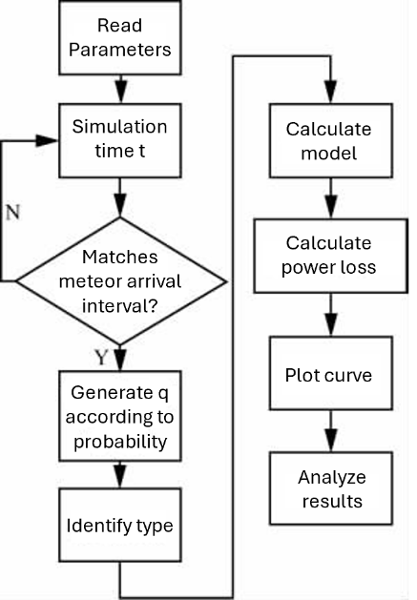
Figure 6 Flowchart of hybrid channel simulation

Results and Analysis
Using the above method and procedure, the authors implemented the simulation in C++ 6.0. The final channel simulation result is shown in Figure 7.

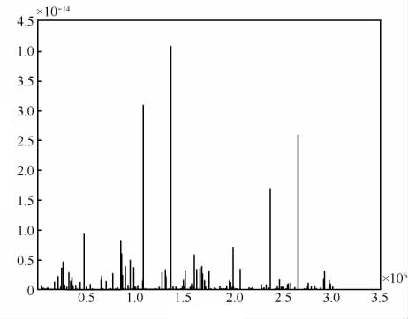
Figure 7 Synthesized-channel simulation result.
The figure presents the received-signal-power variation of a synthesized channel generated according to the occurrence probabilities of the different meteor-trail channel types. Meteor trails occur approximately once every few seconds; most are underdense and a small number are overdense. Underdense trails last approximately several hundred milliseconds, while overdense trails last from several hundred milliseconds to several seconds.
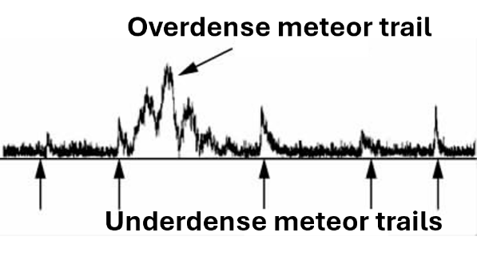
Figure 8 Measured received-signal-power curve
Figure 8 shows an actually measured received-signal-power curve. Comparison of Figures 7 and 8 indicates that the simulated results agree with actual observations in terms of timing, channel type, probability, and other characteristics, thereby reflecting the principal properties of the meteor burst channel.
Because the underdense meteor-cluster and multipath channels have relatively low occurrence probabilities, multiple simulations were performed to illustrate their characteristics. In simulations in which these special cases occurred, the corresponding time intervals were extracted and displayed. Figure 9 shows an underdense meteor-cluster channel: multiple underdense meteors occur consecutively within a short period, and the signal power exhibits superposition over several seconds.
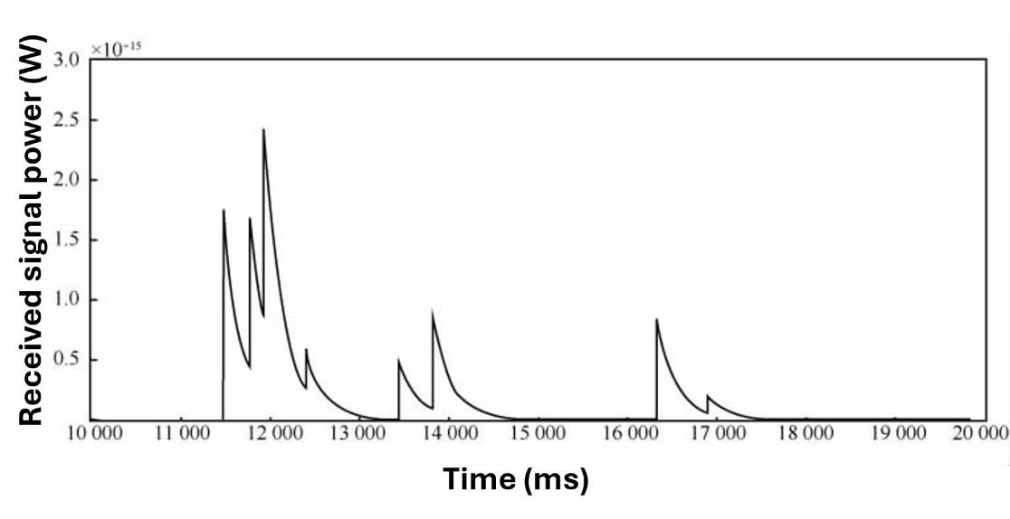
Figure 9 Simulation result for an underdense meteor-cluster channel.
Figure 10 shows a multipath channel: multiple simultaneous signals exhibit small time delays and clear superposition within several hundred milliseconds. These two cases supplement the simulation results and improve their completeness.
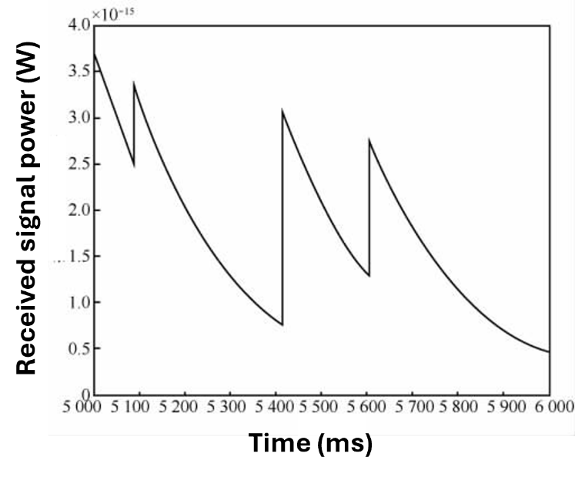
Figure 10 Simulation result for a multipath channel.

Conclusion
This paper establishes a meteor burst channel simulation model and performs simulation analysis to address the complex characteristics of meteor burst channels and the high cost of measurement. The principal work is as follows.
First, the mathematical models discussed in previous literature are derived, optimized, and simulated, yielding computer-model expressions for underdense and overdense meteor-trail channels.
Second, based on simulation analysis of the mathematical models, the various situations that can occur during the meteor burst process are considered. Underdense meteor clusters and multipath channels are incorporated into the channel-modeling process, and methods and models for handling these two cases are provided.
Third, based on statistical results from actual observations and principles of probability theory, the four channel models are combined to establish a hybrid meteor burst channel model. This model provides a description of the meteor burst channel that is more consistent with actual conditions.
Finally, the hybrid channel model is simulated using a program-design approach. The simulation results agree with actual conditions and can be further applied to other simulations of meteor burst communication, giving the model good portability.
Future work will further investigate the parameters involved in the model and reduce the number of assumptions so that the model more closely matches actual conditions. In addition, the simulation results will be applied to simulations of meteor burst communication networking performance, providing model support for networking-performance research.

References
- LI Z, LIU Z J, SHEN J. Meteor Trail Communication Theory and Application. Beijing: Electronic Industry Press, 2011: 24-28.
- JOHN D O. An analysis of meteor burst communications for military applications. IEEE Transactions on Communications, 1980, 28(9): 1591-1601.
- ZHENG X B, LE Y, ZHANG G D, et al. Meteor trail channel statistical properties and model analysis. Journal of Radio Communication Technology, 2013, 39(2): 17-20.
- ZHANG J P, HAN J J, JIN L J. Meteor trail communication channel modeling and performance simulation. Journal of Radio Communication Technology, 2002, 28(5): 41-44.
- WANG D L, QIN J C. Matlab simulation of the meteor burst channel. Journal of Radio Communication Technology, 2007, 33(5): 17-19.
- ESHLEMAN V R, MANNING L A. Radio communication by scattering from meteoric ionization. IRE, 1954, 42: 530-536.
- HINES C O, FORSYTHE P A. The forward scattering of radio waves from over-dense meteor trails. Canadian Journal of Physics, 1957, 35(9): 1033-1041.
- HAN B J, CAI J P, LI Z, et al. Meteor trail channel modeling and system simulation based on SPW. Journal of System Simulation, 2010, 22(7): 1782-1788.
- SCHANKER J Z. Meteor Burst Communications. Norwood: Artech House Inc., 1990: 24.
- SHENG Z, XIE S Q, PAN C Y. Probability and Mathematical Statistics. Beijing: Higher Education Press, 2001: 241-252.
- MCKINLEY D W R. Meteor Science and Engineering. New York: McGraw-Hill, 1961: 14-15.
- LI Z, CHEN Y X, DIAO S L, et al. Meteor communication receiver based on fast channel capture and coefficient-mapping equalization. Journal of Electronics, 2005, 33(10): 1729-1733.

Author Biographies
ZHENG Yanshan (1991-), male, master's student at Rocket Force University of Engineering. His research focuses on simulation and evaluation of operational effectiveness of command information systems.
XIA Bing (1991-), male, master's student at Rocket Force University of Engineering. His research focuses on simulation of meteor burst communication systems.
LI Linlin (1974-), female, PhD, associate professor at Rocket Force University of Engineering. Her research focuses on simulation and effectiveness evaluation of command information systems.

ChatGPT translation note. This document is a faithful English translation based on the supplied PDF. Several equations in the source PDF are extracted with broken fraction/superscript layout; where the source text did not permit an unambiguous reconstruction, the translation preserves the equation number and describes the associated expression rather than silently guessing the missing mathematical symbols. All figures and equations were rendered manually.

