The HamSCI Personal Space Weather Station HF Receiver
Nathaniel A. Frissell, W2NAF
Manuscript for August 2026 QST (1200-1800 words)
1 May 2026
The HamSCI Personal Space Weather Station (PSWS) is a project led by the Ham Radio Science Citizen Investigation (HamSCI, hamsci.org) to study radio propagation, the ionosphere, and the coupled geospace system in near-Earth space. It uses a suite of inexpensive ground-based instruments that can be deployed by individuals — especially amateur radio operators.
Many different instruments are part of the HamSCI PSWS suite, including a wideband 0.1–64 MHz software defined radio (SDR) receiver, the WWV/WWVH/CHU “Grape” HF Doppler receivers, a VLF “Whistler Catcher” receiver, a ground magnetometer, and the WSPRSonde 8-band WSPR/FST4W beacon transmitter. These systems report observations back to a variety of central databases, including psws.hamsci.org, wsprdaemon.org, wsprnet.org, pskreporter.info, and others. Collectively, distributions of these instruments are spread across the globe and comprise the HamSCI PSWS Network.
Of all of these instruments, the wideband 0.1–64 MHz SDR receiver is the most general-purpose — and the most immediately useful to amateurs who are not only interested in contributing to science but also want a device that can immediately inform operating conditions at their own station. Because its primary use to date has been receiving the 1.8–30 MHz range, we call it the HamSCI PSWS HF Receiver, and it is the focus of this article.
There are already 30 of these receivers deployed around the world, with another 25 being deployed as part of a US National Science Foundation-funded Distributed Array of Small Instruments (DASI) project. The most exotic installations are likely those receivers on operated Ellesmere Island at VY0ERC in the Canadian High Arctic and the German Neumayer Station DP0GVN in the Antarctic, as shown on the cover of this QST. These two sites also have WSPRSonde Beacons, so you may also be able to hear them if you monitor WSPR transmissions at your own QTH!

HamSCI PSWS HF Receiver
While there are many HF-capable SDR receivers on the market, the HamSCI HF PSWS Receiver is unique. First, it’s important to understand that the HamSCI HF Receiver is not simply a pre-made device that you buy. Instead, it is made up of a variety of devices that work together via a suite of open-source software.
Secondly, we have a unique development model — one where the system is developed as a collaboration between volunteers, organizations (such as TAPR, Frankford Radio Club), and universities (The University of Scranton, University of Alabama, New Jersey Institute of Technology, Case Western Reserve University, Dartmouth, Massachusetts Institute of Technology’s Haystack Observatory, and others). The United States National Science Foundation, NASA, ARDC, and the Yasme Foundation all provide support to enable the activities to make this happen.
In this collective development model, individual volunteers can work on what interests them, rather than what someone mandates. This has led to a system that although not fully polished, has capabilities that simply cannot be found elsewhere – including some that are not fully duplicated in professional scientific remote sensing networks.
Figure 1 shows a photo of the PSWS system, and Figure 2 shows a block diagram. A few key technologies make this system possible:
- The RX888 radio, a wide-band 0.1–64 MHz 16 bit direct-sampling SDR that is capable of sending all 64 MHz of bandwidth to the computer via a high-speed USB3 connection. No other radio that we know of at the ~US$250 price point can match this bandwidth and sampling bit depth.
- Low-cost (~US$300), high-performance Linux minicomputers with sufficient processing power to easily handle our signal processing demands. For our NSF-funded project, we are currently using the BeeLink SER5 Mini PC, AMD Ryzen 5 5560U (6C/12T, up to 4.0GHz).
- A Leo Bodnar mini GPSDO is the key to making precise frequency measurements. It synchronizes to the atomic-clock timing signal broadcast by the Global Navigation Satellite System (GNSS) constellation including GPS, supplying a frequency reference with stability of 0.000001 parts per million (ppm) to the rest of the system.
- Custom accessories by TAPR and Turn Island Systems, including the RX888 External Clock Adapter Kit, the TS1 TimeSync Injector Module, and the F3060 shelf and low pass filter. These accessories work together to deliver both precise frequency and timing to the RX888: the Leo Bodnar 27 MHz reference passes through the TS1 and then the TAPR clock adapter into the RX888, while the TS1 simultaneously generates its own GPS-derived pulse (PPS) signal and injects a precision phase coded (BPSK) timing marker directly into the HF signal path — enabling timing accuracy for PSWS measurement that is better than ±1 µs.
- The ka9q-radiosoftware package by Phil Karn, KA9Q, handles the heavy-lift signal processing required by the system. To accomplish this, ka9q-radio uses a multicast Ethernet based architecture to deliver data from a technique called fast convolution. This algorithm allows the software to convert to the frequency domain through a full bandwidth fast Fourier transform (FFT) every 20 ms, subsequently applying frequency-domain filter masks to carve out individual slice receivers, and finally computing inverse FFTs to recover each slice back in the time domain. The fast convolution method, taken from signal processing work, is so computationally efficient that it is possible to simultaneously create many arbitrary-bandwidth slice receivers for signal capture and remote sensing even on a conventional CPU.
- The wsprdaemon program by Rob Robinett, AI6VN, takes the multiple slice receivers provided by ka9q-radio and manages their processing as appropriate, including WSPR/FT8 decoding, raw spectrum recording, and other applications.
Any reasonable wide-band HF receive antenna can be used. For our NSF-funded Distributed Array of Small Instruments (DASI) project, we are using the DX Engineering RSEAV-1 active vertical antenna. This nearly omni-directional antenna covers 0.1–30 MHz, is modest in size, easy to install, well documented, and affordable.

What Can I Do with the PSWS?
The modular, open-source approach to the HamSCI PSWS HF Receiver software suite provides numerous capabilities that will be of interest to amateur radio operators, shortwave listeners, and scientists alike. Most of these capabilities are offered through server software that is running on the Linux mini-PC. In other cases, data collected by the system is uploaded to and accessed via servers on the internet.
Web SDR: Of immediate interest to the radio amateur and shortwave listener is the web-based SDR capability (Figure 3) developed by John Melton G0ORX and others. This interface creates a real-time waterfall display of the full 64 MHz of sampled radio spectrum, which immediately gives the operator unparalleled interactive insight into the quality of their local RF environment at those frequencies. This interface also allows the user to “Start Audio” and easily listen to any station they wish, selected using a cursor, in AM, SSB, CW, FM, or user defined modes.
Multi-Band WSPR/FT8 Monitoring: Thanks to the wsprdaemon project, the HamSCI PSWS HF Receiver can continuously and automatically decode WSPR, FT8, and other digital mode spots across all amateur bands within the 0.1-64 MHz spectrum. These observations provide a wealth of information about real-time operating conditions and HF propagation at your individual station. Figure 4 shows a screenshot of the PSWS Contesting DX Dashboard, which is developed by students at the University of Scranton W3USR and the Frankford Radio Club. It provides real-time views of received signals through a web-based server running on the local Linux machine and is being developed specifically to help support people who are interested in contesting and DXing. Spots are also sent to the web and can be viewed in real-time at popular websites such as pskreporter.info and wspr.rocks.
Scientific Beacon Monitoring: In addition to serving as a general-purpose web SDR and WSPR/FT8 monitor, the HamSCI PSWS HF receiver can make precision frequency measurements of time/frequency and other similar beacon stations such as WWV, WWVH, and CHU. Shifts in the known frequency of these signals as they propagate to a PSWS node are a key enabler of studies of ionospheric dynamics on multiple frequencies simultaneously. Figure 5 shows example measurements of WWV/WWVH frequencies received at W2NAF near Scranton, PA during the 8 April 2024 solar eclipse. Operators of a HamSCI PSWS HF Receiver can download figures like this for their station each day from psws.hamsci.org. Data from HamSCI PSWS HF Doppler receivers are already being used in peer-reviewed publications, such as the one recently published by NJIT undergraduate Sebastian Fernandes et al.
And more: Novel projects are being built for this platform each day. For instance, HamSCI member Michael Hauan AC0G is building an application that can take multi-band observations of WWV, WWVH, and CHU time signals, perform multi-method WWV/WWVH discrimination, and discipline your local system clock to +/- 0.5 ms, even without use of standard internet network time protocol (NTP) or the previously mentioned TS1 timing injector. This example demonstrates that the open HamSCI PSWS platform is ripe for additional innovation.

Starting Low-Cost
For science purposes, I hope every operator could build a PSWS station that includes the GPSDO, RX888 Clock Adapter Kit, and Time Sync Injector. These components and their capabilities are really what sets this system apart as a real science-grade instrument. However, you can still start to build a useful system without these components, especially if you are primarily interested in amateur applications such as the web-based SDR and multi-band WSPRDaemon monitor. For instance, you could start out with a simple dipole antenna, an RX888, and a Linux minicomputer. You can add on the rest of the components to bring your system up to science-grade in the future.

Building a System and Joining our Network
One of the most exciting aspects of the HamSCI PSWS HF Receiver project is the fast development speed we have seen in the community. The HamSCI and TAPR groups are constantly working to build and improve our system. We currently have under development several improvements including our own design to replace the RX888, plans for more integrated hardware, and better control systems and user interfaces for our software and websites. I am writing this QST article in April 2026, and with any luck by the time you read this in August, the information will still be useful but might be slightly outdated due to project improvements. Things are moving fast! Ultimately, I hope that you will check out hamsci.org/psws for the latest updates, build a system, and join our PSWS network. I look forward to having you be part of our community!

Acknowledgments
HamSCI collaborators gratefully acknowledge the funding of NSF AGS-2045755, AGS-2432821, AGS-2432822, AGS-2432824, AGS-2432823, AGS-2431666, OPP-2332427 and NASA Grants 80NSSC23K1322, 80NSSC25K7026, and 80NSSC26K0051, Frankford Radio Club and ARDC grants. Claude.AI was used to help prepare this manuscript; all content is reviewed, edited, and approved by the author.

Author Bio
Nathaniel A. Frissell, W2NAF, is an Associate Professor in the Department of Physics and Engineering at the University of Scranton and the founder and lead of HamSCI (Ham Radio Science Citizen Investigation). His research uses amateur-radio observations to study the ionosphere and the coupled geospace system, with particular interest in traveling ionospheric disturbances and the effects of solar eclipses and geomagnetic storms. Email: nathaniel.frissell@scranton.edu.

Author Contact Information
- Name: Nathaniel A. Frissell, Ph.D.
- Call sign: W2NAF
- Email: nathaniel.frissell@scranton.edu
- Postal address: Department of Physics and Engineering, The University of Scranton, 314 Kressler Court, Scranton, PA 18503

Figure Captions
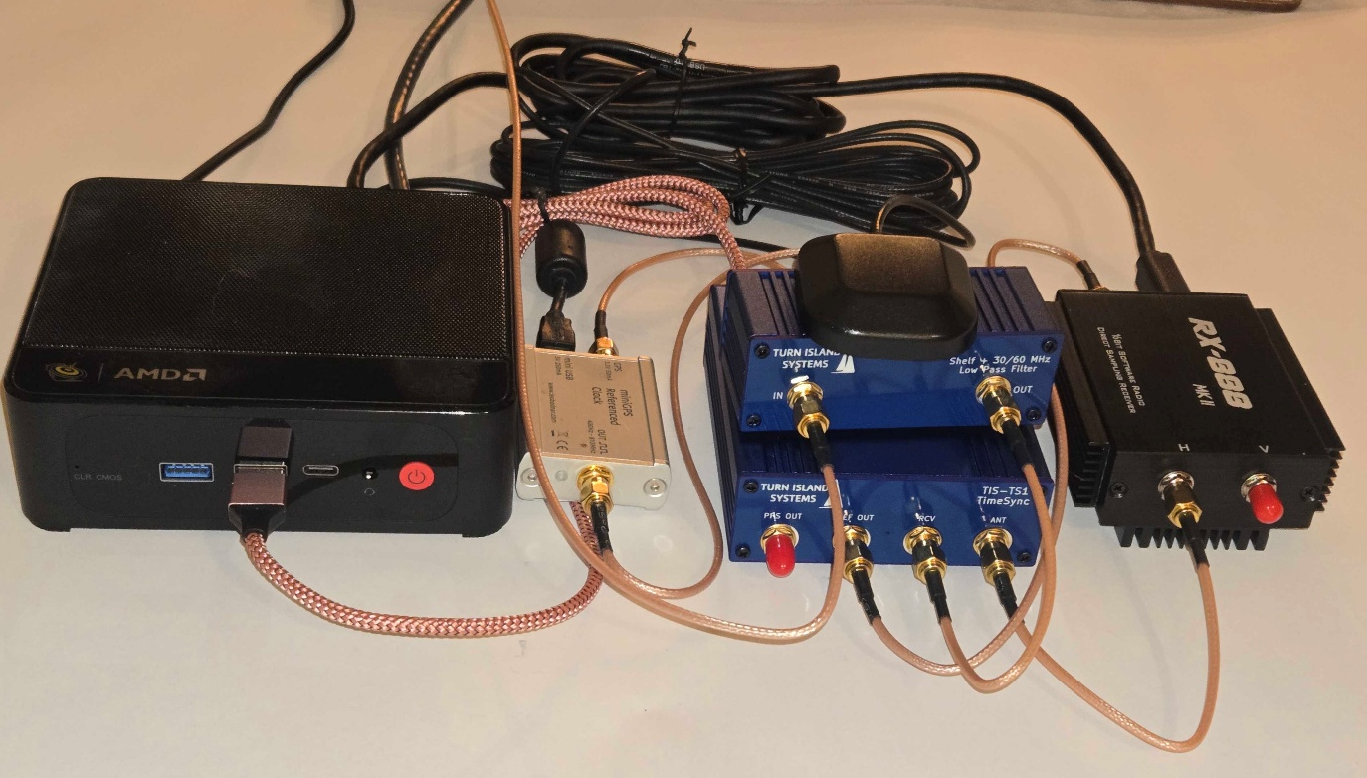
Figure 1: A complete HamSCI PSWS HF Receiver. From left: A small Linux x86 mini-PC running the ka9q-radio and wsprdaemon software, a Leo Bodnar mini GPSDO providing the 27 MHz frequency reference; a Turn Island Systems filter (top) and TS1 timing injector (bottom), and an RX888 0.1-64 MHz SDR receiver modified with TAPR clock adapter. A GPS antenna sits on top of the filter. Total parts cost is approximately US$1,000 plus the HF antenna. Photo by Paul Elliott, WB6CXC.

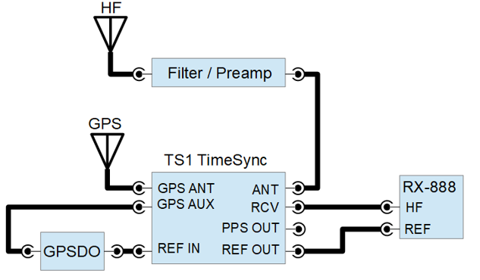
Figure 2: Block diagram of the HamSCI PSWS HF Receiver. The HF antenna feeds a filter/preamp module, which enters the TS1 TimeSync (Turn Island Systems) at its ANT input. A separate GPS antenna provides the timing reference; a Leo Bodnar mini GPSDO provides the 10 MHz frequency reference. The TS1 TimeSync routes the disciplined RF signal and the reference clock into the RX-888 MkII direct-sampling SDR, which talks to a Linux mini-PC over USB (not shown). Diagram by Paul Elliott, WB6CXC.

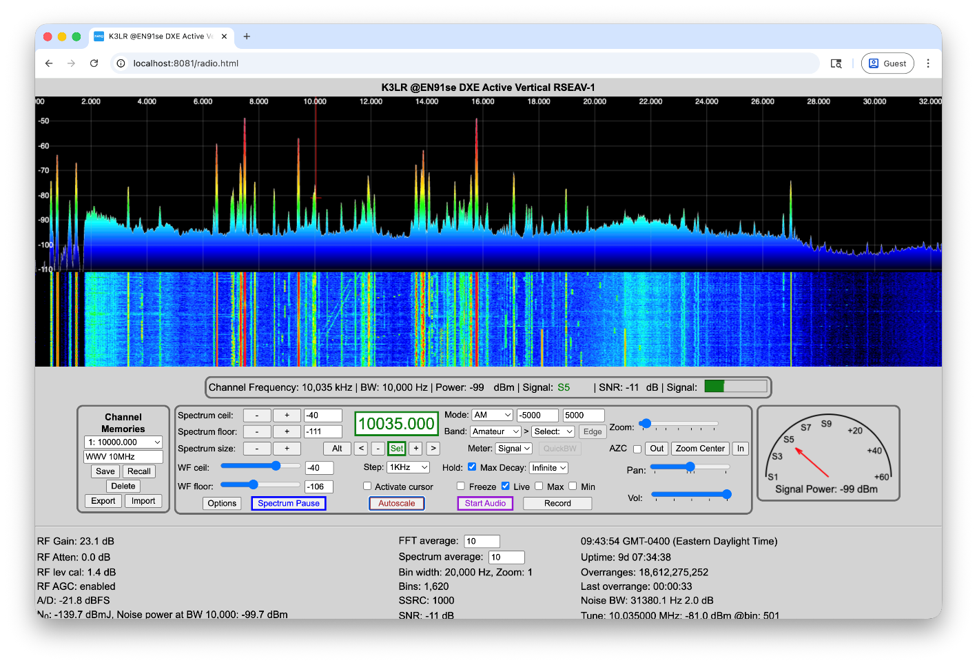
Figure 3: Using the KA9Q-Web SDR interface, the HamSCI PSWS HF Receiver can be used as a general coverage web-based software defined radio receiver. The user can configure this to be accessible only on their private LAN, or accessible over the Internet from anywhere in the world. Screenshot by Nathaniel A. Frissell, W2NAF.

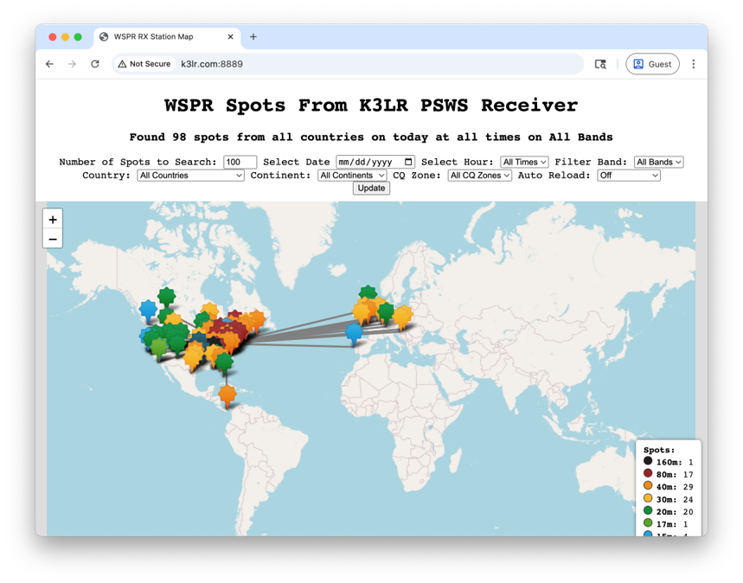
Figure 4: The HamSCI PSWS HF Receiver can automatically decode WSPR, FT8, and other digital mode spots simultaneously across all amateur bands within the 0.1-64 MHz spectrum. The PSWS Contesting DX Dashboard developed by University of Scranton W3USR and the Frankford Radio Club provides real-time views through a web-based server running on the local Linux machine. Spots are also sent to the web and can be viewed real-time at popular websites such as pskreporter.info and wspr.rocks. Screenshot by Nathaniel A. Frissell, W2NAF.

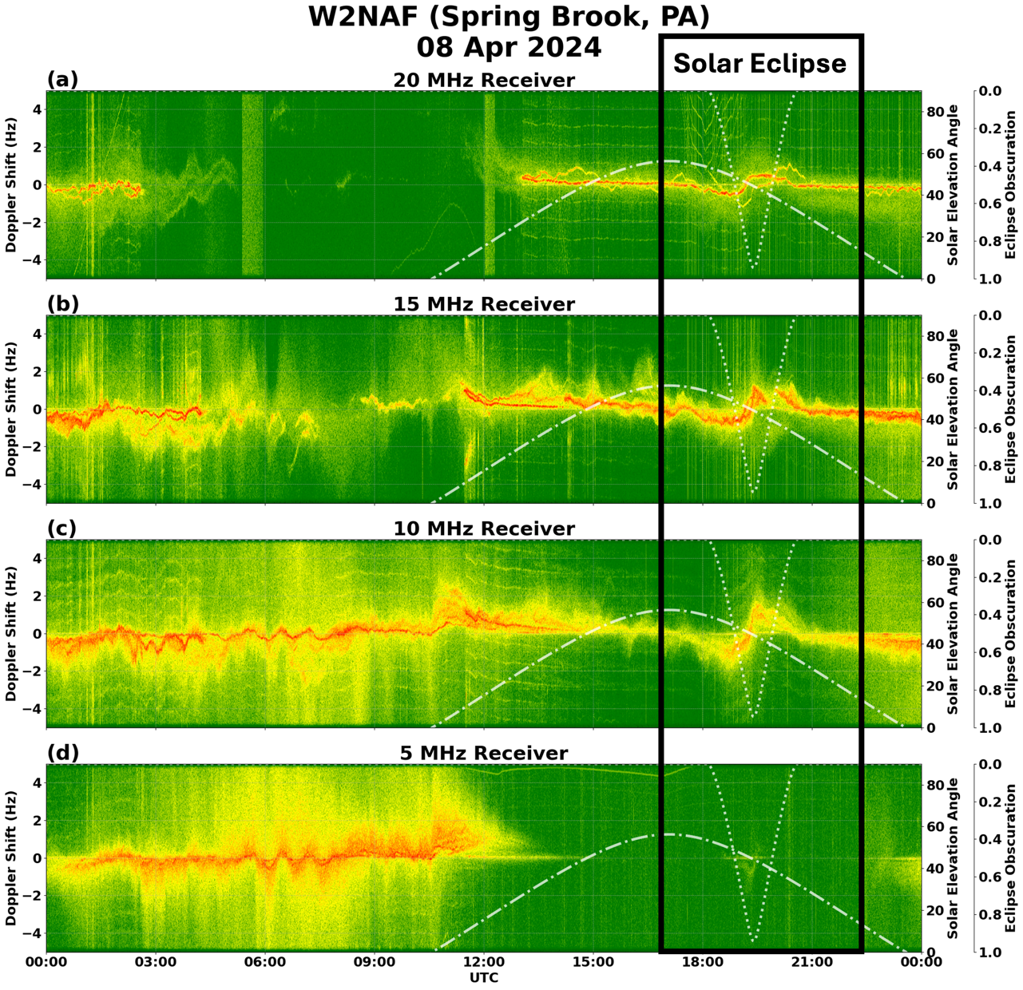
Figure 5: In addition to serving as a general-purpose web SDR and WSPR/FT8 monitor, the HamSCI PSWS HF receiver can make precision frequency measurements of beacon stations such as WWV, WWVH, and CHU for the purpose of studying ionospheric dynamics on multiple frequencies simultaneously. This figure shows measurements of the WWV/WWVH frequencies received at W2NAF near Scranton, PA during the 8 April 2024 solar eclipse. Operators of a HamSCI PSWS HF Receiver can download figures like this for their station each day from psws.hamsci.org.

https://ka9q-radio.org/
https://www.wsprdaemon.org/
https://github.com/HamSCI/frc_contesting
https://doi.org/10.3389/fspas.2026.1713968
https://github.com/mijahauan/hf-timestd

