
CCEN 356 - Computer Networks
Fall 2026
Course Project #1
Design, Implementation, and Analysis of RIP-Based Dynamic Routing Using Cisco Routers and Python Automation in a School Network
Progress Report
Submitted by
Name | Student ID | Role
Saif Altamimi | 100063323 | Network design and configuration
Mohammad Alhamoud | 100065556 | Python automation, testing
Zayed Alnuaimi | 100061300 | Measurement and visualisation
Abdel Rahman Abu Shamleh | 100064694 | Analysis and demonstration
Professor: Dr. Mahmoud Meribout
Assistant Professor: Nada Kawde
Submitted: 7 November 2026

Contents
1. Introduction 3
2. Progress Summary 3
3. Network Design 4
3.1 Topology 4
3.2 IP Addressing 4
3.3 Design Change: All-Ethernet Links 5
3.4 How the VLANs Work 5
3.5 Subinterfaces and Trunks 5
3.6 Following a Packet Between Rooms 6
4. RIP Configuration and Verification 7
4.1 Configuration 7
4.2 Baseline Routing Table 7
4.3 Capturing RIP Updates 8
5. Python Automation 9
6. Link-Failure Tests and Preliminary Results 10
6.1 Test Plan 10
6.2 Method 10
6.3 Results 10
6.4 Preliminary Observations 11
7. Remaining Work 11
8. Source Code Repository 12

1. Introduction
This progress report covers our work on Course Project #1 up to 7 November 2026. In the project we designed a network for a school with three rooms (Library, Teachers' room and Laboratory), ran RIP version 2 between three Cisco 2901 routers, and used Python to configure the routers, collect their routing tables and measure how RIP reacts when a link fails.
We built the network on the lab hardware and tested it on 6 November 2026. Every link-failure test (T0 to T5) was run at least three times, and our Python scripts collected the results. What is left is the written analysis, the final report and the demonstration.
Objectives:
- build a three-router topology with redundant paths
- configure and verify RIPv2
- automate configuration and data collection over SSH with Python
- measure convergence time and route changes after link failures
- identify the limitations of RIP from the measurements

2. Progress Summary
Table 1 goes through the requirements of the project brief one by one, with the status of each and where the evidence for it can be found.
Table 1. Progress against the project brief
Requirement from project brief | Status | Evidence
3 × Cisco 2901 routers, 3 Cisco switches | Done | Built in the lab; topology in Figure 1
At least two redundant paths | Done | Triangle topology: every room has two paths to every other room
Ethernet and serial links (where applicable) | Done | All-Ethernet; serial not applicable (Section 3.3)
RIPv2, network statements, no auto-summary | Done | Running configs exported from all six devices
Verify routing tables (show ip route) | Done | Baseline tables on all routers (Section 4.2)
Capture RIP updates: debug ip rip and Python | Done | Debug captures recorded by a Python script (Section 4.3)
Python: connect over SSH (netmiko) | Done | connect_test.py, inventory.py
Python: push configuration | Done | push_config.py pushed the RIP blocks and test changes
Python: store routing tables (JSON/CSV) | Done | 37 JSON snapshots and routes.csv
Python: analyse changes after link failures | Done | Tests T1 to T5, three runs each (Section 6)
Visualise routing behaviour | Done | Convergence and route-timeline charts
Written report | In progress | This progress report; final report sections assigned (Section 7)
Demonstration | Planned | To be rehearsed on the rebuilt network
Source code repository | Done | Scripts, router exports and documentation on GitHub

3. Network Design

3.1 Topology
Each room has one router and one Catalyst 3560-8PC switch. The three routers are connected in a triangle, so every room's LAN can be reached over two different paths. Figure 1 shows the topology as we built it.
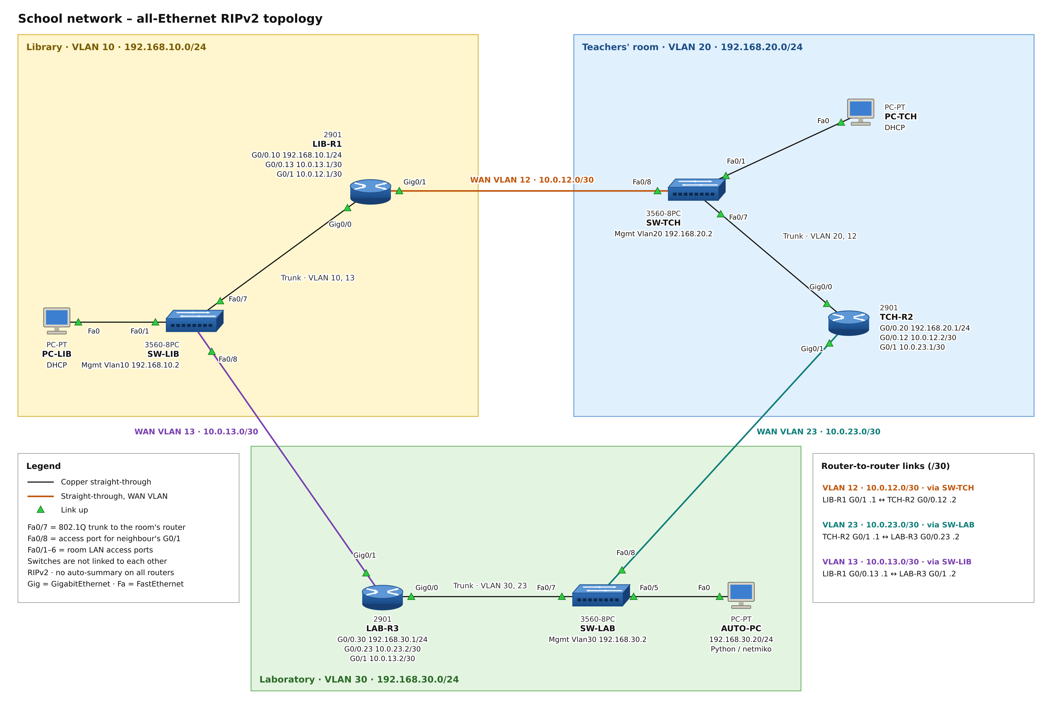
Figure 1. Network topology as built in the lab (all-Ethernet, RIPv2)
In the repository: full-size diagram: topology/topology.png · rack and cabling photos: topology/photos/

3.2 IP Addressing
Table 2. IP addressing plan
Device | LAN interface | WAN interfaces | Notes
LIB-R1 | G0/0.10 192.168.10.1/24 | G0/1 10.0.12.1/30  G0/0.13 10.0.13.1/30 | Library  DHCP pool for PCs
TCH-R2 | G0/0.20 192.168.20.1/24 | G0/0.12 10.0.12.2/30  G0/1 10.0.23.1/30 | Teachers' room  DHCP pool
LAB-R3 | G0/0.30 192.168.30.1/24 | G0/0.23 10.0.23.2/30  G0/1 10.0.13.2/30 | Laboratory  DHCP pool
SW-LIB / SW-TCH / SW-LAB | Vlan10/20/30 at .2 | - | Management addresses
AUTO-PC | 192.168.30.20/24 | - | Runs the Python scripts

3.3 Design Change: All-Ethernet Links
The original design used serial links between the routers. The lab's 2901 routers have only two onboard Gigabit Ethernet ports and no serial interface cards, so serial links were not applicable, we decided to use Ethernet links since the brief asks for serial links only "where applicable".
To give each router a third connection without extra hardware, each router's G0/0 is an 802.1Q trunk to its room switch (port Fa0/7). The trunk carries the room's LAN and one WAN link as separate VLANs on subinterfaces. Each router's G0/1 is cabled to the next room's switch (port Fa0/8), which places it in that WAN VLAN. The three WAN links are VLAN 12 (LIB-R1 to TCH-R2), VLAN 13 (LIB-R1 to LAB-R3) and VLAN 23 (TCH-R2 to LAB-R3), each a /30 subnet as there are only 2 devices connected to it.0

3.4 How the VLANs Work
Each router needs three connections: its room's LAN and a link to each of the other two routers, but the 2901 router has only two ports. The switches cannot provide the missing connection by routing, because a layer-2 switch does not route, it only forwards frames within one network, and all routing between the three rooms is done by the routers. VLANs solve the problem by letting one switch and one cable to the router carry two separate networks.
So each switch carries two VLANs: its room's LAN and one router-to-router link (Table 3). Only two devices sit on the link VLAN, the room's router (through its trunk) and the G0/1 port of the neighbouring router, so for those two routers it works like a private point-to-point /30 link. No PC is on it, which also means RIP updates between the routers never reach a room's LAN.
Table 3. Networks carried by each switch
Switch | LAN VLAN | Link VLAN (the two routers on it) | Link subnet
SW-LIB | 10 | 13 (LIB-R1 G0/0.13, LAB-R3 G0/1) | 10.0.13.0/30
SW-TCH | 20 | 12 (TCH-R2 G0/0.12, LIB-R1 G0/1) | 10.0.12.0/30
SW-LAB | 30 | 23 (LAB-R3 G0/0.23, TCH-R2 G0/1) | 10.0.23.0/30

Every link has one physical end (a G0/1) and one subinterface end, and carries traffic in both directions, data between the rooms and RIP updates between the two routers. ‘show ip protocols’ on LIB-R1 lists two update sources: 10.0.12.2 (TCH-R2, heard on G0/1) and 10.0.13.2 (LAB-R3, heard on G0/0.13).

3.5 Subinterfaces and Trunks
Subinterfaces are configured on the routers only. A router interface joins exactly one IP network, but LIB-R1's G0/0 must join two: the Library LAN as its gateway 192.168.10.1, and the link to LAB-R3 as 10.0.13.1. The interface is therefore split into two logical interfaces. ‘encapsulation dot1Q’ binds each subinterface to a VLAN tag, and ‘ip address’ places the router on that VLAN's network:
LIB-R1# show running-config

...
interface GigabitEthernet0/0
description Trunk to SW-LIB Fa0/7 (VLAN 10 LAN, VLAN 13 WAN to LAB-R3)
no ip address
duplex auto
speed auto
!
interface GigabitEthernet0/0.10
description LAN - Library (VLAN 10)
encapsulation dot1Q 10
ip address 192.168.10.1 255.255.255.0
!
interface GigabitEthernet0/0.13
description WAN - to LAB-R3 G0/1 through SW-LIB (VLAN 13)
encapsulation dot1Q 13
ip address 10.0.13.1 255.255.255.252
!
interface GigabitEthernet0/1
description WAN - to TCH-R2 G0/0.12 through SW-TCH Fa0/8 (VLAN 12)
ip address 10.0.12.1 255.255.255.252
duplex auto
speed auto
...
full running config: configs/exports/LIB-R1.txt all six devices: configs/exports/ configs as typed in: configs/source/
G0/0.10 and G0/0.13 are separate interfaces to the routing table and to RIP, this is what allows RIP to be passive on the LAN subinterface so no updates are sent to the PCs while still exchanging updates on the link subinterface. On the other hand, the switches have no subinterfaces: a switch does not join the networks it carries. It is configured with VLANs and port modes instead (Table 4), and its only IP address (‘interface Vlan10’, 192.168.10.2 on SW-LIB) is used to manage it.
Table 4. Switch port types and VLAN tagging
Port | Connected to | Mode | Frames on the cable
Fa0/7 | The room's router (G0/0) | Trunk: LAN and link VLANs | Tagged; the router uses the tag to choose the subinterface
Fa0/8 | The neighbouring router (G0/1) | Access: link VLAN | Untagged; the switch removes the tag
Fa0/1-6 | PCs | Access: LAN VLAN | Untagged

3.6 Following a Packet Between Rooms
To see how this works in practice, take a ping from a Teachers' room PC (192.168.20.5) to a Library PC (192.168.10.7). The packet goes through these steps:
- The PC sends an untagged frame into SW-TCH Fa0/1. The switch places it in VLAN 20 and sends it up the trunk tagged 20. TCH-R2 then receives it on G0/0.20
- TCH-R2 looks up 192.168.10.7 in its routing table: 192.168.10.0/24 via 10.0.12.1 adn out G0/0.12. It sends a new frame tagged 12 back down the same trunk
- SW-TCH removes the tag and sends the frame out Fa0/8 which is an access port in VLAN 12. LIB-R1 receives it untagged on G0/1
- LIB-R1 forwards it out G0/0.10 tagged 10. SW-LIB removes the tag and delivers it to the Library PC
A VLAN tag therefore exists only on one trunk cable, every router that forwards the packet builds a new frame with its own tag. The IP header stays the same from end to end, apart from the TTL which each router decreases by one.
Telling RIP updates from data. RIP updates and data share the same links, the router separates them by their headers. A RIP update is sent to the multicast address 224.0.0.9 on UDP port 520, so the router hands it to its RIP process, and the update's source address becomes the next hop for the routes it carries. A data packet is addressed to a host in another network, so the router looks up its destination in the routing table and forwards it. The VLAN tag is read first on a trunk to select the subinterface.

4. RIP Configuration and Verification

4.1 Configuration
All three routers use the same RIP block, and only the LAN network is different on each. We made the LAN subinterface passive so the routers do not send RIP updates towards the PCs. This is the block from LIB-R1's running configuration:
LIB-R1# show running-config

...
router rip
version 2
passive-interface GigabitEthernet0/0.10
network 10.0.0.0
network 192.168.10.0
no auto-summary
...
full running config: configs/exports/LIB-R1.txt all six devices: configs/exports/
We pushed the RIP blocks to the routers from Python with push_config.py, one router at a time, and saved what it printed. This is the command we ran for LIB-R1 and its output:
PS> python scripts/push_config.py configs/push/rip-LIB-R1.txt LIB-R1

6 commands from configs/push/rip-LIB-R1.txt:
router rip
version 2
no auto-summary
network 10.0.0.0
network 192.168.10.0
passive-interface GigabitEthernet0/0.10

=== LIB-R1 ===
configure terminal
Enter configuration commands, one per line. End with CNTL/Z.
LIB-R1(config)#router rip
LIB-R1(config-router)# version 2
LIB-R1(config-router)# no auto-summary
LIB-R1(config-router)# network 10.0.0.0
LIB-R1(config-router)# network 192.168.10.0
LIB-R1(config-router)# passive-interface GigabitEthernet0/0.10
LIB-R1(config-router)#end
LIB-R1#
write mem
Building configuration...
[OK]
LIB-R1#
pushed file: configs/push/rip-LIB-R1.txt push outputs: data/verification/ all push files: configs/push/

4.2 Baseline Routing Table
With all links up, each router learns the two remote LANs at metric 1 (one hop). This is LIB-R1's routing table:
LIB-R1# show ip route

... (codes legend omitted)
Gateway of last resort is not set

10.0.0.0/8 is variably subnetted, 5 subnets, 2 masks
C 10.0.12.0/30 is directly connected, GigabitEthernet0/1
L 10.0.12.1/32 is directly connected, GigabitEthernet0/1
C 10.0.13.0/30 is directly connected, GigabitEthernet0/0.13
L 10.0.13.1/32 is directly connected, GigabitEthernet0/0.13
R 10.0.23.0/30 [120/1] via 10.0.13.2, 00:00:03, GigabitEthernet0/0.13
[120/1] via 10.0.12.2, 00:00:09, GigabitEthernet0/1
192.168.10.0/24 is variably subnetted, 2 subnets, 2 masks
C 192.168.10.0/24 is directly connected, GigabitEthernet0/0.10
L 192.168.10.1/32 is directly connected, GigabitEthernet0/0.10
R 192.168.20.0/24 [120/1] via 10.0.12.2, 00:00:09, GigabitEthernet0/1
R 192.168.30.0/24 [120/1] via 10.0.13.2, 00:00:03, GigabitEthernet0/0.13
full output: data/verification/LIB-R1.txt TCH-R2: data/verification/TCH-R2.txt LAB-R3: data/verification/LAB-R3.txt
LIB-R1 learns the far /30 link (10.0.23.0/30) from both neighbours at the same cost, so it keeps both routes. The ‘show ip protocols’ output below confirms version 2, no automatic summarisation and the default timers: updates every 30 s, invalid after 180 s, hold-down 180 s and flush after 240 s.
LIB-R1# show ip protocols

*** IP Routing is NSF aware ***

Routing Protocol is "rip"
Outgoing update filter list for all interfaces is not set
Incoming update filter list for all interfaces is not set
Sending updates every 30 seconds, next due in 7 seconds
Invalid after 180 seconds, hold down 180, flushed after 240
Redistributing: rip
Default version control: send version 2, receive version 2
Interface Send Recv Triggered RIP Key-chain
GigabitEthernet0/0.13 2 2
GigabitEthernet0/1 2 2
Automatic network summarization is not in effect
Maximum path: 4
Routing for Networks:
10.0.0.0
192.168.10.0
Passive Interface(s):
GigabitEthernet0/0.10
Routing Information Sources:
Gateway Distance Last Update
10.0.12.2 120 00:00:08
10.0.13.2 120 00:00:02
Distance: (default is 120)
all show commands, every router: data/verification/ screenshots: data/verification/screenshots/

4.3 Capturing RIP Updates
To capture the RIP updates we wrote capture_rip_debug.py. It turns on ‘debug ip rip’ and ‘debug ip routing’, reads the output back from the router's log buffer and switches the debugs off again at the end. We ran it as ‘python scripts/capture_rip_debug.py LIB-R1 --label T0-updates --duration 40’. One update cycle from that capture:
...
Nov 6 19:20:54.323: RIP: sending v2 update to 224.0.0.9 via GigabitEthernet0/1 (10.0.12.1)
Nov 6 19:20:54.323: RIP: build update entries
Nov 6 19:20:54.323: 10.0.13.0/30 via 0.0.0.0, metric 1, tag 0
Nov 6 19:20:54.323: 192.168.10.0/24 via 0.0.0.0, metric 1, tag 0
Nov 6 19:20:54.323: 192.168.30.0/24 via 0.0.0.0, metric 2, tag 0
Nov 6 19:21:00.131: RIP: received v2 update from 10.0.12.2 on GigabitEthernet0/1
Nov 6 19:21:00.131: 10.0.23.0/30 via 0.0.0.0 in 1 hops
Nov 6 19:21:00.131: RT: updating rip 10.0.23.0/30 (0x0) via 10.0.12.2 Gi0/1
Nov 6 19:21:00.131: 192.168.20.0/24 via 0.0.0.0 in 1 hops
Nov 6 19:21:00.131: RT: updating rip 192.168.20.0/24 (0x0) via 10.0.12.2 Gi0/1
Nov 6 19:21:00.131: 192.168.30.0/24 via 0.0.0.0 in 2 hops
Nov 6 19:21:00.131: RT: updating rip 192.168.30.0/24 (0x0) via 10.0.12.2 Gi0/1
...
full capture: data/debug_logs/T0-updates_LIB-R1.txt captures of all routers and runs: data/debug_logs/
Split horizon is visible here: LIB-R1 does not advertise 192.168.20.0/24 back to TCH-R2, the router it learned it from. TCH-R2 advertises a 2-hop path to the Laboratory LAN, which LIB-R1 ignores while its 1-hop route is up, this backup path is what RIP falls back to in the link-failure tests.

5. Python Automation
The scripts run on AUTO-PC in the Laboratory and connect to the routers over SSH with netmiko. Table 5 lists them.
Table 5. Python scripts
Script | Purpose
inventory.py | Router list and SSH connection helper used by every other script
connect_test.py | Logs into each router and checks its hostname
push_config.py | Applies configuration lines from a file to one or more routers
get_routes.py | Saves the RIP routing table of every router to JSON and CSV
compare_routes.py | Lists routes added, removed or changed between two snapshots
capture_rip_debug.py | Records debug ip rip and debug ip routing output from a router
parse_rip_debug.py | Parses a debug capture and measures convergence time
monitor_convergence.py | Polls a router every second and logs each route change
run_experiment.py | Runs one test end to end: snapshots, debug, monitor, route diff
collect_results.py | Builds the results table from all the saved logs
visualize.py | Draws the convergence and route-timeline charts

For every router, each snapshot stores the network, metric, next hop, interface and status of each RIP route. An excerpt of the baseline snapshot:
{
"time": "2026-11-06T16:17:29",
"label": "T0-baseline",
"routers": {
"LIB-R1": [
{
"network": "10.0.23.0/30",
"metric": 1,
"next_hop": "10.0.13.2",
"interface": "GigabitEthernet0/0.13",
"status": "up"
},
...
taken with python scripts/get_routes.py T0-baseline full snapshot: data/snapshots/20261106T161729_T0-baseline.json all snapshots: data/snapshots/ every snapshot as one table: data/routes.csv
We also wrote 59 automated tests for the scripts. They run without any routers connected.
In the repository: scripts: scripts/ automated tests: tests/

6. Link-Failure Tests and Preliminary Results

6.1 Test Plan
Table 6. Link-failure tests
Test | Action | Expected result
T0 Baseline | All links up | Every remote LAN at metric 1
T1 | Library-Teachers link down | LIB-R1 reaches 192.168.20.0/24 via LAB-R3, metric 2
T2 | Library-Laboratory link down | LAB-R3 reaches 192.168.10.0/24 via TCH-R2, metric 2
T3 | Teachers-Laboratory link down | TCH-R2 reaches 192.168.30.0/24 via LIB-R1, metric 2
T4 | T1 link restored | The 1-hop route returns
T5 Silent failure | LAB-R3 stops sending updates (passive-interface) | LIB-R1 waits for RIP's timers, about 240-270 s

6.2 Method
Because the WAN links go through switches, a router cannot see its neighbour's interface go down. So in each link test we shut down both ends of the link, the same as a cut cable. We measured convergence on the router's own clock from the debug capture, starting when the failed route was removed and stopping when the new route was installed. In T5 nothing goes down, so we started timing from the last update LIB-R1 heard from LAB-R3, which is when RIP's invalid timer starts counting. A lab PC kept pinging during every run so we could count the lost packets.

6.3 Results
Table 7. Convergence time (seconds) and pings lost.
Test | Run 1 | Run 2 | Run 3 | Average | Pings lost (avg)
T1 Library-Teachers down | 7.10 | 5.64 | 4.65 | 8.56* | 32
T2 Library-Laboratory down | 16.47 | 19.12 | 27.04 | 20.87 | 29
T3 Teachers-Laboratory down | 9.20 | 16.93 | 11.36 | 12.50 | 33
T4 Recovery (T1 link up) | 17.56 | 20.41 | 27.96 | 21.98 | 0
T5 Silent failure | 260.26 | 248.65 | 262.35 | 257.09 | 24
* T1 had a fourth run (16.85 s), included in the average.
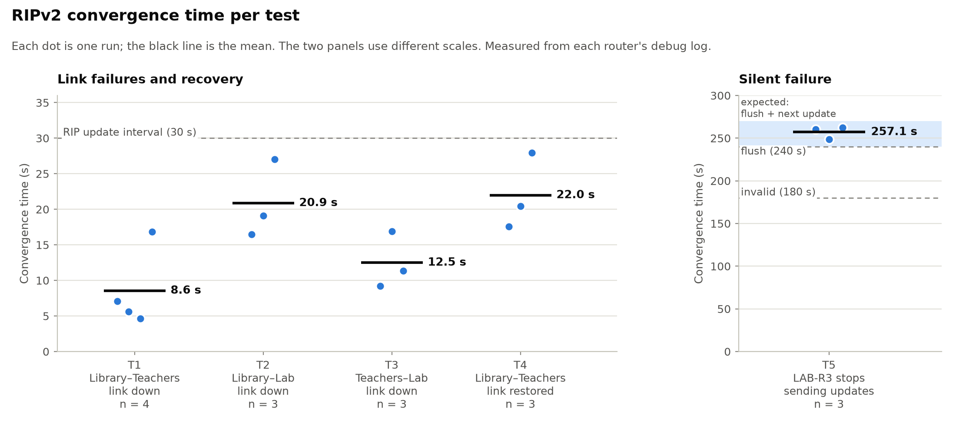
Figure 2. Convergence time per test: each run as a dot, the mean as a line
In the repository: results: data/results.csv debug captures: data/debug_logs/ route monitor logs: data/monitor_logs/ · ping and traceroute photos: data/ping_logs/photos/ charts, incl. a timeline per test: data/charts/ routing snapshots: data/snapshots/ console logs: data/console_logs/

6.4 Preliminary Observations
- Link failures took 5-28 s to converge. The router drops the failed route straight away, but the backup route only arrives with the neighbour's next periodic update, which can be up to 30 s later. That is why the times vary so much between runs.
- The silent failure (T5) took about 257 s. Since no interface goes down, the stale route stays in the table until the invalid timer (180 s) runs out. The route is then held down, and it is only replaced after the flush timer (240 s) removes it and the next update comes in. This fits the 240-270 s we expected.
- No packets were lost during recovery (T4), because the 2-hop path kept carrying traffic until the better route came back.
- We saw several of RIP's limitations directly: split horizon, hold-down (routes marked "possibly down"), asymmetric routing after T5, and a count-to-infinity incident caused by a loose cable during setup. These will be analysed in the final report.
In the repository: count-to-infinity incident (TCH-R2): data/verification/incident_TCH-R2_G0-0_down_count-to-infinity.txt

7. Remaining Work
The lab work is complete. All six devices were erased after the session, the network will be rebuilt from the saved configurations for the demonstration. Table 8 lists the remaining tasks.
Table 8. Remaining tasks
Member | Remaining work
Saif | Final report sections 2-4 (network design, RIP configuration, verification); configuration appendix
Zayed | Review of section 6a (link-failure tests and results); script listings; final choice of charts
Abdulrahman | Sections 1, 6b, 7 and 8 (introduction, convergence analysis, limitations of RIP, conclusion)
Mouhamed | Demonstration plan; review and submission of the final report
Whole team | Rebuild the network and rehearse the demonstration

8. Source Code Repository
All scripts, router configuration exports, routing-table snapshots, debug captures, results and documentation are in the project repository: github.com/HamSudo/ccen356-rip-project.

