## ****What is HamWAN?****

HamWAN is a multi-megabit data network that promotes microwave linking via amateur radio. From linking VHF repeaters to offering regional connectivity to EOCs, it is the cutting edge of amateur-data radio. The most prevalent radio communication today is high‑speed digital: we show what amateurs can do!

## ****How much does it cost?****

You can get on the network with just a small investment in equipment and no reoccurring cost. A typical installation costs about $200. Client equipment options include the following:

* Integrated, flat-panel MIMO antenna/radio/modem
* MIMO radio/modem with a dedicated panel antenna
* Mesh dish with single-channel radio/modem

## ****What is the coverage area?****

See [www.HamWAN.org](http://www.HamWAN.org) for the coverage map. The map is a rough estimate based on a computer model. A line-of-site link is best on the HamWAN microwave channels. MIMO technology improves link signal and stability. In some areas coverage is worse than predicated, and in other it is better than predicated. You might still have coverage! Jump on to the IRC channel or query the mailing list and ask about coverage in your area. We can help you make it work.

**Ready to start?**

**Want to know more?**

# Visit our website:

# [www.HamWAN.org](http://www.HamWAN.org)

# Visit the chat room:

# #HamWAN on <irc.freenode.org>

# Ask the mailing list:

# psdr@HamWAN.org

# Send mail:

# HamWAN 1122 E Pike St., Unit 570 Seattle, WA 98122-3916

# 

**A modern, multi‑megabit, IP‑based, digital network for amateur‑radio!**

## What does HamWAN do?

On the reliable and dependable HamWAN, amateurs can stream and transfer data within thousands of square miles, and to data networks in other regions. Here’s what you can do with HamWAN:

• Provide VOIP and videoconferencing

• Learn about microwave design considerations and standard practices

• Learn computer networking technologies

Any licensed radio amateur in the service area can connect their shack directly to the network with just a small investment in equipment and no reoccurring cost.

Because many traditional (commercial) uses for Internet at home are not compatible with Part 97 rules, HamWAN does NOT replace your home Internet connection. However, it works and acts just like one.

## Put HamWAN to Work!

HamWAN networks have been used for all kinds of useful purposes:

• Low-latency repeater linking

• Real-time video feeds from distant locations

• Serving APRS I-gates

• Providing redundant internet access to emergency operations centers (EOCs)

©2016 HamWAN

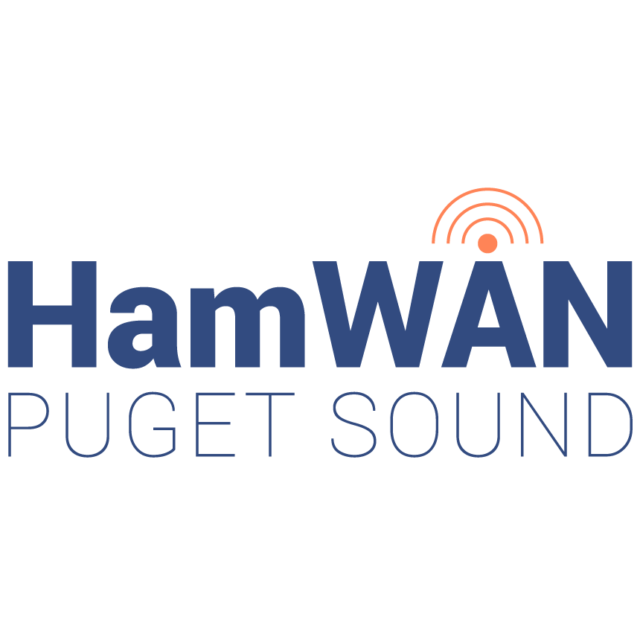

## Mailing List

Sign up to the mailing list by sending an email to [psdr-join@HamWAN.org](mailto:psdr-join@HamWAN.org). The subject and body are not important. Archives of the distribution list are also available (great for searching the knowledge base).

## Online Chat Room

Participate in the conversation, ask for help or just follow along in real time. Hang out in the project's IRC channel #HamWAN on <irc.freenode.org>. Use your own IRC client or use the one linked at [www.HamWAN.org](http://www.HamWAN.org).

## Volunteer

We love volunteers! This is a great opportunity to learn about data networking, Internet routing, and microwave installations and propagation. If you want to volunteer for any HamWAN work please send an email to the mailing list to let us know.

We have members called "Elmers" who are eager to help you, from beginners to advanced hams. Please feel free to contact us at any time.

## http://img.routerboard.com/mimg/919_m.png

## Linking Radio Sites

Get involved! If you think your site would make a good HamWAN cell site, let us know! If it's a good location, we'll fund the deployment with HamWAN donations at no expense to you!

## Become a Member

HamWAN is funded by donations from hams like you. You can become a sustaining member and support this good work. See the PayPal® donation link at HamWAN.org.

## Supporting Organizations

We want to thank these organizations for their generous support of the HamWAN project.

Image