**What do corona-infected people depend on?**

**(Consideration based on data from each prefecture)**

**Hamabe Riku(211X114X)**

1. **Introduction**

**More than a year has passed since the corona infection was confirmed in Japan. The high number of infected people in big cities such as Tokyo and Osaka is often talked about, but in the news, I feel that the number of infected people in tourist areas such as Okinawa and Hokkaido is also high. In this article, we will examine the trend of infection in terms of both population and number of tourists.**

1. **Method**

**Using the number of coronary infections in each prefecture [1], the population in each prefecture [2], the number of tourists in each prefecture, and Japan map data [3], we will create a scatter plot of the number of infected people in relation to the population and the number of infected people in relation to the number of tourists.**

**For the number of tourists, data for 2020 was not available, so we decided to use the number of overnight visitors [4]. Clicking on a prefecture on the map of Japan will show the data in a scatter plot.**

1. **Result・Discussion**

**As a result, when we compared the scatter plots, we found that the number of tourists was proportional to the population rather than the number of people. However, the number of infected people in Okinawa is higher than that of the population, indicating that it is affected by the number of tourists. Looking at Saitama Prefecture, the number of infected people was higher in relation to the number of tourists, which suggests that prefectures where people move around a lot tend to have more cases.**

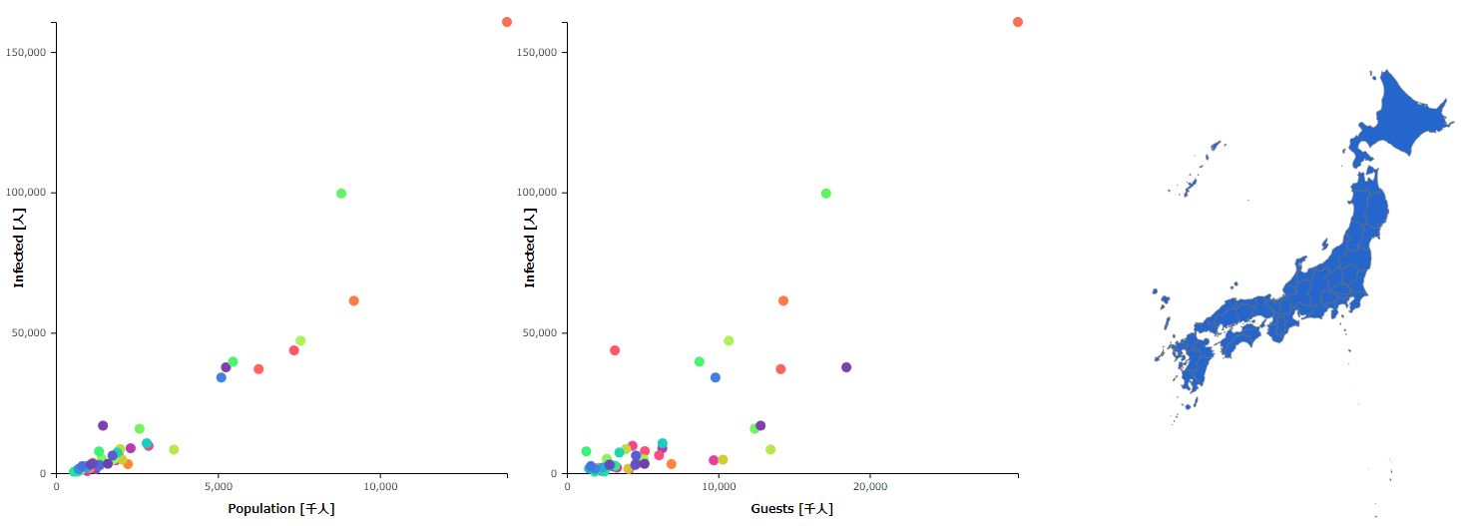

Figure : Number of infected people against population (left), number of infected people against number of tourists (right)

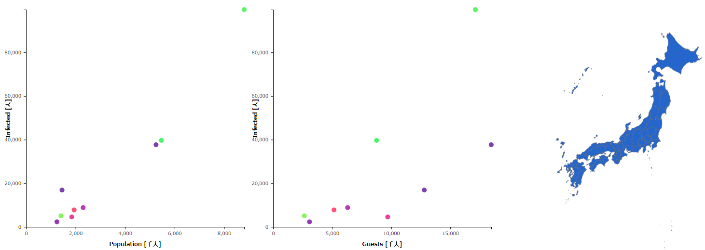

Figure : Click on a prefecture on the map of Japan to see its data

1. **Conclusion**

**In conclusion, the number of infected people tends to increase as the number of people moving around increases, so I think that refraining from going out is the best way to prevent infection.**

1. **Reference**

**[1]** **https://www3.nhk.or.jp/news/special/coronavirus/data/**

**[2]** **https://www.stat.go.jp/data/nihon/02.html**

**[3]** **https://www.naturalearthdata.com/**

**[4]** **https://www.mlit.go.jp/kankocho/siryou/toukei/shukuhakutoukei.html#cp1**