Covariance and Pearson Correlation
Machine Learning (ML_PCOM7E) · Unit 3 · e-Portfolio Activity: Correlation and Regression (Exercise 1)
Code evidence: unit03_correlation_regression/covariance_pearson_correlation.ipynb

Aim
To calculate the covariance and Pearson's r by hand and using NumPy/SciPy, and to manipulate the values of the data points and observe how each statistic is affected.

What I did
I used ten (hours studied, exam score) pairs as a baseline. I then manipulated the data in six different ways: added a single outlier, introduced increasing amounts of random measurement error, reversed the order of the relationship, converted hours to minutes, used a perfect non-linear relationship (y = x²), and simulated a confounder (temperature causing both ice-cream sales and drownings).

Results
Table 1: Effect of changing the data on covariance and r.
Scenario | Covariance | Pearson r
Baseline (10 points) | 51.67 | 0.996
One outlier (10 h, score 10) | 12.67 | 0.204
Noise sd = 5 | 51.35 | 0.980
Noise sd = 15 | 45.49 | 0.788
Noise sd = 30 | 25.96 | 0.340
Relationship reversed | -51.67 | -0.996
Hours converted to minutes | 3100.00 | 0.996
y = x² on [-5, 5] | 0.00 | 0.000
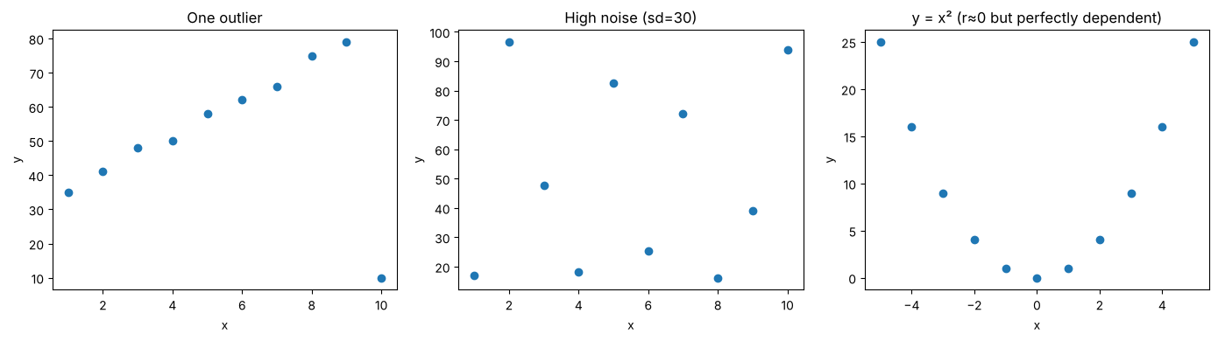
Figure 1: An outlier, heavy noise, and a perfect non-linear (but r ≈ 0) relationship.

Analysis
- Outliers dominate small samples. A single point reduced r from 0.996 to 0.204. If there are not many observations, then one unusual one can destroy a good relationship, so I would always graph the data before reporting r.
- Noise weakens, but does not reverse, correlation. r fell to 0.34 at sd = 30 and the p-value (0.34) no longer supported a real relationship in only ten points.
- r is unit-free; covariance is not. When the covariance was multiplied by 60, the r value did not change, so that is why r is used to compare relationships.
- r only measures linear association. y = x² is perfectly dependent yet r = 0.
- Correlation is not causation. Ice-cream sales and drownings gave r = 0.644, but after removing the effect of temperature, the partial correlation was -0.054. The correlation was caused by a third factor.

Learning outcomes addressed
- Articulate the legal, social, ethical and professional issues faced by machine learning professionals.
- Understand the applicability and challenges associated with different datasets for the use of machine learning algorithms.
It is important that if a correlation is used as evidence for cause, it is presented fairly; otherwise, it can be used in situations such as pricing, hiring, or risk-scoring that result in unfair or damaging decisions, which is why ML professionals need to communicate the caveats of the relationship between correlation and cause. On the data side, small amounts of data, outliers and confounders restrict the data to a certain amount of validity.

