Simple Linear Regression
Machine Learning (ML_PCOM7E) · Unit 3 · e-Portfolio Activity: Correlation and Regression (Exercise 2)
Code evidence: unit03_correlation_regression/linear_regression.ipynb

Aim
To fit y = b0 + b1·x by ordinary least squares, compare the result with scikit-learn and note how the shape of the fitted line changes as a function of the size of the sample as well as the presence of noise and outlier data points.

What I did
I generated data on a known line (intercept 10, slope 3 and added random noise) and plotted it with the closed-form least-squares formulas and LinearRegression, then did the same with n = 10, 50 and 500 points and noise levels of 1, 5 and 20 and plotted the result of the fit. Finally, I added one extreme point at (20, -40).

Results
Both methods returned the same line (intercept 10.483, slope 2.944, R² = 0.932 for n = 50, noise 5).
Table 1: Selected runs
n | Noise sd | Slope (true = 3) | Intercept (true = 10) | R²
10 | 1 | 3.075 | 8.664 | 0.999
10 | 20 | 4.509 | -16.728 | 0.820
50 | 5 | 2.944 | 10.483 | 0.932
50 | 20 | 2.777 | 11.934 | 0.434
500 | 5 | 3.058 | 9.465 | 0.930
500 | 20 | 3.230 | 7.859 | 0.480
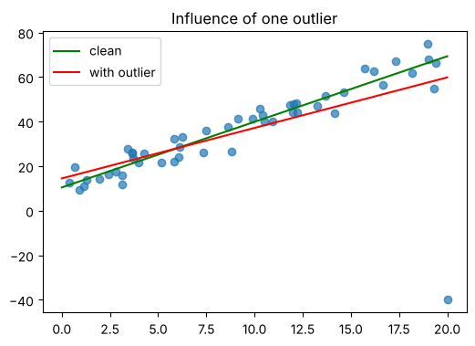
Figure 1: One extreme point rotates the least-squares line (slope 2.944 → 2.268; R² 0.932 → 0.430).

Analysis
- More data stabilises the estimates. With ten noisy points, the slope was 4.51 (true value 3); with 500 points, it was 3.23.
- R² depends on noise, not sample size. R² remained in the range of 0.43-0.48 even with 500 points at noise 20, because the noise itself can only account for a limited amount of variance.
- Least squares is sensitive to outliers. The errors are squared, and the extreme errors have a big influence, which is why one record change made the difference of just over half in R2 and about 23 % in the slope.

Learning outcomes addressed
- Articulate the legal, social, ethical and professional issues faced by machine learning professionals.
- Understand the applicability and challenges associated with different datasets for the use of machine learning algorithms.
Too few or unrepresentative records can lead to a false impression of a regression when, in fact, it is not. Professionals need to communicate their awareness of this uncertainty. This activity clearly illustrated the effect of sample size and outliers on the data that can be supported.
.

