Polynomial Regression
Machine Learning (ML_PCOM7E) · Unit 3 · e-Portfolio Activity: Correlation and Regression (Exercise 4)
Code evidence: unit03_correlation_regression/polynomial_regression.ipynb

Aim
To demonstrate that a straight line is an underfit model for curvilinear data, that a high-degree polynomial can be an overfit model, and that comparing training and test error can show it.

What I did
I sampled 60 noisy points from the cubic curve, divided them into 70/30, and then I fitted polynomials of degree 1 through 12. For each degree, I recorded training MSE, test MSE and test R².

Results
Degree | Train MSE | Test MSE | Test R²
1 | 49.92 | 41.42 | 0.378
2 | 9.00 | 19.25 | 0.711
3 | 6.16 | 9.92 | 0.851
6 | 5.61 | 12.66 | 0.810
9 | 5.53 | 11.69 | 0.825
12 | 5.54 | 11.49 | 0.828
Table 1 – Train and test error by polynomial degree.
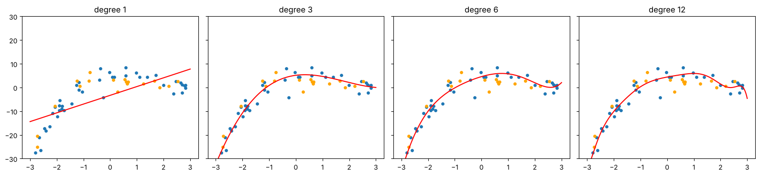
Figure 1: Fits of degree 1, 3, 6 and 12 (blue = training points, orange = test points).
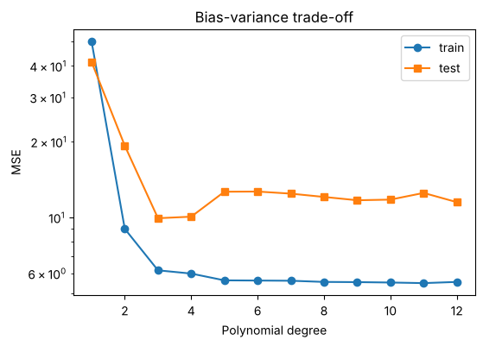
Figure 2: Training error keeps falling slightly while test error stops improving after degree 3.

Analysis
Degree 1 underfits (test R² 0.378). Degree 3 showed good agreement with the actual form and the test MSE (9.92) was the lowest. From degree 3 upwards, the gap between training MSE and test MSE increased, even though training MSE improved from ~6.2 to 5.5 and test MSE increased from 11.5 to 12.7. Overfitting pattern: additional flexibility starts to fit noise. The selection of the degree should be based on the held-out data and not the training error.

Learning outcomes addressed
- Understand the applicability and challenges associated with different datasets for the use of machine learning algorithms.
Choosing model complexity on held-out data is how the suitability of an algorithm for a dataset is judged. If you only have 60 points, a flexible model has little evidence to learn from, but this is a data size problem, and not an algorithm problem.

References
Hao, J. and Ho, T.K., 2019. Machine learning made easy: a review of scikit-learn package in python programming language. Journal of educational and behavioral statistics, 44(3), pp.348-361.
Kubat, M., 2005. Introduction to machine learning. In Advanced Topics in Artificial Intelligence: International Summer School Prague, Czechoslovakia, July 6–17, 1992 Proceedings (pp. 104-138). Berlin, Heidelberg: Springer Berlin Heidelberg.

