Wiki Post: Relating the K-means Animations to Algorithm Logic
Machine Learning (ML_PCOM7E) · Unit 5 · e-Portfolio Activity: Wiki Activity: Clustering
Code evidence: unit05_clustering_wiki/kmeans_animation_replication.ipynb

Wiki post
The animations (Harris's Visualizing K-Means Clustering and step-by-step demo at shabal.in) both illustrate Lloyd's K-means algorithm. By observing them, each line of the algorithm could be made visible:
- Initialise. k points are selected as the initial centroids. In Harris' animation, this is the 'I'll choose' case: the initial positions are hand-clicked.
- Assign. Each point is assigned the colour of its closest centroid. Harris's animation is shaded with the Voronoi cells, which are the areas that are closest to the centroids.
- Update. Every centroid is moved to the average of the points sharing its colour.
- Repeat until stable. When no point changes colour, the centroids stop moving. The algorithm always converges as the Sum of Squared Distance can only decrease or remain constant, but it might converge to a local optimum.
Then I tried ‘I’ll choose’ and ‘Uniform Points’ and did the experiment in Python (notebook above). Three things were apparent:
- Start position changes the path and the answer. The three centroids were clustered near the left, so K-means required 15 iterations (final SSE 1258.4). It required 5 with well-spread centroids (SSE 1251.0). The two final partitions agreed only partly (adjusted Rand index 0.829). In the SSE, the range of results from many random starts is from 1210.6 to 1368.4, which means that different random starts lead to different local optima.
- K-means finds clusters even when none exist. There are no natural groups of uniform points; however, the algorithm yielded three neat regions. The boundaries were a by-product of the starting position of centroids.
- Lower SSE does not mean better k. SSE decreases from 1934 (k = 2) to 825.7 (k = 4) and 517.2 (k = 6) when there is no structure in the data, so k should be selected based on other evidence (silhouette, domain knowledge).
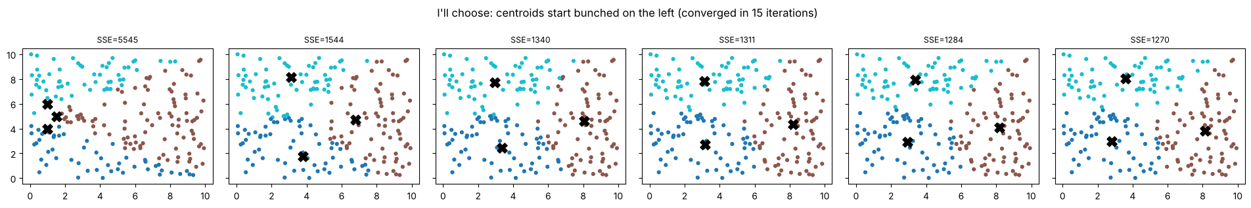
Figure 1: The first six of 15 iterations from a bunched start on uniform points (black crosses = centroids).
Practical takeaways: Create multiple restarts and/or k-means++ (with 10 restarts, SSE is 1216.6), understand that the output from the clusters is not a real group, and be aware that clusters marking people as people can be taken as a real category.

Peer responses
The brief asks for comments on peers’ wiki posts. I cannot see my peers’ posts from here, so the two replies below are drafts to adapt after reading the actual posts. Replace the square brackets.
- [Name], I liked your point about [their point]. In my own run on the uniform-points data, changing only the starting centroids gave a different final partition (adjusted Rand index 0.83) and a different SSE, which suggests that [their conclusion] depends on initialisation as well as on the data. Did you try more than one start, or k-means++?
- [Name], your explanation of the update step is clear. One extension: the animation always returns k groups, even on uniform points where I would not expect any. Did you compare different values of k, and what would you use besides SSE to decide which one is meaningful?

Learning outcomes addressed
- Articulate the legal, social, ethical and professional issues faced by machine learning professionals.
- Understand the applicability and challenges associated with different datasets for the use of machine learning algorithms.
K-means can generate seemingly meaningful groups from data that has no inherent grouping, which can be important if the groups are subsequently treated differently. The animations also demonstrated that the algorithm is distance-based (numeric), meaning that data should be appropriate for such distance-based operations.

References
Harris, N. (2014). Visualizing K-Means Clustering. Available at: https://www.naftaliharris.com/blog/visualizing-k-means-clustering/
Kubat, M., (2005). Introduction to machine learning. In Advanced Topics in Artificial Intelligence: International Summer School Prague, Czechoslovakia, July 6–17, 1992 Proceedings (pp. 104-138). Berlin, Heidelberg: Springer Berlin Heidelberg.
Shabal.in (n.d.). K-means clustering demo. Available at: http://shabal.in/visuals/kmeans/2.html

