The Simple Perceptron
Machine Learning (ML_PCOM7E) · Unit 7 · e-Portfolio Activity: Perceptron Activities (Exercise 1)
Code evidence: unit07_perceptron/simple_perceptron.ipynb

Aim
To implement a single perceptron, train it with the perceptron learning rule, and see how the learning rate and the separability of the data affect training.

What I did
The perceptron computes the dot product z = w·x + b, and returns 1 if z > 0. After each example, it updates w ← w + η (target − output) x and b ← b + η (target − output). I trained it on two distinct clusters, then on four different learning rates: 0.001, 0.01, 0.1, and 1.0, and finally on two very similar (overlapping) clusters.

Results
Table 1: Separable data.
Learning rate | Epochs to reach zero errors | Accuracy
0.001 | 10 | 1.00
0.01 | 3 | 1.00
0.1 | 3 | 1.00
1.0 | 3 | 1.00
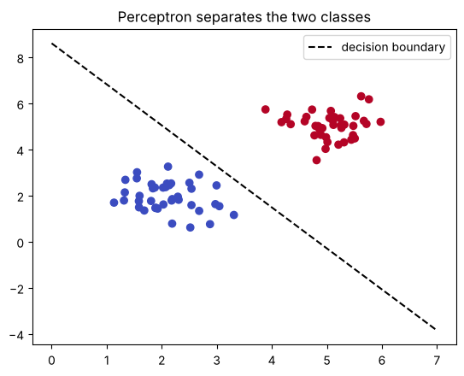
Figure 1: Decision boundary learned on the separable clusters.
For the overlapping clusters, the perceptron did not get to 0 errors, and after 100 epochs it had 37 errors with a final accuracy of 72.5 %.

Analysis
- A perceptron will not converge if the classes overlap, but if they can be separated by a straight line, then it will converge.
- The learning rates of 0.01 to 1.0 were all the same speed on this problem, and a very small rate (0.001) was slower. In contrast with gradient-descent methods, a rate that is too large will diverge (see Unit 8).
- During testing, I found that training on the class-sorted data produced apparently good results, since the boundary might move between the two halves of the epoch. In each epoch, the shuffling of the examples resolved this and the result is dependent on the order of the training data.

Learning outcomes addressed
- Understand the applicability and challenges associated with different datasets for the use of machine learning algorithms.
The activity illustrates that algorithms need to be appropriate for the data set: One perceptron is suitable for linearly separable data and real data may overlap.

References
Kubat, M., (2005). Introduction to machine learning. In Advanced Topics in Artificial Intelligence: International Summer School Prague, Czechoslovakia, July 6–17, 1992 Proceedings (pp. 104-138). Berlin, Heidelberg: Springer Berlin Heidelberg.

