Perceptron and the AND Operator
Machine Learning (ML_PCOM7E) · Unit 7 · e-Portfolio Activity: Perceptron Activities (Exercise 2)
Code evidence: unit07_perceptron/perceptron_AND_operator.ipynb

Aim
To train a perceptron on the truth table of the AND operator, inspect the learned weights, and compare AND and OR (which a perceptron can learn) with XOR (which it cannot).

Results
Starting from zero weights and a learning rate of 0.1, the perceptron reached zero errors in 6 epochs with w = [0.2, 0.1] and b = −0.2.
Table 1: Learned AND gate (the output is 1 only when z > 0).
x1 | x2 | AND target | z = w·x + b | Prediction
0 | 0 | 0 | -0.2 | 0
0 | 1 | 0 | -0.1 | 0
1 | 0 | 0 | 0.0 | 0
1 | 1 | 1 | 0.1 | 1
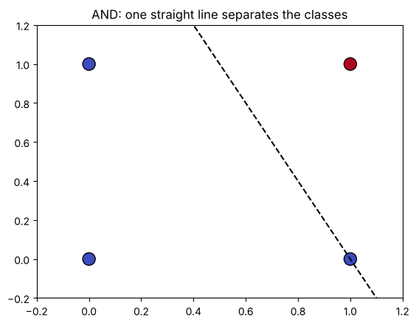
Figure 1: One straight line separates (1,1) from the other three inputs.
Table 2: Learning rate and gate type.
Gate | Learning rate | Epochs run | Errors remaining
AND | 0.01 / 0.1 / 1.0 | 6 / 6 / 6 | 0
OR | 0.01 / 0.1 / 1.0 | 4 / 4 / 4 | 0
XOR | 0.01 / 0.1 / 1.0 | 100 / 100 / 100 | 4 / 4 / 4

Analysis
The weights have a clear interpretation: x1 counts twice as much as x2 and the bias of −0.2 means both inputs must be on before z becomes positive. The learning rate did not change how quickly AND or OR were learned. XOR was never learned: four mistakes remained after 100 epochs at every learning rate, because no single line separates its classes. The multi-layer perceptron in Exercise 3 is motivated by this limitation.

Learning outcomes addressed
- Understand the applicability and challenges associated with different datasets for the use of machine learning algorithms.
The difference between AND, OR and XOR demonstrates how the structure of a problem determines the applicability of an algorithm. If the model does not represent the pattern, it cannot be saved by further training or tuning.

References
Kubat, M., (2005). Introduction to machine learning. In Advanced Topics in Artificial Intelligence: International Summer School Prague, Czechoslovakia, July 6–17, 1992 Proceedings (pp. 104-138). Berlin, Heidelberg: Springer Berlin Heidelberg.

