Multi-Layer Perceptron and the Sigmoid Function
Machine Learning (ML_PCOM7E) · Unit 7 · e-Portfolio Activity: Perceptron Activities (Exercise 3)
Code evidence: unit07_perceptron/multi_layer_perceptron.ipynb

Aim
To demonstrate that one can train a network to learn XOR with a hidden layer that has a sigmoid activation function, σ(z) = 1 / (1 + e^−z), and to understand how many hidden units and learning rates are needed and how they affect the training.

What I did
I've created a 2-input, 1-hidden-layer, 1-output network with NumPy and trained it with the squared-error loss function using backpropagation. A (1 − A) is the derivative of the sigmoid and is used to backpropagate the error. I then varied the hidden layer size (1, 2, 4, 8) and the learning rate (0.05, 0.5, 2.0) for 5000 epochs each.

Results
The network with 4 hidden units learned XOR: the responses for the four inputs were 0.016, 0.985, 0.986 and 0.017.
Table 1: Final loss after 5000 epochs, and whether XOR was solved.
Hidden units | LR 0.05 | LR 0.5 | LR 2.0
1 | 0.1844 (not solved) | 0.1675 (not solved) | 0.1668 (not solved)
2 | 0.1404 (not solved) | 0.1258 (not solved) | 0.1252 (not solved)
4 | 0.0899 (solved) | 0.0006 (solved) | 0.0001 (solved)
8 | 0.0203 (solved) | 0.0005 (solved) | 0.0001 (solved)
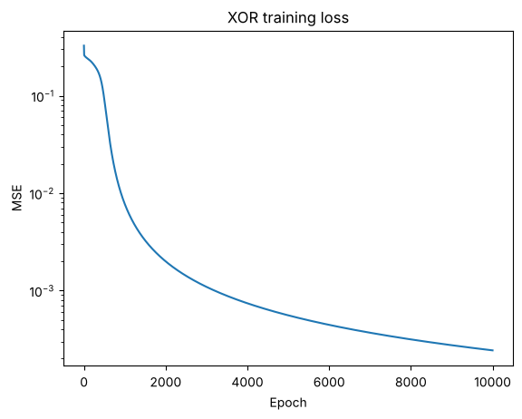
Figure 1: XOR training loss (4 hidden units, learning rate 0.5).

Analysis
- The hidden layer makes it possible to use two straight-line boundaries, sufficient for XOR. This run was not solved by the network with one or two hidden units and it took four hidden units to solve it.
- The final four hidden units had a loss of 0.0899 after 5000 epochs, but the other rates were much faster to converge. The results are all based on a single random start, and may vary based on a different random start.
- The sigmoid is smooth, allowing gradients to be calculated when back-propagating errors through the network; the derivative of the sigmoid has a maximum at z = 0, and is close to 0 for large values of |z| that can make learning more difficult in deeper networks.

Learning outcomes addressed
- Understand the applicability and challenges associated with different datasets for the use of machine learning algorithms.
The activity relates the selected architecture to the data structure: This means that a more flexible model can represent problems which a simple one cannot represent; however, a more flexible model introduces parameters which must be tuned, and requires more data to be trusted.

References
Kubat, M., (2005). Introduction to machine learning. In Advanced Topics in Artificial Intelligence: International Summer School Prague, Czechoslovakia, July 6–17, 1992 Proceedings (pp. 104-138). Berlin, Heidelberg: Springer Berlin Heidelberg.

