Gradient Descent and the Cost Function
Machine Learning (ML_PCOM7E) · Unit 8 · e-Portfolio Activity: Gradient Cost Function
Code evidence: unit08_gradient_descent/gradient_descent_cost_function.ipynb

Reading: Mayo (2017)
Mayo's article details how a network learns through a cost function that it uses to measure its error, and then iteratively pushes all its weights a little bit in a direction that lowers the cost, with the gradients provided by backpropagation. On the simplest model, a line, ŷ = m·x + c, I applied the same idea, so that the entire process can be observed: cost J = mean ((y − ŷ)²), gradients ∂J/∂m and ∂J/∂c, and the update m ← m − η·∂J/∂m.

What I did
I created a data set of 100 points of y = 4x + 7 + noise (sd 2), and performed 0.01 learning rate gradient descent for 1000 iterations. I then changed the number of iterations (10, 100, 1000) and the learning rate (0.0001, 0.001, 0.01, 0.05, 0.1) and recorded the final cost.

Results
The default run gave m = 3.912, c = 7.405 and a cost of 3.227, almost the same as the closed-form least-squares solution (m = 3.908, c = 7.430). The actual values were 4 and 7.
Table 1: Final cost (MSE) by learning rate and number of iterations.
Learning rate | 10 iterations | 100 iterations | 1000 iterations
0.0001 | 718.06 | 240.11 | 14.54
0.001 | 258.85 | 14.55 | 7.40
0.01 | 14.66 | 7.43 | 3.23
0.05 | diverged | diverged | diverged
0.1 | diverged | diverged | diverged
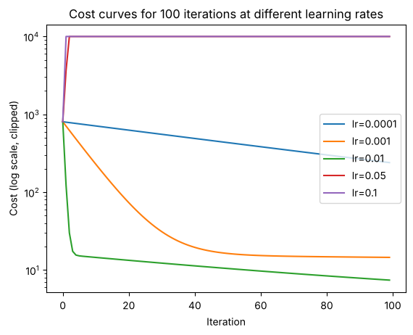
Figure 1: Cost over 100 iterations. The two largest learning rates explode and are clipped at the top of the chart.

Observations
- More iterations reduce the cost, with diminishing returns. At learning rate 0.01, the cost fell from 14.66 to 7.43 to 3.23 as iterations increased from 10 to 100 to 1000.
- A learning rate that is too small wastes computation. At 0.0001, the cost was still 14.54 after 1000 iterations.
- A learning rate that is too large diverges. At 0.05 and 0.1, each step overshot the minimum; the error grew with every iteration and the values overflowed.
- The practical choice is the largest learning rate that still lowers the cost smoothly (0.01 here).

Learning outcomes addressed
- Understand the applicability and challenges associated with different datasets for the use of machine learning algorithms.
Gradient descent is sensitive to hyperparameters as well as data size, especially when using the same algorithm on different datasets. A badly chosen learning rate fails silently unless the cost is monitored.

References
Kubat, M., (2005). Introduction to machine learning. In Advanced Topics in Artificial Intelligence: International Summer School Prague, Czechoslovakia, July 6–17, 1992 Proceedings (pp. 104-138). Berlin, Heidelberg: Springer Berlin Heidelberg.
Pardos, E.P., (2025). Machine Learning Recurrent Neural Networks and Applications.

