CNN Object Recognition and Ethical Implications
Machine Learning (ML_PCOM7E) · Unit 9 · e-Portfolio Activity: CNN Model Activity
Code evidence: unit09_cnn/cnn_object_recognition.ipynb

Part 1 – Running the CNN
I created a basic 2-convolution, 2 ReLU, 2 max-pooling (13,706 parameters) network in PyTorch, and optimized it using the Adam algorithm. If it fails to download, the notebook attempts to download the CIFAR-10 dataset and then falls back to the 8×8 digits dataset from scikit-learn.
Note on the dataset. Important: I ran the reported results using the digits fallback (1347 training images and 450 test images) because CIFAR-10 was not available in the environment where I ran this notebook. If you are using Google Colab, you will automatically be using CIFAR-10, and should repeat this notebook before submission to update the figures below.
Table 1: Results of the executed run.
Measure | Result
Dataset used | sklearn digits (8×8 greyscale)
Training accuracy | 0.963
Test accuracy | 0.944
Indices 1–16 predicted correctly | 16 of 16
Lowest confidence (correct) | 0.721 (index 10)
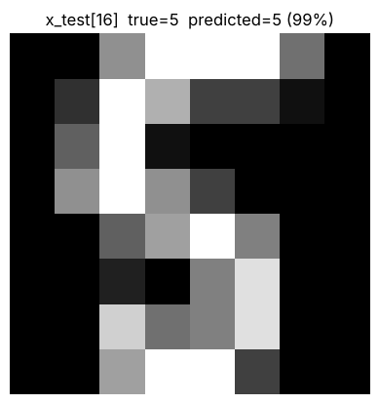
Figure 1: Prediction for x_test[16]: true 5, predicted 5 (99 % confidence).
The correct class was obtained in every iteration when changing the index of x_test[…] from 16 to 1-15, with confidence ranging from 0.721 to 0.999. The accuracy per class varied from 0.791 (class 8) to 1.000 (classes 3 and 7) in the entire test set. This is the reason that a model correct on 16 examples can be bad for specific classes.
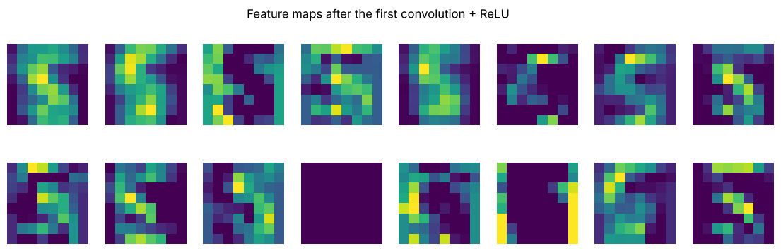
Figure 2: Feature maps after the first convolution: each filter highlights different strokes and edges.

Part 2 – Ethical and social implications (Wall, 2019)
Wall (2019) discusses the possibility of facial recognition technology in public spaces, and the worry of it being inaccurate and biased. The CNNs are the backbone of these systems: the same convolution, pooling and classification network I used to recognise small digit images is used to recognise faces when upscaled. The article has been cited, and reference should be made to the wider literature; I have not been able to include figures from the article in my reflection.
- Bias and unequal accuracy. On a clean benchmark, this run had some inaccuracy between classes. The study of commercial face analysis revealed that the errors were significantly higher for darker-skinned females than for lighter-skinned males (Buolamwini and Gebru, 2018). If such a system is applied by the police or employers, errors disproportionately fall on certain groups.
- Consequences of false matches. The person who has not matched may be stopped, questioned or excluded. These costs are not reflected by overall accuracy figures and require subgroup testing and a human decision-maker.
- Privacy and consent. Faces are biometric information. Collecting them in public without substantive consent, with no other purpose, creates legal issues in the UK (UK GDPR considers biometric data used for identification as special category data) and under the EU GDPR and undermines legitimate activity, including protest.
- Professional responsibility. For ML, make sure to record training data and limits, and do not deploy it, or do so sparingly, if the stakes for errors are high and no consent is given by the representative sets of data.
- Benefits. While legitimate uses of this technology include helping to locate missing persons, the benefits do not preclude the responsibility to quantify harms.

Learning outcomes addressed
- Discuss Legal, Social, Ethical and Professional challenges for Machine Learning Professionals.
- Understand the applicability and challenges associated with different datasets for the use of machine learning algorithms.
Part 2 explores the legal, social, ethical and professional considerations of CNN technology. In Part 1, data-related challenges are demonstrated, with performance being dependent on the data, and accuracy in a few examples not being representative of the classes.

References
Buolamwini, J. and Gebru, T. (2018). ‘Gender shades: intersectional accuracy disparities in commercial gender classification’, Proceedings of Machine Learning Research, 81, pp. 77–91.
Kubat, M., (2005). Introduction to machine learning. In Advanced Topics in Artificial Intelligence: International Summer School Prague, Czechoslovakia, July 6–17, 1992 Proceedings (pp. 104-138). Berlin, Heidelberg: Springer Berlin Heidelberg.
Wall, M. (2019). Biased and wrong? Facial recognition tech in the dock. BBC News.

