Model Performance Measurement: AUC and R²
Machine Learning (ML_PCOM7E) · Unit 11 · e-Portfolio Activity: Model Performance Measurement
Code evidence: unit11_model_performance/model_performance_measurement.ipynb

Aim
To change model parameters and data conditions and observe their effect on the AUC (classification) and R² (regression) performance measures.

Part 1 – AUC
I created a binary classification dataset of 15 features and benchmarked the logistic regression against a random forest. The AUC of the random forest with default parameters was 0.947 compared to 0.819 for logistic regression.
Table 1: Effect of regularisation and tree depth on AUC.
Model | Parameter | Train AUC | Test AUC
Logistic regression | C = 0.0001 | 0.771 | 0.784
Logistic regression | C = 1 | 0.800 | 0.819
Random forest | max_depth = 1 | 0.782 | 0.774
Random forest | max_depth = 4 | 0.915 | 0.884
Random forest | max_depth = 8 | 0.990 | 0.934
Random forest | unlimited | 1.000 | 0.947
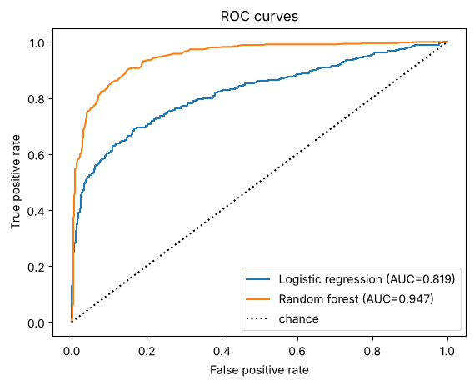
Figure 1: ROC curves for the two models.

Class imbalance
Table 2: Random forest under increasing imbalance.
Class balance | Accuracy | AUC | Minority recall | Minority precision
50/50 | 0.873 | 0.947 | 0.855 | 0.887
90/10 | 0.930 | 0.874 | 0.406 | 0.867
98/2 | 0.973 | 0.790 | 0.077 | 1.000
As the minority class decreased in size, accuracy increased from 0.873 to 0.973 and AUC decreased to 0.790, with only 7.7 % of the minority cases identified. The accuracy of a model may be very high, but it may not be capable of finding the rare class.

Part 2 – R²
Table 3: Test R² for polynomial models on cubic data with increasing noise.
Noise sd | Degree 1 test R² | Degree 3 test R² | Degree 10 test R²
0.5 | 0.696 | 0.997 | 0.996
3 | 0.663 | 0.892 | 0.867
10 | 0.304 | 0.331 | 0.173
This cubic model had an R² of 0.997 when it was tested with clean data, and 0.331 when tested with very noisy data, so the R² is a reflection of the noise ceiling along with the quality of the model. At noise sd 10, the degree-10 model had train R² 0.459 but test R² 0.173 (overfitting). Ridge regularisation with alpha = 1 and alpha = 100 respectively gave an increase in R2 test of 0.899 and 0.764, from 0.867 when no regularisation was applied, at noise sd 3.

Conclusions
- Always compare train and test scores: a perfect train AUC (1.000) with a lower test AUC signals memorisation.
- On imbalanced data, report AUC, recall and precision for the minority class as well as accuracy.
- Interpret R² relative to the noise in the data, not as an absolute measure of quality.

Learning outcomes addressed
- Articulate the legal, social, ethical and professional issues faced by machine learning professionals.
Using only a positive metric like accuracy on an imbalanced dataset can mislead stakeholders about a model's risks. Professional integrity involves selecting and stating the correct performance metrics in machine learning.

References
Pedregosa, F., Varoquaux, G., Gramfort, A., Michel, V., Thirion, B., Grisel, O., Blondel, M., Prettenhofer, P., Weiss, R., Dubourg, V. and Vanderplas, J., (2011). Scikit-learn: Machine learning in Python. the Journal of machine Learning research, 12, pp.2825-2830.
Kubat, M., (2005). Introduction to machine learning. In Advanced Topics in Artificial Intelligence: International Summer School Prague, Czechoslovakia, July 6–17, 1992 Proceedings (pp. 104-138). Berlin, Heidelberg: Springer Berlin Heidelberg.
Novakovic, J.D., Veljovic, A., Ilic, S.S., Papic, Z. and Tomovic, M., (2017). Evaluation of classification models in machine learning. Theory and Applications of Mathematics and Computer Science, 7(1), pp.39-46.

