Picture content | Sample picture
Picture – 1  - Core conductor and insulation sleeve showing measurement for one phase. (Visible three phases in a single picture.) | 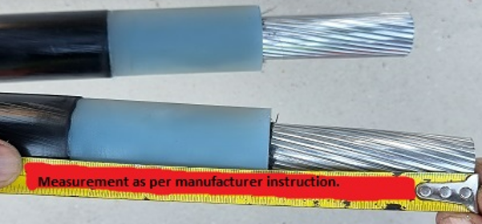
Picture – 2  - A stress control tube was installed and shrunk.  - Connector with clay, sleaved both ends for all phases.  (Visible three phases in a single picture.) | 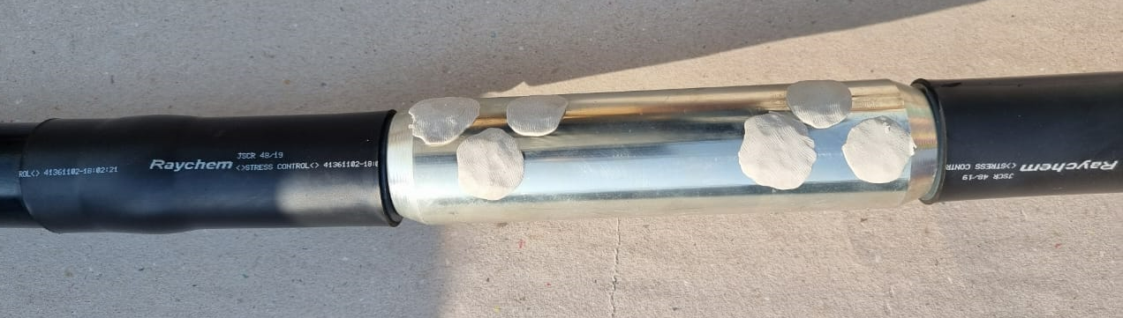
Picture – 3  - Copper mesh was applied on all cores and a wire shield connected with one shield connector | 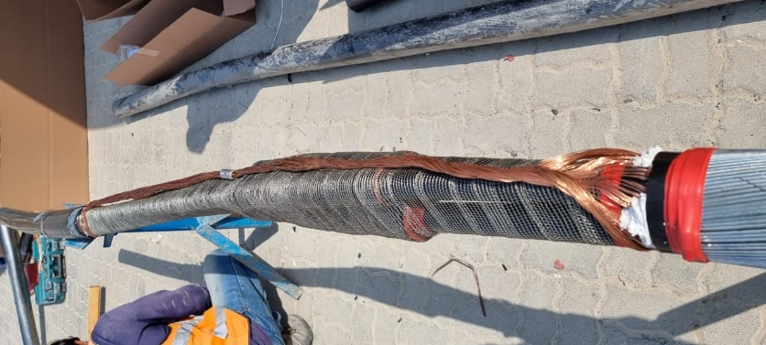
Picture – 4
Picture of the Jointer along with the completed joint, Certificate, and overall site.

