Date of Termination: 18-02-2025

Termination location | Aljimi | Contractor name | Time Electro
SS name | JM-0340 | Contract /PO No | A-18392
Conductor (AL / Cu) | AL | Scheme No. / WO No. | ND-11-24-085
Cable size and voltage | 400 sq.mm | Termination Manufacturer | Raychem

New Termination (First termination) New termination (Replacement to the failed termination)
y
SN | Content | YES | NO | NA | Remark
1 | Documents such as NOCs, Approved method statement, risk assessment, route layout to be available at site. | Y
2 | Valid Competency of the jointer. | Y
3 | Adequate 2 meters of loop available outside substation. | Y
4 | End cap to be available at the cable ends (IN case of not connected). | Y
5 | Manufacture instruction booklet available and read. | Y
6 | Preparation of cable end as per manufacturer manual. | Y
7 | All necessary & recommended tools with calibration required for the job. | Y
8 | All accessories required are available with the kit. | Y
9 | Do not use Knife to remove semi-conductor layer | Y
10 | Conductor length and insulation removal as per installation instructions. | Y
11 | All 3 cores should be straightening V shape. | Y
12 | No sharp edges of crimped lugs. | Y
13 | Sand/dust/moisture is cleaned from lugs and tubes. | Y
14 | The stress control tube and stress control patch are located properly and shrunk without any wrinkles. | Y
15 | Cable should be properly clamped. | Y
16 | Cable tag is to be provided for the termination. | Y
17 | Required photos as proof are collected. | Y
18 | Ensure Insulation resistance and VLF is performed. | y
Note: The preparation of the termination should adhere to the manufacturer's guidelines, this checklist is intended solely
to verify the implementation of key areas.

Contractor Representative |  | Supervision Team
Name / ID | Saiful Islam Khan | Name | Hamad Sultan
Signature |  | Signature

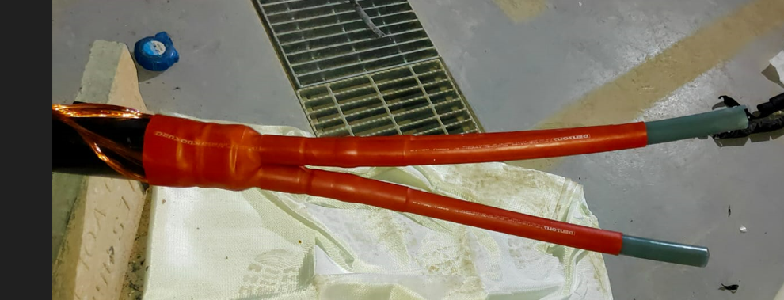 | 