Global Temperature

Project DAND by Udacity

By: Hamad S. Alassafi

Table of Contents

Steps taken to prepare the data to be visualized in the chart: 2

How I have calculated the moving average: 3

key considerations for deciding how to visualize the trends: 5

Line chart with local and global temperature trends 5

My Observations: 6

# Steps taken to prepare the data to be visualized in the chart:

I have used SQL queries to extract the data from the database

I used this SQL command to know whether my city is listed in the database or not which are from (city_list) table, and I find my city which is (Riyadh city).

SELECT country, city FROM city_list

WHERE country = ‘Saudi Arabi’;

I used this SQL command to extract the data from (global_data) table:

SELECT year,avg_temp FROM global_data;

I used this SQL command to extract the data from (city_data) table:

SELECT year,avg_temp FROM city_data WHERE city = ‘Riyadh’;

I have Used Excel spreadsheet to view my data that I extract from the database and to make the line chart.

# How I have calculated the moving average:

I have calculated the moving average using (Data Analysis) tool which are pre-defined in Excel spreadsheet. The tool allows you calculate any column you want immediately

This is pictures for further explanation about the tool and how it calculates the moving average

1. **At data option in the menu bar there is option at the right side called (Data Analysis).**

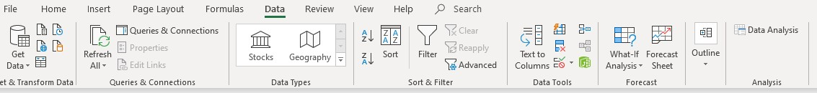

1. **There is menu will appear with too many analysis tools I have selected (Moving Average) tool then I clicked ok**

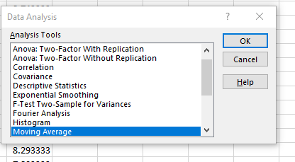

1. **Moving Average menu have appear, then I choose the input range and the output range then I clicked ok, and the moving average directly calculated for the (global_data) column based on the (average temperature) and my city (Riyadh) column based on the (average temperature).**

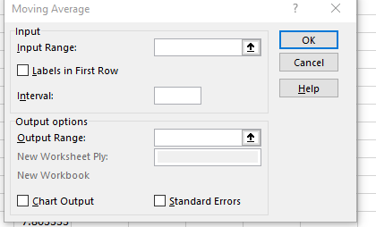

1. **Is at shown the moving average has been calculated in the output range that I choose.**

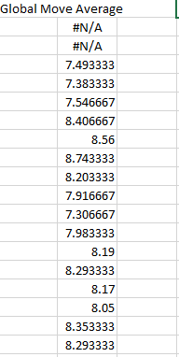

# Key considerations for deciding how to visualize the trends:

1750

1759

1768

1777

1786

1795

1804

1813

1822

1831

1840

1849

1858

1867

1876

1885

1894

1903

1912

1921

1930

1939

1948

1957

1966

1975

1984

1993

2002

2011

I have considered to take the moving average for my city (Riyadh) and the global temperature moving average based on the years, I have make sure to show the title and put label in the x-axis and y-axis, and using good colouring to make the graph more attractive.

# Line chart with local and global temperature trends



**Comparing Between Global Temperature and**

**Temperature in Riyadh City**

30

25

20

15

10

5

0

**YEAR**

Global

Riyadh

**TEMPERATURE**

# My Observations:

1. **My city (Riyadh) is way hotter than the average temperature is it shown in the graph**
2. **My city have become more hotter during the years, also the global temperature has become hotter.**
3. **The temperature is changing slowly over the years.**
4. **The temperature become more hotter in years, especially last twenty years.**
5. **The increasing of the temperature in my city (Riyadh) is larger than the global temperature increasing.**