Reproducible Research

hamada zidan

5‏/2‏/2022

# Reproducible Research Week 2 Project

## *Loading and preprocessing the data*

### Load the data Process/transform the data (if necessary) into a format suitable for your analysis

# download file from web  
download.file("https://d396qusza40orc.cloudfront.net/repdata%2Fdata%2Factivity.zip", destfile = "activity.zip", mode="wb")  
# unzip data and read   
unzip("activity.zip")  
stepdata <- read.csv("activity.csv", header = TRUE)  
head(stepdata)

## steps date interval  
## 1 NA 2012-10-01 0  
## 2 NA 2012-10-01 5  
## 3 NA 2012-10-01 10  
## 4 NA 2012-10-01 15  
## 5 NA 2012-10-01 20  
## 6 NA 2012-10-01 25

# 1. Calculate total number of steps taken each day

library(magrittr)  
library(dplyr)

##   
## Attaching package: 'dplyr'

## The following objects are masked from 'package:stats':  
##   
## filter, lag

## The following objects are masked from 'package:base':  
##   
## intersect, setdiff, setequal, union

databydate <- stepdata %>% select(date, steps) %>% group_by(date) %>% summarize(tsteps= sum(steps)) %>%na.omit()  
hist(databydate$tsteps, xlab = "Total daily Steps",main="Histogram of Total Steps by day", breaks = 20)

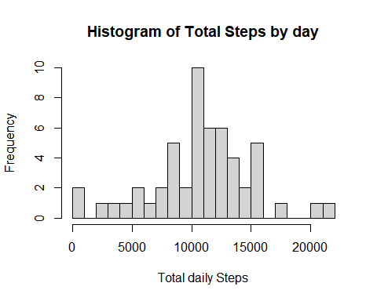

# 2. Calculate and report the mean and median of the total number of steps taken per day

mean(databydate$tsteps)

## [1] 10766.19

mean(databydate$tsteps)

## [1] 10766.19

# 4. Time series plot

library(ggplot2)  
databyinterval <- stepdata%>% select(interval, steps) %>% na.omit() %>% group_by(interval) %>% summarize(tsteps= mean(steps))   
ggplot(databyinterval, aes(x=interval, y=tsteps))+ geom_line()

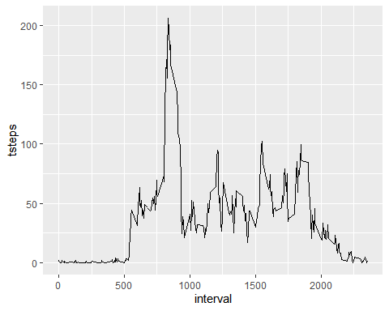

# 5.The 5-minute interval that, on average, contains the maximum number of steps

databyinterval[which(databyinterval$tsteps== max(databyinterval$tsteps)),]

## # A tibble: 1 x 2  
## interval tsteps  
## <int> <dbl>  
## 1 835 206.

# Imputing missing values

# 1. Calculate and report the total number of missing values in the dataset (i.e. the total number of rows with NAs)

# generate listing of NA's  
missingVals <- sum(is.na(data))

## Warning in is.na(data): is.na() applied to non-(list or vector) of type  
## 'closure'

missingVals

## [1] 0

# 2.Devise a strategy for filling in all of the missing values in the dataset. The strategy does not need to be sophisticated. For example, you could use the mean/median for that day, or the mean for that 5-minute interval, etc.

## I will use the mean for that 5 -minute interval to replace all the missing values in the dataset. At the end, I will check if all the NAs have been replaced

library(magrittr)  
library(dplyr)  
  
replacewithmean <- function(x) replace(x, is.na(x), mean(x, na.rm = TRUE))  
meandata <- stepdata%>% group_by(interval) %>% mutate(steps= replacewithmean(steps))  
head(meandata)

## # A tibble: 6 x 3  
## # Groups: interval [6]  
## steps date interval  
## <dbl> <chr> <int>  
## 1 1.72 2012-10-01 0  
## 2 0.340 2012-10-01 5  
## 3 0.132 2012-10-01 10  
## 4 0.151 2012-10-01 15  
## 5 0.0755 2012-10-01 20  
## 6 2.09 2012-10-01 25

## 4 Make a histogram of the total number of steps taken each day and Calculate and report the mean and median total number of steps taken per day.

FullSummedDataByDay <- aggregate(meandata$steps, by=list(meandata$date), sum)  
  
names(FullSummedDataByDay)[1] ="date"  
names(FullSummedDataByDay)[2] ="totalsteps"  
head(FullSummedDataByDay,15)

## date totalsteps  
## 1 2012-10-01 10766.19  
## 2 2012-10-02 126.00  
## 3 2012-10-03 11352.00  
## 4 2012-10-04 12116.00  
## 5 2012-10-05 13294.00  
## 6 2012-10-06 15420.00  
## 7 2012-10-07 11015.00  
## 8 2012-10-08 10766.19  
## 9 2012-10-09 12811.00  
## 10 2012-10-10 9900.00  
## 11 2012-10-11 10304.00  
## 12 2012-10-12 17382.00  
## 13 2012-10-13 12426.00  
## 14 2012-10-14 15098.00  
## 15 2012-10-15 10139.00

# Summary of new data : mean & median

summary(FullSummedDataByDay)

## date totalsteps   
## Length:61 Min. : 41   
## Class :character 1st Qu.: 9819   
## Mode :character Median :10766   
## Mean :10766   
## 3rd Qu.:12811   
## Max. :21194

## *Making a histogram*

hist(FullSummedDataByDay$totalsteps, xlab = "Steps", ylab = "Frequency", main = "Total Daily Steps", breaks = 20)

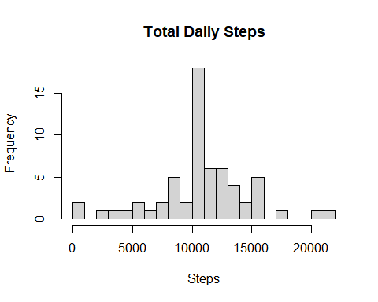

## 4C Compare the mean and median of Old and New data

oldmean <- mean(databydate$tsteps, na.rm = TRUE)  
newmean <- mean(FullSummedDataByDay$totalsteps)  
# Old mean and New mean  
oldmean

## [1] 10766.19

newmean

## [1] 10766.19

oldmedian <- median(databydate$tsteps, na.rm = TRUE)  
newmedian <- median(FullSummedDataByDay$totalsteps)  
# Old median and New median  
oldmedian

## [1] 10765

newmedian

## [1] 10766.19

# Are there differences in activity patterns between weekdays and weekends?

meandata$date <- as.Date(meandata$date)  
meandata$weekday <- weekdays(meandata$date)  
meandata$weekend <- ifelse(meandata$weekday=="Saturday" | meandata$weekday=="Sunday", "Weekend", "Weekday" )  
library(ggplot2)  
meandataweekendweekday <- aggregate(meandata$steps , by= list(meandata$weekend, meandata$interval), na.omit(mean))  
names(meandataweekendweekday) <- c("weekend", "interval", "steps")  
  
ggplot(meandataweekendweekday, aes(x=interval, y=steps, color=weekend)) + geom_line()+  
facet_grid(weekend ~.) + xlab("Interval") + ylab("Mean of Steps") +  
 ggtitle("Comparison of Average Number of Steps in Each Interval")

