POSHTEXTILES

# Picking

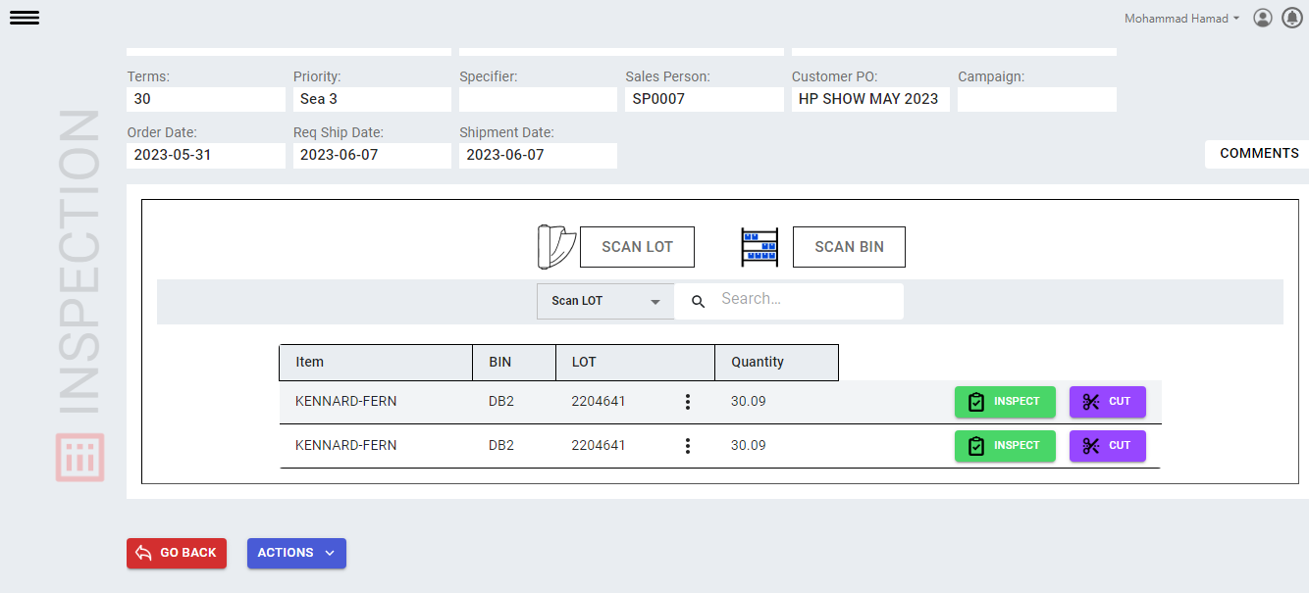

This search box , just filter local data, which is visible on tab.

After filtering you can click on threeDots to get lots

Clicking on threeDots API will run to get all available LOTS for this item.

**But after selecting lot number which API should be call to update this pickItem data into Business Central Model? pickDetails( there no Patch example)**Currently change of lot is happening on frontend level. While in video this point is not mentioned just told that lot should be patched.

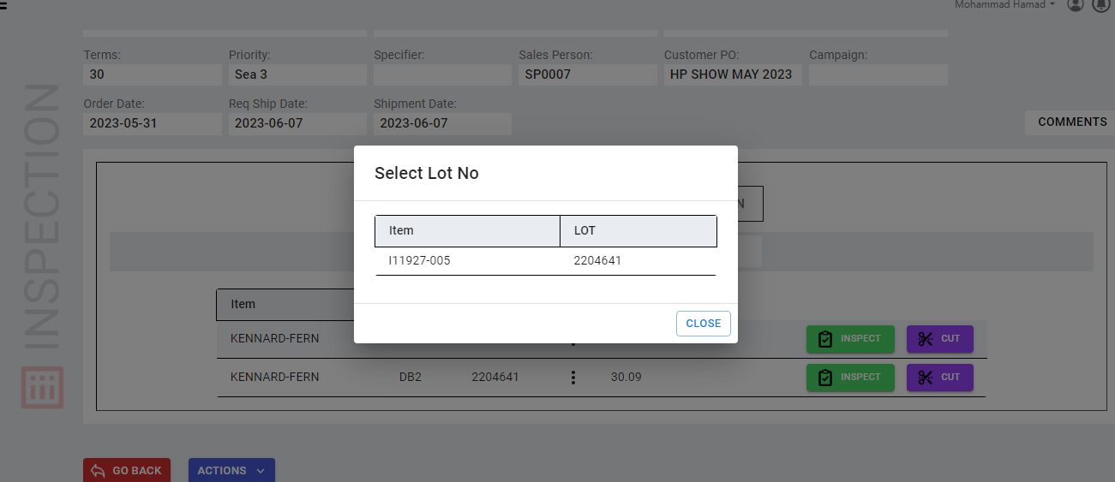

EDC-Inventory (/edcInventory?$filter=itemNo eq **'P10001-001'** and locationCode eq **'SYOSSET'**). When ItemNo like ("I11927-005") is used then we get a lot number bydefault. However when **no: "PI044348"** is used nothing or not lot number is found. So I used ItemNo to get info.  
  
**Update about it why it is happening to regulate API properly?**

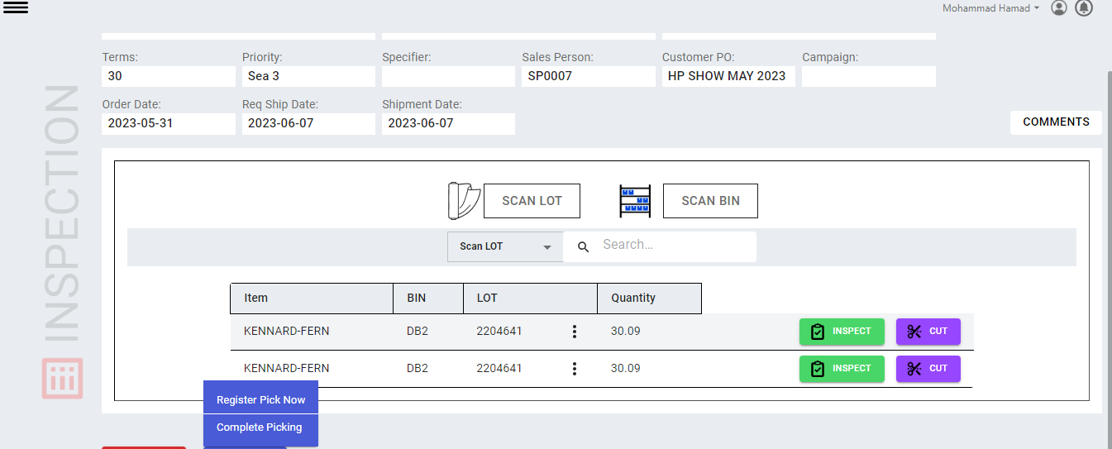

I case of Register Pick API, its body IS

{

"WhsePickNo" : "PI042141"

}

As you can see ERROR is responed back   
Lot No. must have a value in Warehouse Activity Line: Activity Type=Pick, No.=PI044348, Line No.=10000. It cannot be zero or empty.  
To solve this problem let me know .

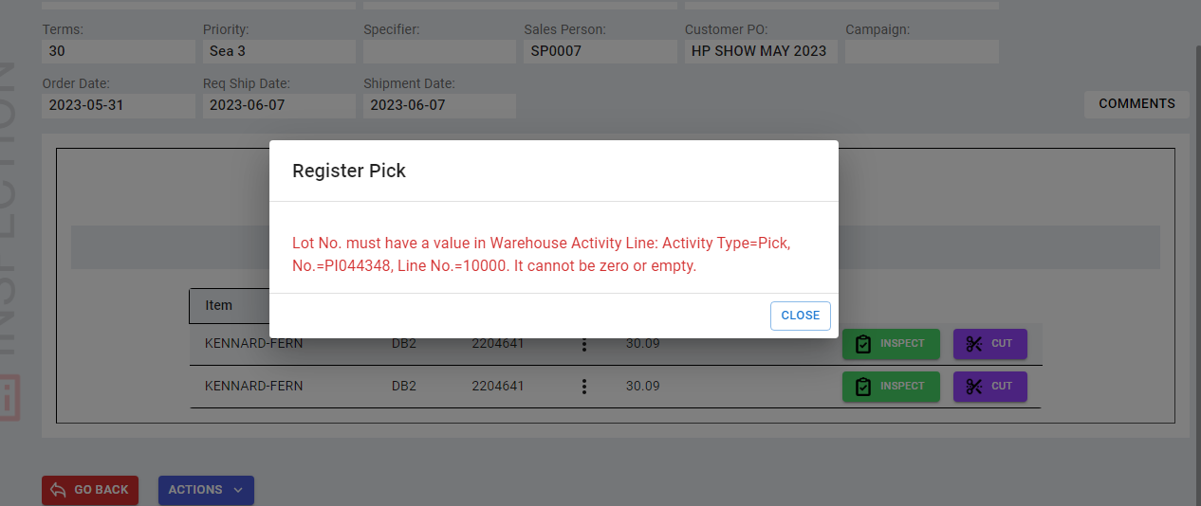

# Packing

In Packing section there is PackingDetails (Create & Get) API and createPacking API are main.

while on **creatie Packing** the **createPacking API** is used to fetch packing status, then then Side bar is enabled to proceed next processing.

when and where to use GET method of PackingDetails?

Also, when and where to use CREATE(POST) method of PackingDetails? Also tell me about **packingLines** details, in our application there is no such form or section which can create **packingLines ?**

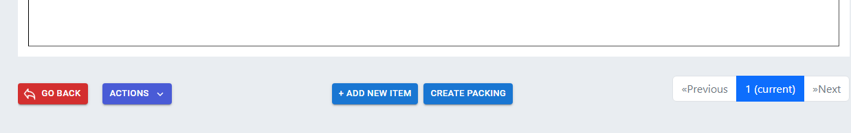

creatPacking API

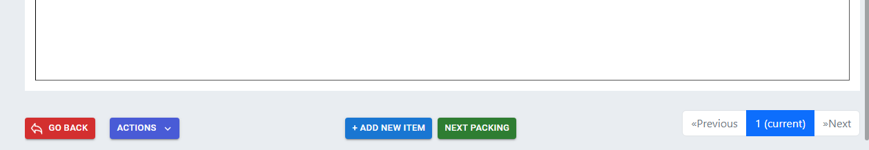

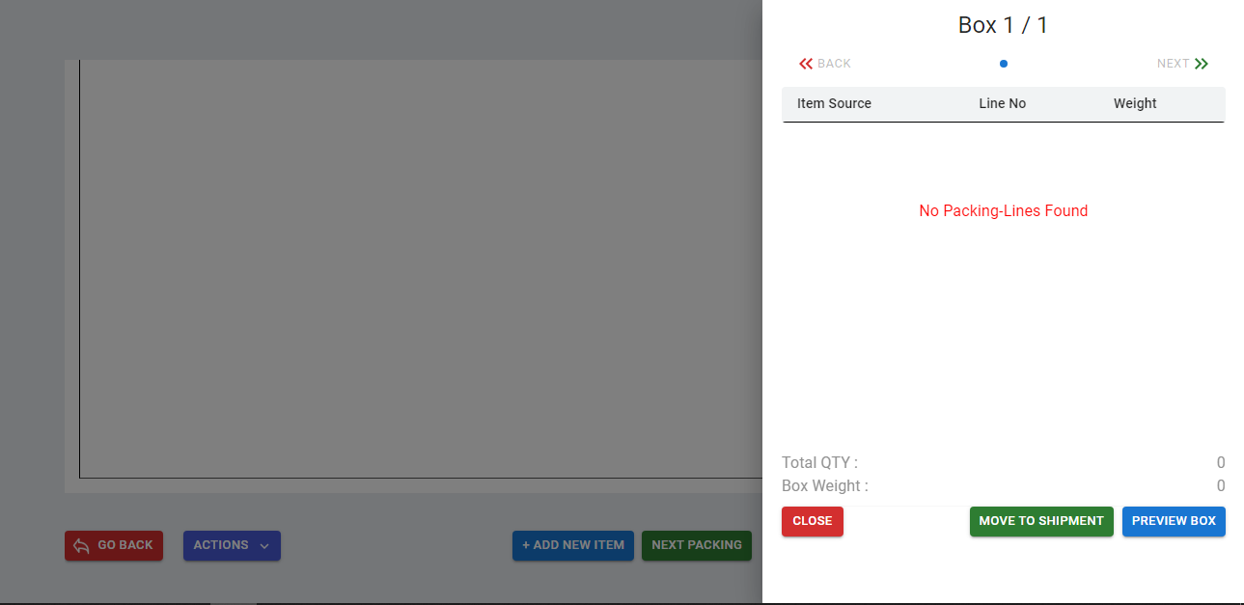

packingDetails – Get Method API