Kidney Stone and Size Detection Using Deep Learning Techniques.

Shaik. Hamadi 1  
Computer and Communication Engineering  
Amrita Vishwa VidyapeethamChennai  
hamadiengg@gmail.com

Gokul. S 1  
Computer and Communication Engineering  
Amrita Vishwa VidyapeethamChennai  
line 5: email

Ganesh Kumar. C 2  
Electronics and Communication Engineering  
Amrita Vishwa VidyapeethamChennai  
line: email

*Abstract*—Kidney stones are a common and painful urologic condition affecting millions of people worldwide. Early and accurate detection of kidney stones is crucial for proper treatment planning and management. However, manual analysis of medical imaging data can be time-consuming, subjective, and prone to errors. This paper aims to develop an automated system for detecting kidney stones and estimating their size using a deep learning approach based on the Faster Region-Based Convolutional Neural Network (Faster R-CNN) algorithm. The process begins with data preprocessing, which involves splitting the dataset into training, validation, and testing sets. Augmentation techniques and Resnet-50 are used for feature extraction. The faster R-CNN algorithm is a state-of-the-art object recognition model that combines a Region Proposition Network (RPN) and a Deep Convolutional Network for classification and bounding box regression. The model is trained on a large dataset of CT images of patients with and without kidney stones, accurately locating kidney stones and drawing boundaries on CT images. The performance of the proposed system is evaluated by precision-recall curves.

Keywords— Kidney Stones, Deep Learning, Faster R-CNN, Object detection, medical imaging, CT images, Stone Detection, Bounding box method

# Introduction

# Kidney stones form when minerals and salts accumulate in urine due to water shortage, often caused by diabetes, hypertension, and obesity. Analyzing kidney stones using methods like urine tests, blood tests, CT scans, and X-ray filters is challenging. Robotized kidney stone orders use CT images via BPN. Kidney stones are a prevalent medical condition affecting millions of individuals worldwide, with a significant impact on health and quality of life. The timely and accurate detection of kidney stones, as well as the determination of their size, are crucial steps in their management and treatment planning. Traditional methods of kidney stone detection and sizing often involve manual interpretation of medical imaging such as Ultrasound scans, which can be time-consuming, subjective, and prone to human error. If we have a small stone it won't be identified in some cases.

In recent years, advancements in computer vision and deep learning techniques have offered promising avenues for automating the detection and characterization of kidney stones. One such approach is the Faster R-CNN (Region-based Convolutional Neural Network) algorithm, renowned for its efficiency and accuracy in object detection tasks.

In this paper, we propose the application of the Faster R-CNN algorithm for kidney stone detection and size estimation from medical imaging data, particularly focusing on CT scans. By leveraging deep learning techniques, we aim to develop a robust and automated system capable of accurately identifying the presence of kidney stones within the renal system and providing precise measurements of their sizes. The utilization of the Faster R-CNN algorithm offers several advantages, including its ability to simultaneously detect multiple objects within an image while providing bounding box coordinates and classification scores. Moreover, its ability to handle complex and overlapping structures makes it well-suited for the intricate morphology of kidney stones.

This paper presents the methodology, implementation, and experimental results of our proposed approach. Additionally, we discuss the challenges encountered during the development process and potential avenues for future research and improvements. Overall, the application of the Faster R-CNN algorithm for kidney stone detection and sizing holds immense promise in enhancing the efficiency and accuracy of clinical diagnosis and treatment planning, ultimately leading to improved patient outcomes and healthcare delivery.

# RELATED WORK

[1] The paper uses convolutional neural networks (CNN) to diagnose kidney disease, focusing on tumors, cysts, normal, and stones. The study demonstrates CNN's effectiveness in accurately classifying kidney diseases, with training and test accuracies of up to 99%. Early detection is crucial for effective treatment and recovery, and the model is trained using images of kidney tumors, cysts, and normal stones.

[2] A study analyzed 63 human kidney stones, including calcium oxalate monohydrate, uric acid, magnesium ammonium phosphate hexahydrate, calcium hydrogen phosphate dihydrate, and cystine stones. A deep convolutional neural network (CNN) model, ResNet-101, was applied to each image. The results showed a composition prediction recall of 94% for UA, 90% for COM, 86% for MAPH/struvite, 75% for cysteine, and 71% for CHPD/brushite. The study concluded that deep CNNs can accurately identify kidney stone composition from digital photographs, but further research is needed.

[3] Kidney stones are a major global health issue, with inherited and hereditary kidney diseases being common. A new ordering framework, ROI+CNN, has been developed to improve accuracy, specificity, sensitivity, FPR, and FNR. The approach has reduced false-acceptance rates to 100% and yielded positive results for KIDNEY datasets. The study demonstrates the effectiveness of the proposed method on KIDNEY datasets and suggests further analysis for better diagnosis and treatment.

[4] This study proposes five 3D-CNN models for detecting and classifying kidney stones in endoscopy images using deep learning techniques. The models, trained on a novel dataset of 1000 images from Ethiopia, achieved an accuracy score of 0.985. The authors emphasize the importance of early detection and treatment for kidney stones, highlighting the potential of machine learning to reduce physician workload and improve diagnostic accuracy.

[5] Researchers have developed a deep-learning model for detecting and predicting chronic kidney disease using doctor consultation data. The model, inspired by artificial intelligence, achieves 99.23% accuracy, outperforming existing methods. The approach improves classification, precision, F-measure, and sensitivity metrics.

# ARCHITECTURE

Object detection in computer vision has been revolutionized by Faster R-CNN, a deep-learning architecture. Using a Region Proposal Network (RPN) and a Region-based CNN (RCNN), it employs a two-stage detection approach. To provide precise object detection, the ResNet-50 backbone network pulls complex information from input images. A modified version of the Residual Network (ResNet) architecture called ResNet-50 introduces skip connections to solve the vanishing gradient issue. This allows extraordinarily deep networks to be trained without performance reduction. Within the image, the RPN suggests regions of interest (ROIs), which are further processed by Region of Interest Pooling. To accurately locate and identify objects inside the image, the RCNN performs bounding box regression and object classification using the ROI features.

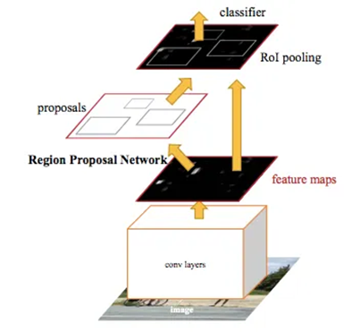

Fig 1: Faster R-CNN Architecture.

# METHODOLOGY – Stage 1

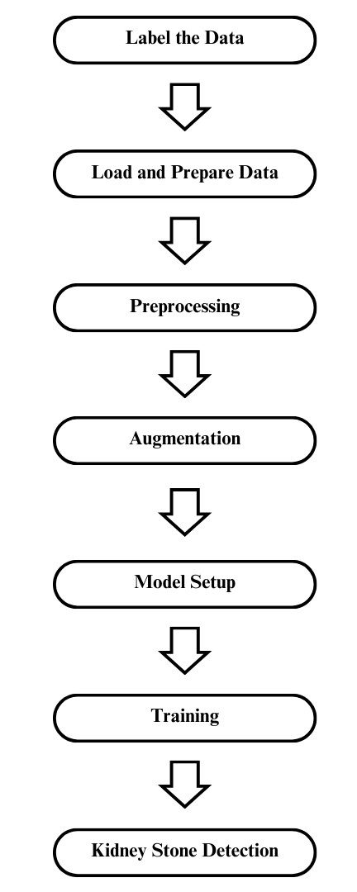

Fig 2: Block Diagram for Kidney Stone Detection.

Faster R-CNN is used in the process of Kidney stone Detection. This Algorithm gives us fast and precise classification and detection results. Fig 2 shows the stage-1 block diagram of kidney stone detection. Two-stage process in which first we will be classifying and identifying the two classes with kidney stones and the particular region where the stone is located images and without kidney stones.

Initially, the data set is loaded into the Image Labeler app in MATLAB. And the images are Labeled with bounding boxes. The data will be prepared after labeling the images in the format of a table in which 1st column contains the image paths and the 2nd column contains the bounding box details. That data will be split into training data, testing, and validation data. The training data will undergo both pre-processing and augmentation by which we can get better results for training data. The model will be set for training and the model will be trained with the given data. And detection results will be obtained.

# METHODOLOGY-STAGE 2

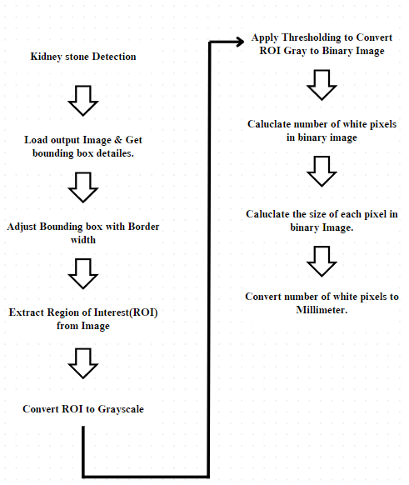

Fig 3: Block diagram for Kidney stone size detection.

1. LOAD OUTPUT IMAGE & BOUNDING BOX DETAILS

Load the Output image. We will get the bounding box details. Those details will be in the format of [x y width height]. This will store the bounding box coordinates. Where x and y will be the position of the box and width and height include the width of the box and height of the box. Store these box details.

1. ADJUST BOUNDING BOX WITH BORDER WIDTH

While cropping our region of interest from the image from the bounding box details we will get the yellow border which will create some disturbance for the quality and some chance of pixel value changes. So will create some border width to avoid false pixel values being read in that image. We will adjust according to that.

1. EXTRACT REGION OF INTEREST (ROI).

Apply the bounding box around the identified image to extract the area of interest from the image. Using the bounding boxes that have been adjusted using the border width coordinates, we will crop that ROI from the image.

1. CONVERT ROI TO GRAYSCALE.

By converting grayscale, we can simplify the computation time and we can get faster results when compared to rgb. And we can reduce the noise in the images and we can get the information easily without losing the information from the images.

1. CONVERT GRAYSCALE TO BINARY IMAGE.

The greythresh function in MATLAB calculates the threshold for converting grayscale images to binary using Otsu's method. The goal is to find the ideal threshold to distinguish foreground objects from the background. The binarize function converts grayscale images into binary images with pixel intensity between zero and 1, representing white pixels and black pixels respectively.

1. CALCULATE THE NUMBER OF WHITE PIXELS IN A BINARY IMAGE

For calculating the size of the stone we use this technique, pixel per ration which is calculating the number of white pixels by which we can get the particular area and size of the stone from that ROI image.

1. CALUCLATING THE SIZE OF THE EACH PIXEL.

By calculating the size of each pixel, we can get the total area of the white region which is the area of stone from the ROI image. If we have the size of the pixel, we can convert the number of white pixels into the size (millimeters). For every image, we will have a particular dpi value which is also called the resolution of the image. Based on that DPI the pixel size and values will be changing.

In our case, the data set we took had a DPI of 96px. From that, we can understand that we have 96 dots per inch in that image. From this if we convert that into millimeters.

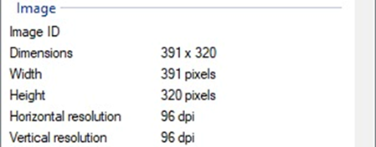

Fig 4: DOI info of Dataset

*Dpi is the pixel intensity or dots per inch.*

*96 dpi means there are 96 pixels per inch.*

*1 inch is equal to 25.4 millimeters.*

*1 inch = 25.4 mm*

*Dpi = 96 px / in*

*96 px / 25.4 mm*

*Therefore, one pixel is equal to*

*1 px = 25.4 / 96*

*1 px = 0.2645833 mm*

1. CONVERT THE NUMBER OF WHITE PIXELS TO MILLIMETERS.

If we convert the total number of white pixels millimeter value that we have calculated above, we will get the size of the stone. The stone's length and width. Using this information, we can determine the stone's length by counting the maximum number of wide pixels that each column in the binary image contains, and we can determine the stone's maximum width by counting the maximum number of white pixels that each column contains.

# RESULTS AND DISCUSSIONS

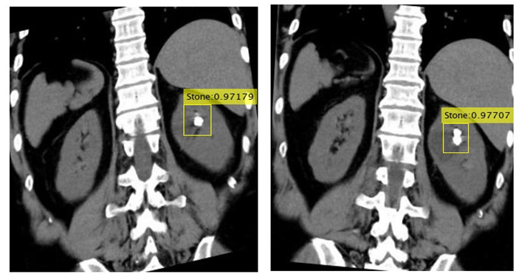

Fig 5: Kidney stone Detected Result

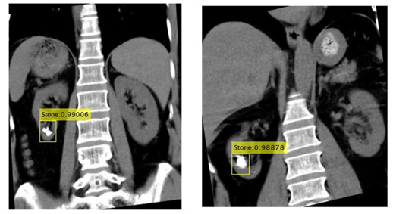

Fig 6: Kidney stone Detected Result.

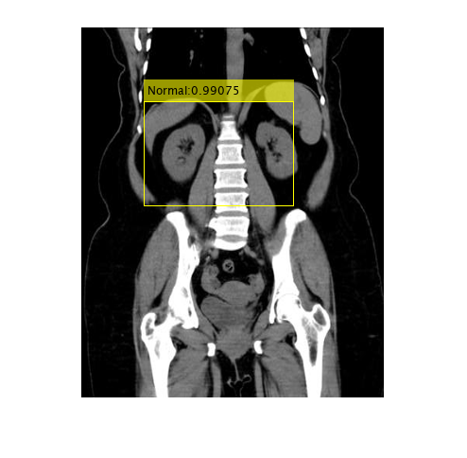

Fig 7: Normal Kidney Detected Result.

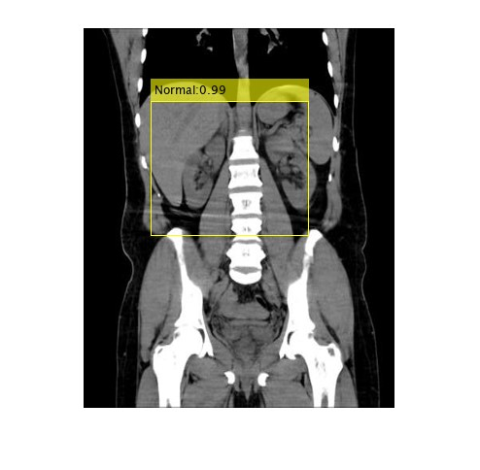

Fig 8: Normal Kidney Detected Result.

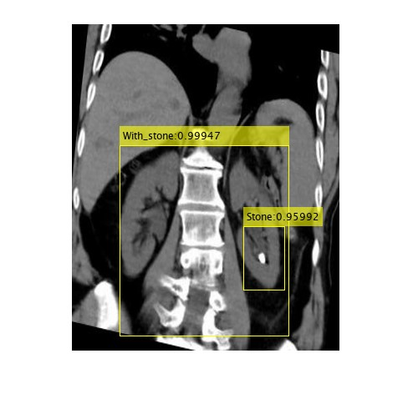

Fig 9: Kidney with stone and stone Detected Result.

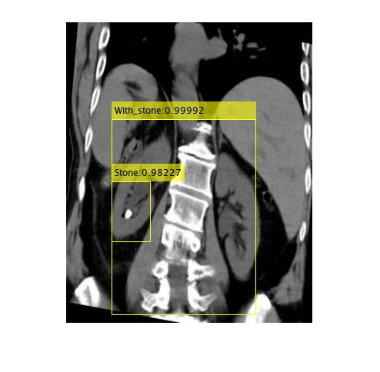

Fig 10: Kidney with stone and stone Detected Result.

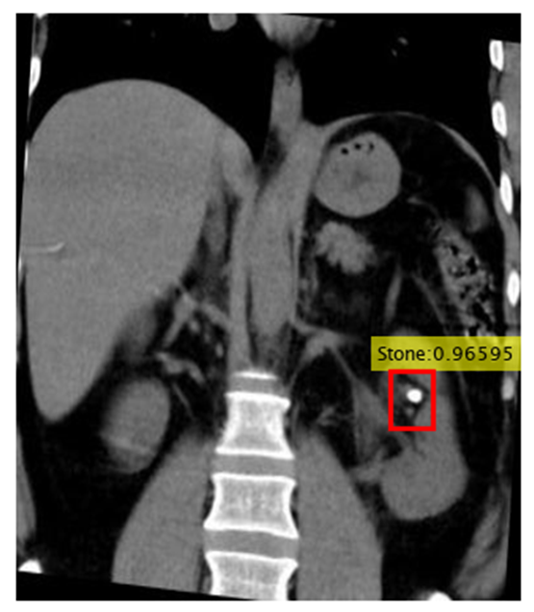

Fig 11: Image used for stone size detecting and a bounding box with stone detected.

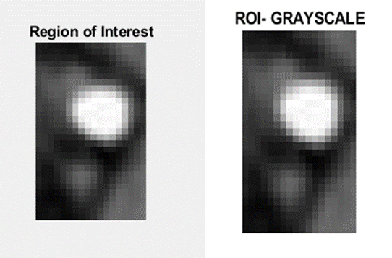

Fig 12(a): ROI cropped from the bounding box from the input image.12(b): Grayscale image of ROI.

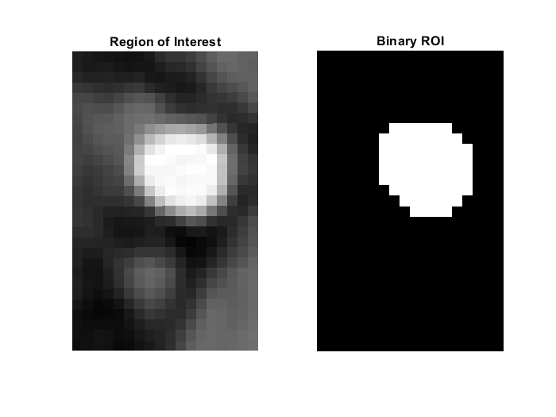

Fig 12: Grayscale ROI to Binary ROI

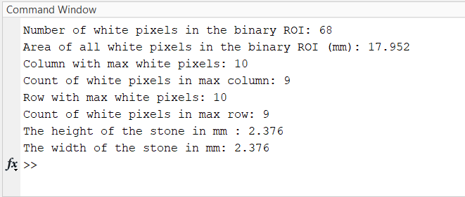

Fig 13: Size Detection and Conversion Results

# EVALUATION RESULTS

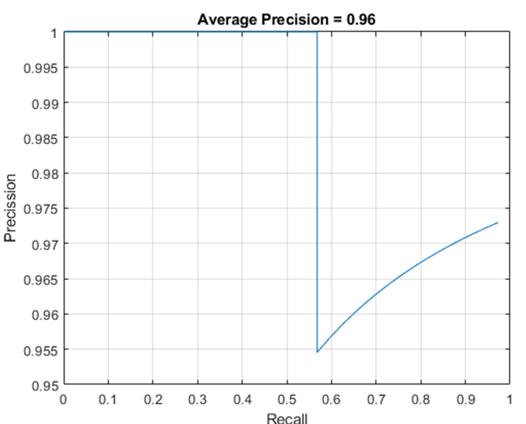

Fig 14: PR curve for Normal Class.

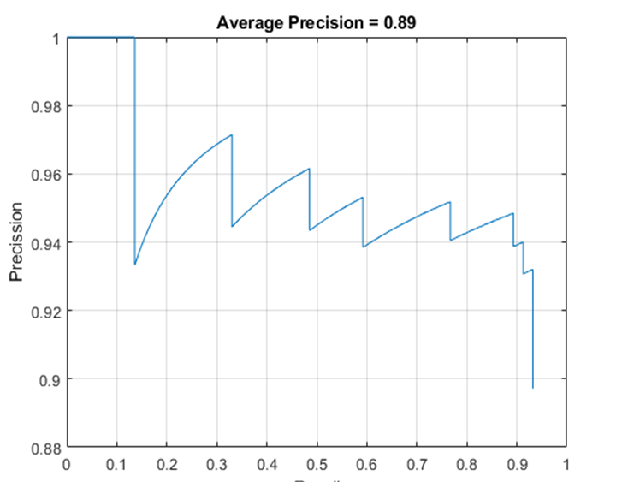

Fig 15: PR curve for Stone Class.

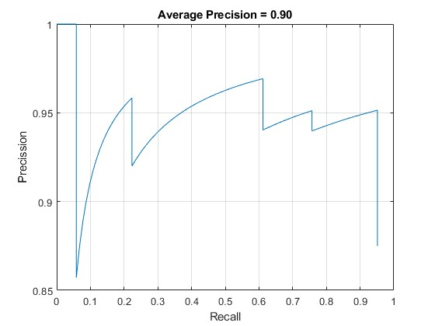

Fig 16: PR curve for with_stone Class.

# CONCLUSION

In this paper, Faster R-CNN is used to detect the kidney stones and size of the kidney stones in the CT scan images. And this is a two stage process which is kidney stone detection and other process is its size detection. This process helps us to find the precise size of the detected kidney stone. Faster R-CNN gives us a accurate and precise classification and also the detection resukts when compated to other because of the two stahe process which includes RPN and ROI pooling in the architecture. And the main advantage of using this model is it can classify and it can bale to detect even the small objects precisely and accurately.

# REFERENCES

1. Q. Rui, L. Sinuo, T. T. Toe and B. Brister, "Kidney Diseases Detection Based on Convolutional Neural Network," 2023 International Conference on Artificial Intelligence in Information and Communication (ICAIIC), Bali, Indonesia, 2023, pp. 508-513, doi: 10.1109/ICAIIC57133.2023.10067085.
2. Kristian, M, Black., Hei, Law., Ali, H, Aldoukhi., Jia, Deng., Khurshid, R., Ghani. (2020). Deep learning computer vision algorithm for detecting kidney stone composition. BJUI, 125(6), 920-924. doi: 10.1111/BJU.15035.
3. Depakkumar R and Suresh Annamalai. 2023. Image Processing Model-Based Kidney Diseases Detection System Using CNN. In Proceedings of the 4th International Conference on Information Management &amp; Machine Intelligence (ICIMMI '22). Association for Computing Machinery, New York, NY, USA, Article 33, 1–4. <https://doi.org/10.1145/3590837.3590870>.
4. Musa, Dima, Genemo. (2023). Kidney stone detection and classification based on deep learning approach. 7(4), 38-42. doi: 10.59287/ijanser.545
5. K, Anand, Kumar., M., Pradeepa., Miroslav, Mahdal., Shikha, Verma., M., V., Rajarao., Janjhyam, Venkata, Naga, Ramesh. (2023). A Deep Learning Approach for Kidney Disease Recognition and Prediction through Image Processing. Applied Sciences, 13(6):3621-3621. doi: 10.3390/app13063621
6. K. Arunkumar., S. Eshwar., D. Mohammed Saleem. and C. Vamsikrishna, "Implementation of Kidney Stone Detection using CNN," 2023 5th International Conference on Smart Systems and Inventive Technology (ICSSIT), Tirunelveli, India, 2023, pp. 1320-1324, doi: 10.1109/ICSSIT55814.2023.10061142.
7. S, A. A, G. S. S, M. P, M. M. M and B. K. N, "Investigation of Kidney Stone Detection using Image Processing," 2022 International Conference on Edge Computing and Applications (ICECAA), Tamilnadu, India, 2022, pp. 946-951, doi: 10.1109/ICECAA55415.2022.9936089
8. M. Akshaya, R. Nithushaa, N. S. M. Raja and S. Padmapriya, "Kidney Stone Detection Using Neural Networks," 2020 International Conference on System, Computation, Automation and Networking (ICSCAN), Pondicherry, India, 2020, pp. 1-4, doi: 10.1109/ICSCAN49426.2020.9262335.
9. H. Dave, V. Patel, J. N. Mehta, S. Degadwala and D. Vyas, "Regional Kidney Stone Detection and Classification In Ultrasound Images," 2021 Third International Conference on Inventive Research in Computing Applications (ICIRCA), Coimbatore, India, 2021, pp. 1108-1112, doi: 10.1109/ICIRCA51532.2021.9545031.
10. Daniel, C., Elton., Evrim, B., Turkbey., Perry, J., Pickhardt., Ronald, M., Summers. (2022). A deep learning system for automated kidney stone detection and volumetric segmentation on non-contrast CT scans. Medical Physics, 49(4):2545-2554. doi: 10.1002/mp.15518.
11. M., Zhang., Yu, Su., Xinping, Hu. (2023). Small target detection based on faster R-CNN. 12511:1251113-1251113. doi: 10.1117/12.2660388.
12. (2023). Real Time Object Detection Using Deep Learning. doi: 10.1109/vitecon58111.2023.10157311.
13. Abbas, Syed Mazhar, and Shailendra Narayan Singh. "Region-based object detection and classification using faster R-CNN." In 2018 4th International Conference on Computational Intelligence & Communication Technology (CICT), pp. 1-6. IEEE, 2018.
14. Ren, Shaoqing, Kaiming He, Ross Girshick, and Jian Sun. "Faster R-CNN: Towards real-time object detection with region proposal networks." IEEE transactions on pattern analysis and machine intelligence 39, no. 6 (2016): 1137-1149.
15. Cao, Changqing, Bo Wang, Wenrui Zhang, Xiaodong Zeng, Xu Yan, Zhejun Feng, Yutao Liu, and Zengyan Wu. "An improved faster R-CNN for small object detection." Ieee Access 7 (2019): 106838-106846