Name: Sheikh Hamad Yousaf
Roll No: 21-L-5176
BCS-6A
PDC Assignment 1



Q1)

Processor:
Intel Core i5-7300U CPU @ 2.60GHz
Processor Family:
Intel core
Vendor:
Genuine Intel
Vector Capabilities: SSE (Streaming SIMD Extensions),AVX (Advanced Vector Extensions),AVX2 (Advanced Vector Extensions 2),FMA (Fused Multiply-Add).
Number of cores:
2 (physical) 4(logical)
Number of hyper-threads:
Support 2 threads per physical cores hence total hyper threads are 4.
Amount of Ram Installed:
7.6 GiB
Type of hard disks:
NVMe SSD

Q2)
Execution times
Python code execution on (1024X1024)
Test case-1:
real 11m57.786s
user 11m16.473s
sys 0m2.370s
Test case-2:
real 9m55.511s
user 9m31.4693s
sys 0m0.804s
Test case-3:
real 12m35.401s
user 12m05.326s
sys 0m0.901s

Java Code execution on (1024X1024)
Test case-1:
real 0m57.010s
user 0m21.119s
sys 0m15.204s
Test case-2:
real 0m47.743s
user 0m16.464s
sys 0m11.671s
Test case-3:
real 0m46.353s
user 0m15.902s
sys 0m10.836s

C Code execution on (1024X1024)
Test case-1:
real 0m28.898s
user 0m6.516s
sys 0m0.244s
Test case-2:
real 0m28.989s
user 0m6.487s
sys 0m0.256s
Test case-3:
real 0m31.123s
user 0m6.774s
sys 0m0.310s

Part-2

List of vector instructions available:
SSE (Streaming SIMD Extensions),AVX (Advanced Vector Extensions),AVX2 (Advanced Vector Extensions 2),FMA (Fused Multiply-Add).

C Code using Vector-Instructions on (1024X1024):
Test case-1:
real 0m56.667s
user 0m18.380s
sys 0m0.489s
Test case-2:
real 0m51.336s
user 0m18.584s
sys 0m0.505s
Test case-3:
real 0m27.126s
user 0m11.694s
sys 0m0.340s

C Code using Multi-threading execution on (1024X1024):
Test case-1:
real 0m26.450s
user 0m11.713s
sys 0m0.340s
Test case-2:
real 0m26.980s
user 0m11.791s
sys 0m0.372s
Test case-3:
real 0m27.126s
user 0m11.694s
sys 0m0.340s

C Code using Multi-threading execution and Vector instructions on (1024X1024):
Test case-1:
real 0m27.861s
user 0m10.805s
sys 0m0.476s
Test case-2:
real 0m27.417s
user 0m10.588s
sys 0m0.580s
Test case-3:
real 0m28.166s
user 0m10.064s
sys 0m0.650s

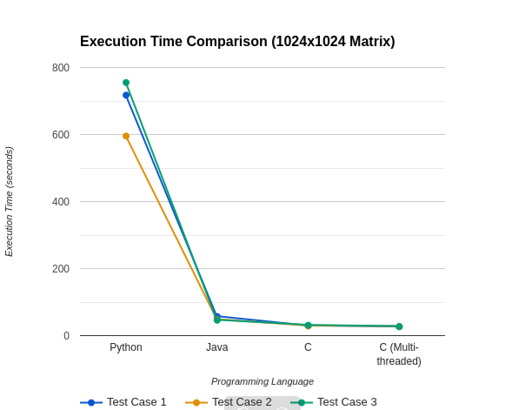

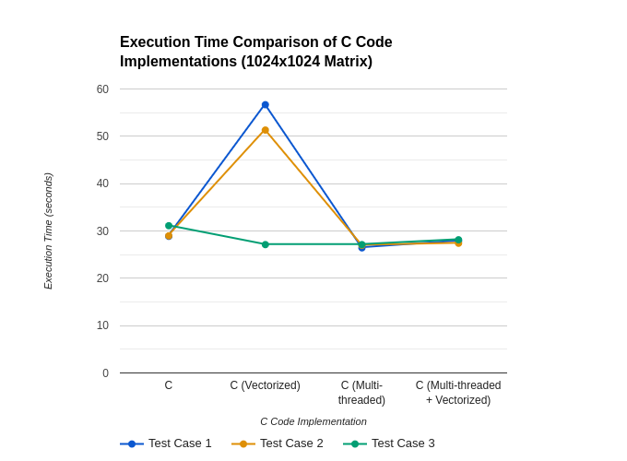

Q5)
a)
This assignment provided valuable insights into the performance differences between serial and parallel computation. The initial exercise involved implementing the same algorithm in three progressive stages moving from high to low-level language. Subsequently, we executed these implementations with identical input sets and compared their execution times. By analyzing the results, we were able to determine the programming language that yielded the most significant and minimal execution time. As expected, lower-level languages demonstrated a clear advantage in terms of execution speed. And then I learned how can parallel computation can result in a significant speed up (utilizing cores and running the codes in parallel and distributing the task by either fine-grained or coarse-grained).And I observed that multi threading results in a speedup then a simple c language code

b)
Maximum speed-up:
When talking about programming language then lower language provides you least time of execution as you have more control over the hardware and you can mold in a way to gain better efficiency and also from the above given execution time we affirms that C language gives to the most significant speed up rather then high level language and python takes most time of execution and then transitioning from lower-level language and converting it into parallel distributed code(multi-threading) gives you a speed up but that is not a significant as we have seen while moving from python to a C language code. Hence if I was given a single option I will definitely opt for changing the programming language.

c)

Plotting the graph shows that the overheads from the parallel code are causing the processor count to plateau when we substitute the language shift from vectors to multithreading to vector+multithreading.

