Name: Sheikh Hamad Yousaf
Roll No: 21-L-5176
BCS-6A
PDC Assignment 2



Part0)

Part1)

Normal C based execution time for 1024X1024 matrix size:

real: 0m6.125s
user: 0m6.040s
sys: 0m0.032s

C based execution time for 1024X1024 matrix size with OpenMP
Test Case-1

real: 0m3.297s
user: 0m10.346s
sys: 0m0.358s

Test Case-2

real 0m3.173s
user 0m10.339s
sys 0m0.033s

Part2)Using 8 core-machine

Test Case-1

real 0m2.095s
user 0m11.770s
sys 0m0.033s

Test Case-2

real 0m2.244s
user 0m11.890s
sys 0m0.037s

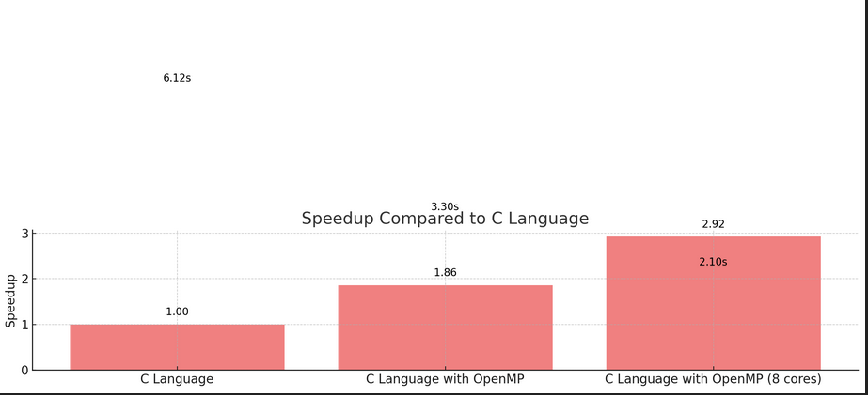
Data:
Model | Test Case 1 (s) | Test Case 2 (s) | Test Case 3 (s)
Python | 717.786 | 575.511 | 755.401
Java | 57.010 | 47.743 | 46.353
C (Simple) | 28.898 | 28.989 | 31.123
C (Vector) | 56.667 | 51.336 | 27.126
C (Multithreading) | 26.450 | 26.980 | 27.126
C (Multithreading + Vector) | 27.861 | 27.417 | 28.166
C (OpenMP) | 3.297 | 3.562 | 4.021
C (OpenMP, 8 Cores) | 2.095 | 2.805 | 2.041

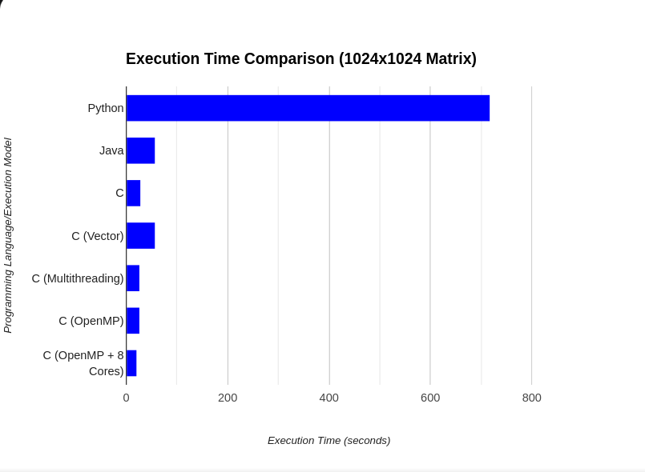

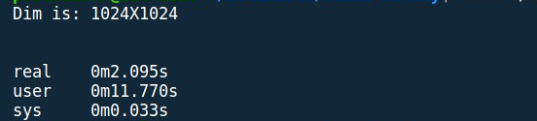

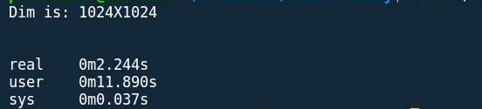
Part 3)



Part4 )

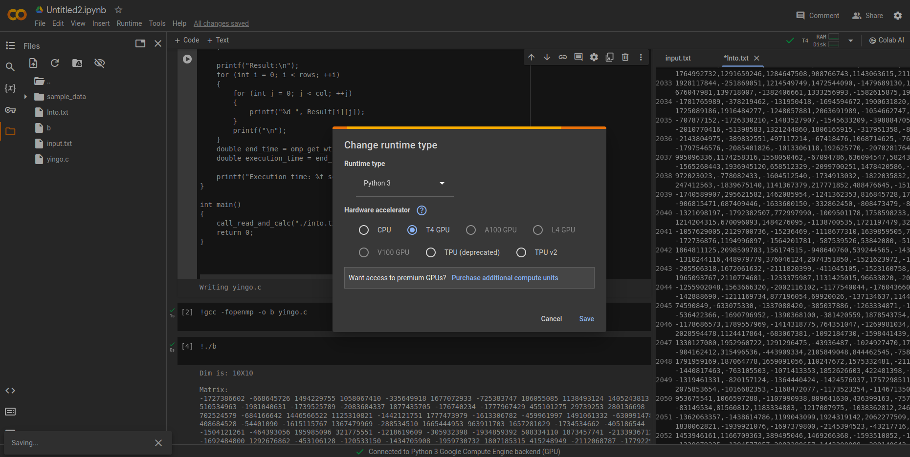

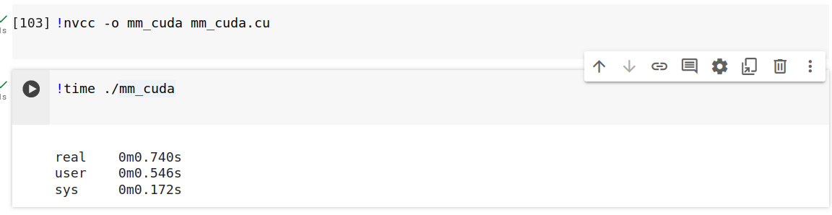

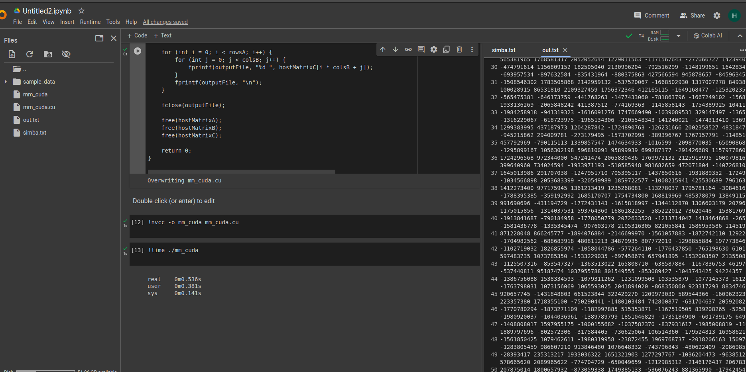
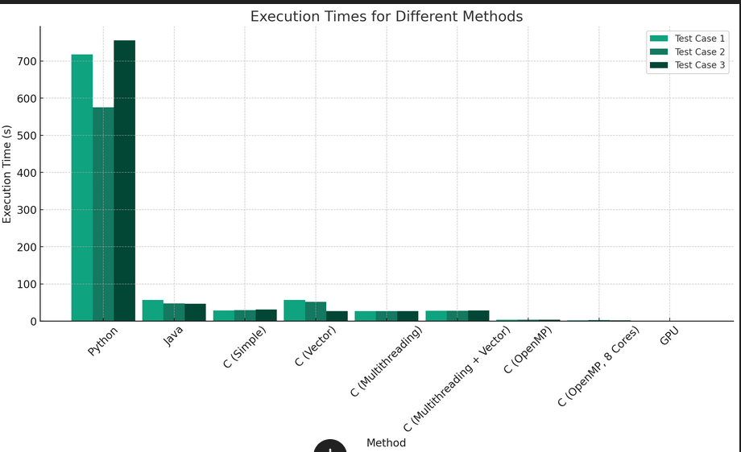

Part-4) TPU

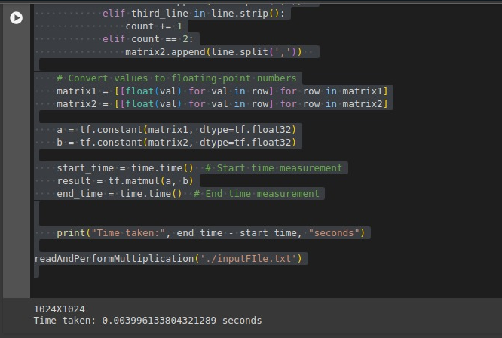

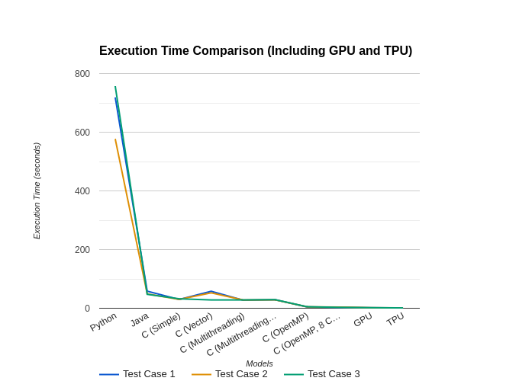

Part-5)

After running our matrix multiplication code and running out multiple test cases for the matrix size of 1024x1024 we can say that the most efficient and fast execution was carried out by TPU.
As TPU uses multiple cores on the backend and it introduces data locality which reduces its time from fetching the data from the memory and also TPU are really expensive and are designed for tasks like machine learning and deep learning and also TPUs have a specialized instruction set tailored for matrix operations. This allows them to perform these calculations with fewer instructions compared to a general-purpose processor like a CPU or a more programmable GPU. GPU also provided very less execution time and GPU may excel in some other work but TPU are designed in a way to carry out such task quickly and in case of openmp (8 cores) program we achieve a significant increase in the speedup then openmp with the cores of one’s laptop(4 in my case). But still TPU stands out the most in case for the speedup.

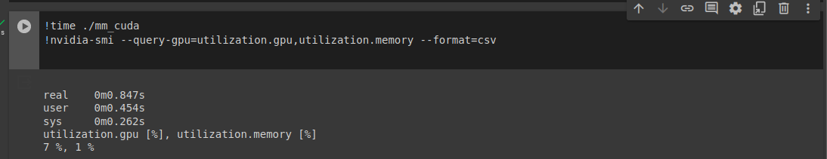
Part 6)

In case of OPENMP
Power usage: 15 W
Execution time: 3.2 s
Energy consumed: 48 J
Performance per watt=3.2/15=0.213333333
In case of GPU

Power usage: 70 W
Execution time: 0.740 s
Energy consumed: 51.8 J
Performance per watt=0.740/70=0.010571429
In case of TPU

Power usage:300 W
Execution time: 0.00399 s
Energy consumed: 1.197 J
Performance per watt=0.00399/300=0.000013
