Project Title: Real-Time Chat Application with Database-Driven Messaging System

Name: Hamad Tahir (solo)

Milestone | Version | Date | Remarks
ERD Diagram | 1.0 | 26/4/2025
Relational Database Schema | 2.o | 26/4/2025

- ERD
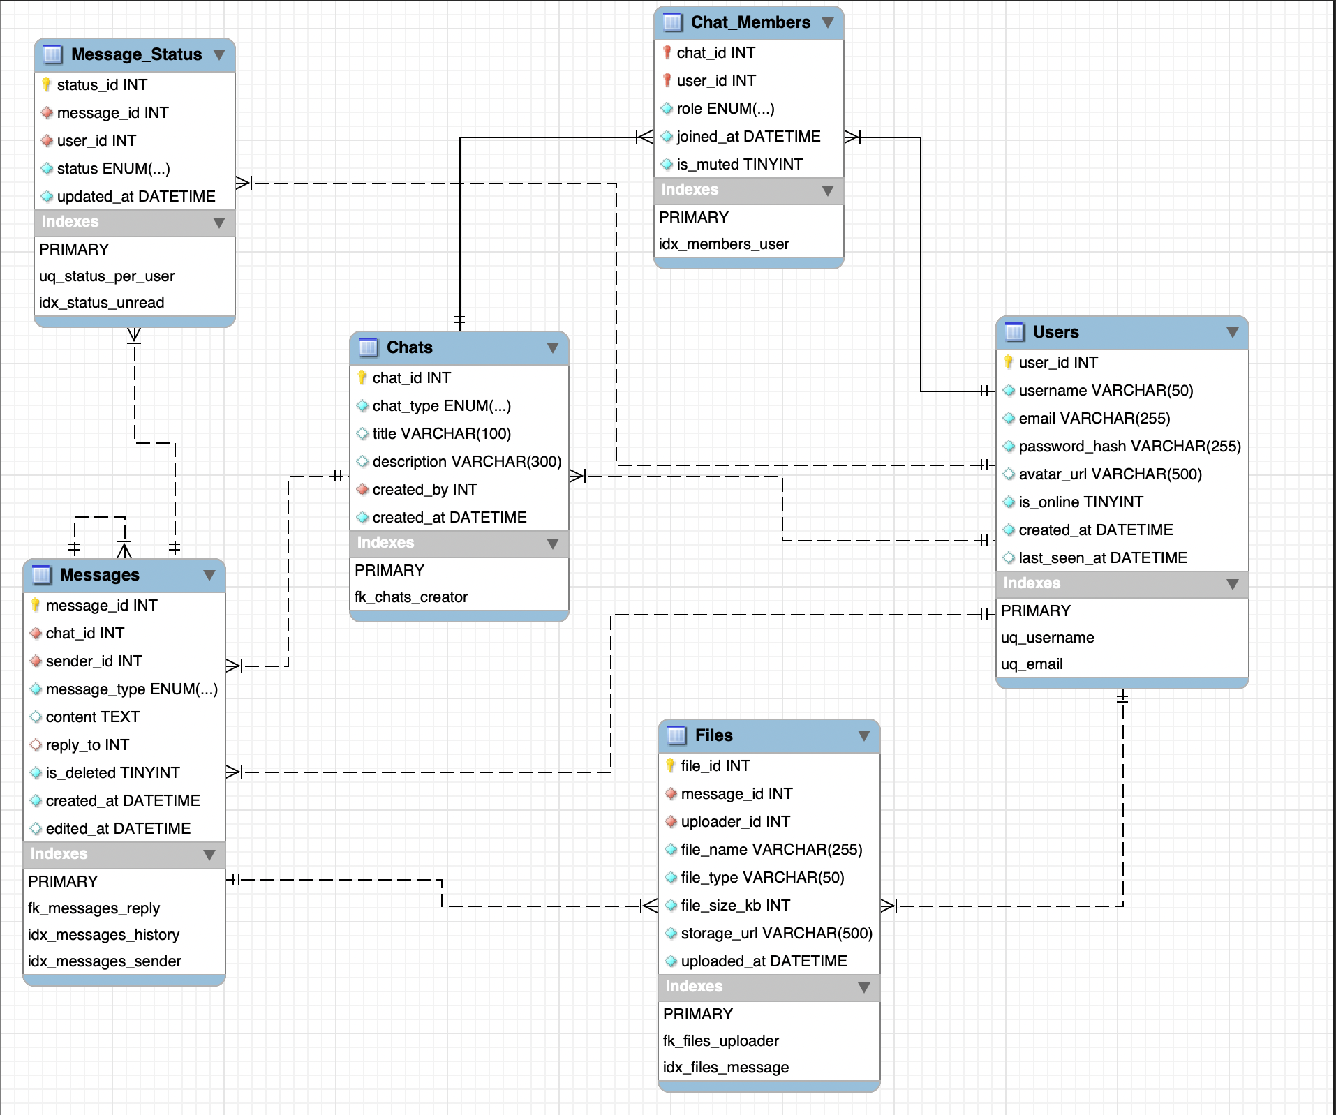

2. Tables, Attributes & Keys

2.1 Users
Stores registered user accounts. Each row represents one user identity used for authentication and display throughout the application.
Table: Users
Column Name | Data Type | Nullable | Key | Description
user_id | INT UNSIGNED | NOT NULL | PK | Auto-increment primary key
username | VARCHAR(50) | NOT NULL | UQ | Unique display name
email | VARCHAR(255) | NOT NULL | UQ | Unique email for auth
password_hash | VARCHAR(255) | NOT NULL |  | Bcrypt-hashed password
avatar_url | VARCHAR(500) | NULL |  | Profile picture URL
is_online | TINYINT(1) | NOT NULL |  | 1 = online, 0 = offline (default 0)
created_at | DATETIME | NOT NULL |  | Account creation timestamp (DEFAULT NOW)
last_seen_at | DATETIME | NULL |  | Last activity timestamp
Note: user_id is the system-wide identifier for every foreign-key relationship that references a person. Unique indexes on username and email prevent duplicate registrations.

2.2 Chats
A Chat is the container for a conversation — either a private (one-to-one) exchange or a named group. Actual participants are recorded in Chat_Members, not here.
Table: Chats
Column Name | Data Type | Nullable | Key | Description
chat_id | INT UNSIGNED | NOT NULL | PK | Auto-increment primary key
chat_type | ENUM('private','group') | NOT NULL |  | Conversation type
title | VARCHAR(100) | NULL |  | Group name (NULL for private chats)
description | VARCHAR(300) | NULL |  | Optional group description
created_by | INT UNSIGNED | NOT NULL | FK → Users.user_id | Creator/owner reference
created_at | DATETIME | NOT NULL |  | Chat creation timestamp (DEFAULT NOW)
Note: For private chats, title and description are NULL. created_by is a soft-ownership reference; full admin rules live in Chat_Members.role.

2.3 Chat_Members
The associative (bridge) table that implements the many-to-many relationship between Users and Chats. Each row records one user's membership in one chat, along with their role and mute preference.
Table: Chat_Members
Column Name | Data Type | Nullable | Key | Description
chat_id | INT UNSIGNED | NOT NULL | PK, FK → Chats.chat_id | Composite PK part 1
user_id | INT UNSIGNED | NOT NULL | PK, FK → Users.user_id | Composite PK part 2
role | ENUM('owner','admin','member') | NOT NULL |  | Member role (default 'member')
joined_at | DATETIME | NOT NULL |  | Timestamp when user joined
is_muted | TINYINT(1) | NOT NULL |  | Notification mute flag (default 0)
Note: The composite primary key (chat_id, user_id) prevents a user from being added to the same chat twice. The role column enforces admin/ownership rules at the data layer.

2.4 Messages
Stores every message sent in any conversation. Supports text, media, and file content types, as well as threaded replies via a self-referencing foreign key.
Table: Messages
Column Name | Data Type | Nullable | Key | Description
message_id | INT UNSIGNED | NOT NULL | PK | Auto-increment primary key
chat_id | INT UNSIGNED | NOT NULL | FK → Chats.chat_id | Chat this message belongs to
sender_id | INT UNSIGNED | NOT NULL | FK → Users.user_id | Sender reference
message_type | ENUM('text','image','file','system') | NOT NULL |  | Content type (default 'text')
content | TEXT | NULL |  | Message text body
reply_to | INT UNSIGNED | NULL | FK → Messages.message_id | Self-ref for threaded replies
is_deleted | TINYINT(1) | NOT NULL |  | Soft-delete flag (default 0)
created_at | DATETIME | NOT NULL | IDX | Send timestamp (indexed for history)
edited_at | DATETIME | NULL |  | Last edit timestamp
Note: is_deleted = 1 implements soft deletion — the row is retained for audit and reply-chain integrity. The composite index on (chat_id, created_at) is the primary performance optimization for paginated history queries.

2.5 Message_Status
Tracks the delivery lifecycle of each message per recipient. A single message in a group chat of N members will have up to N rows in this table, one per recipient.
Table: Message_Status
Column Name | Data Type | Nullable | Key | Description
status_id | INT UNSIGNED | NOT NULL | PK | Auto-increment primary key
message_id | INT UNSIGNED | NOT NULL | FK → Messages.message_id | Message reference
user_id | INT UNSIGNED | NOT NULL | FK → Users.user_id | Recipient reference
status | ENUM('sent','delivered','seen') | NOT NULL |  | Delivery state
updated_at | DATETIME | NOT NULL |  | Last status change timestamp
Note: The UNIQUE constraint on (message_id, user_id) ensures exactly one status record per user per message. Status values progress from 'sent' → 'delivered' → 'seen'.

2.6 Files
Stores metadata for file attachments linked to messages. Binary file content is held in external storage (local filesystem or cloud); only the reference URL and descriptive metadata are stored here.
Table: Files
Column Name | Data Type | Nullable | Key | Description
file_id | INT UNSIGNED | NOT NULL | PK | Auto-increment primary key
message_id | INT UNSIGNED | NOT NULL | FK → Messages.message_id | Associated message
uploader_id | INT UNSIGNED | NOT NULL | FK → Users.user_id | User who uploaded the file
file_name | VARCHAR(255) | NOT NULL |  | Original filename
file_type | VARCHAR(50) | NOT NULL |  | MIME type (e.g. image/png)
file_size_kb | INT UNSIGNED | NOT NULL |  | File size in kilobytes
storage_url | VARCHAR(500) | NOT NULL |  | Cloud/local storage path
uploaded_at | DATETIME | NOT NULL |  | Upload timestamp (DEFAULT NOW)
Note: A message can have multiple attachments (one-to-many). Storing only metadata, not file binaries, keeps the relational database lean and avoids BLOB performance issues.

2.7 Relationships
The table below summarises every foreign-key relationship in the schema. All foreign keys enforce referential integrity; deleting a parent row without first removing child rows will raise a constraint violation.

Parent Table | Child Table | Cardinality | Foreign Key
Users | Chats | 1 : N | Chats.created_by → Users.user_id
Users | Chat_Members | 1 : N | Chat_Members.user_id → Users.user_id
Chats | Chat_Members | 1 : N | Chat_Members.chat_id → Chats.chat_id
Users ↔ Chats | Chat_Members (join) | M : N | Composite PK (chat_id, user_id)
Chats | Messages | 1 : N | Messages.chat_id → Chats.chat_id
Users | Messages | 1 : N | Messages.sender_id → Users.user_id
Messages | Messages | 1 : N (self) | Messages.reply_to → Messages.message_id
Messages | Message_Status | 1 : N | Message_Status.message_id → Messages.message_id
Users | Message_Status | 1 : N | Message_Status.user_id → Users.user_id
Messages | Files | 1 : N | Files.message_id → Messages.message_id
Users | Files | 1 : N | Files.uploader_id → Users.user_id
Note: The Users ↔ Chats many-to-many relationship is fully resolved through the Chat_Members bridge table using a composite primary key.

2.8 Indexes & Performance Constraints
Beyond primary keys, the following indexes and unique constraints are defined to support common application query patterns efficiently.

Table | Column(s) | Index Type | Purpose
Users | username | UNIQUE | Enforce unique username; fast login lookup
Users | email | UNIQUE | Enforce unique email; fast auth lookup
Messages | chat_id, created_at | COMPOSITE | Paginated chat history (ORDER BY created_at)
Messages | sender_id | INDEX | Filter messages by sender
Chat_Members | user_id | INDEX | List all chats a user belongs to
Message_Status | message_id, user_id | UNIQUE | One status row per recipient per message
Message_Status | user_id, status | COMPOSITE | Filter unread messages for a user
Files | message_id | INDEX | Fetch attachments for a given message

