# **CP2406 – A1 – 13705002 – Ha Manh Cuong**

# **User Stories**

User Story 1

As for the user, update vehicle rate when I run simulation so that I can control how many vehicles should place on the road.

Priority is medium and estimate time is 2 days.

For the testing is click the update vehicle rate button to make vehicles faster or slower.

User Story 2

As for the user, I want to reload previous developed city to load simulation so that I can play simulation again with different situation like vehicles and rates.

Priority is low and estimate time is 1 days. Testing is press open button to access the saved city from database.

User Story 3

As for the user, I want to keep my developed city to use again later so that I make sure not to disappear all of changes for my customized city.

Priority is medium and estimate time is 2 days. For the testing, after changing the city, press the save button to save the city with name.

User Story 4

As for the user, I want to develop the simulator customization so I can edit the car, road and length for that.

Priority is high and estimate day is 3 days. For the testing, develop the new city map, add some street and run the simulation.

# **UML Diagram**

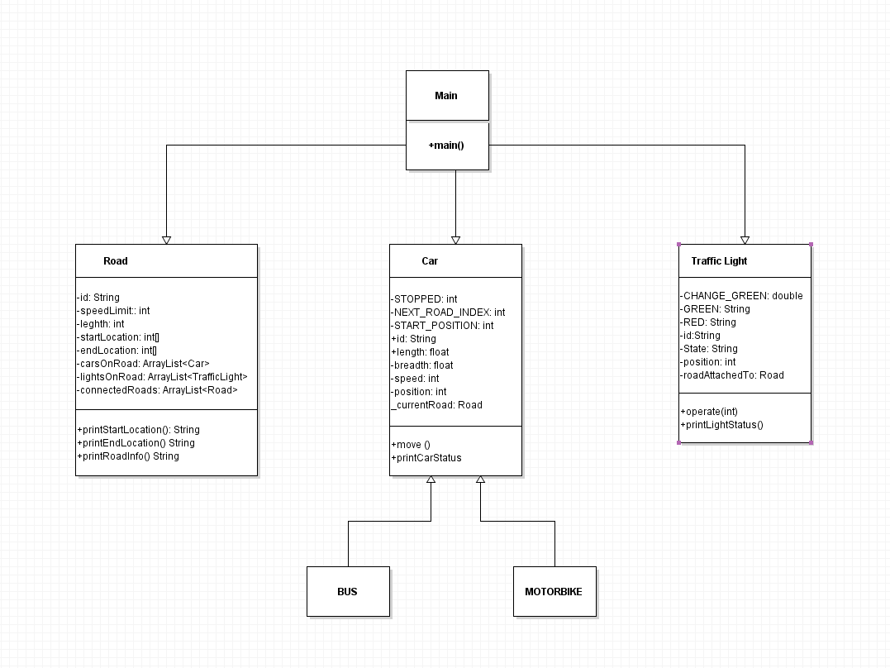

# **GitHub**