COMPANY CAPABILITY PROFILE

Know the ground.
Move with confidence.
Boundary, topographic and engineering surveys, GIS, remote sensing and spatial advisory for land, design, construction and asset decisions.
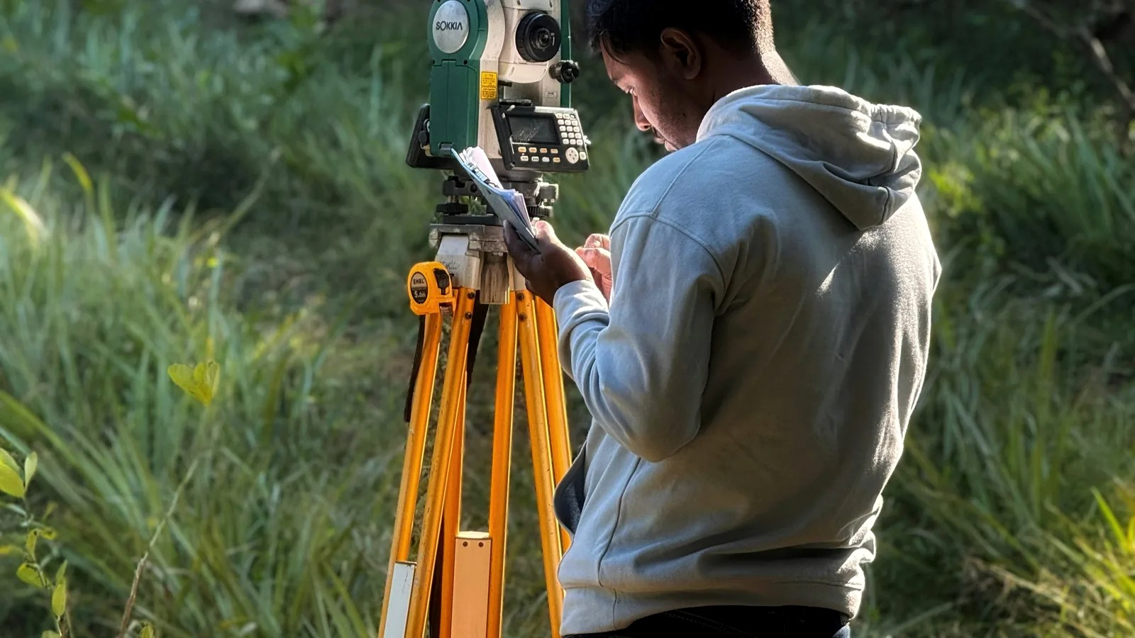
REGISTERED SURVEYOR  Hamid Adebare | CALL / WHATSAPP  +234 803 478 4082 | OPERATIONAL ADDRESS  Oke-Esa, Iseyin, Oyo State
Hambare Geosurveys Nig. Ltd. | RC 1530958

WHAT HAMBARE HELPS CLIENTS ACHIEVE

Survey information for the decision in front of you.
Start with the outcome you need. Hambare will help define the appropriate field requirement and deliverable.
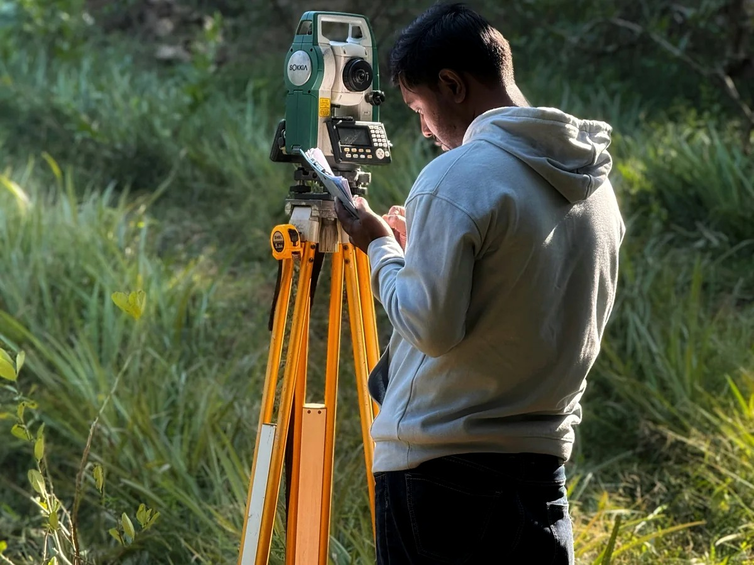 | BOUNDARY AND CADASTRAL SURVEY  Secure or clarify land  Establish parcel identity on the ground, review available survey information and support land documentation or boundary decisions.  Possible outputs: Boundary plan · coordinates · survey records

 | TOPOGRAPHIC SURVEY  Prepare a site for design  Capture terrain, levels and visible site features so architects and engineers can plan from measured conditions.  Possible outputs: Topographic plan · contours · CAD data

 | ENGINEERING SURVEY  Set out and verify construction  Transfer design positions and levels to site, establish control and record completed work.  Possible outputs: Setting-out data · checks · as-built records

 | GIS, MAPPING AND REMOTE SENSING  Map land, routes and assets  Organise locations, imagery and attributes into maps and datasets that are easier to understand and manage.  Possible outputs: GIS layers · maps · imagery products · analysis

SERVICES AND DELIVERY

From field measurement to information your team can use.
The scope is agreed around the project purpose, site conditions, reference requirements and expected output.
Boundary & cadastral survey  Parcel identification, boundary definition and survey records. | Topographic survey  Terrain, spot levels, contours and visible features.
Engineering survey  Setting out, control, level transfer, checks and as-built measurement. | GIS & spatial analysis  Maps, layers, databases and location-based analysis.
Remote sensing  Imagery-supported mapping, monitoring and area analysis. | Land & spatial advisory  Early-stage review of information gaps and suitable outputs.

How an assignment begins
1. Share the need  Location, purpose, approximate extent and available records. | 2. Agree the scope  Field requirement, deliverables, access, timing and commercial terms. | 3. Survey and process  Measurements, checks and data processing for the agreed purpose. | 4. Receive the output  Plans, coordinates, files or reports prepared for the next user.

Company and contact
REGISTERED SURVEYOR  Hamid Adebare | COMPANY REGISTRATION  Hambare Geosurveys Nig. Ltd. · RC 1530958
OPERATIONAL ADDRESS  Alhaji Balogun’s House, Oke-Esa, Iseyin, Oyo State | CALL / WHATSAPP  +234 803 478 4082
Representative industry photography is used for service illustration and is not presented as a Hambare project portfolio.

