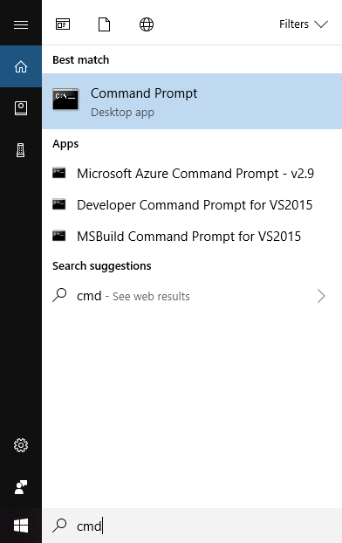

Figure 1 Command Prompt Search

To find the command in Windows, type cmd and select Command Prompt. Notice the directory. 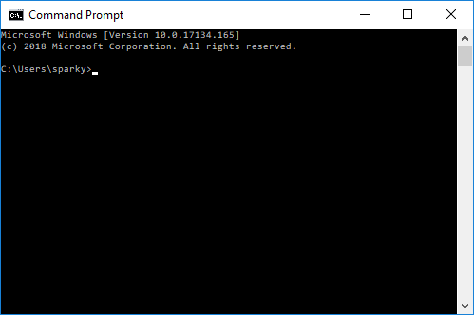

Figure 2 Command Prompt

This directory will be a good place to save your .java file

Using File Explorer, go to the directory you see. Mine is C:\Users\sparky. Yours will be something else.

Next, open a text editor of your choice. When I type text in Windows, WordPad and NotePad pop up:

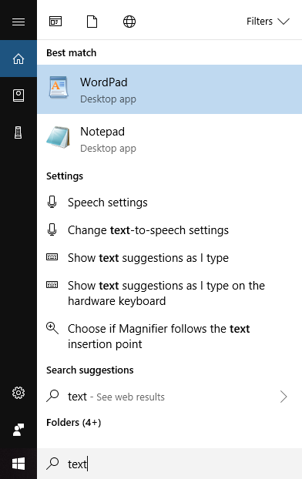

Figure 3 Text Editor

Let’s use NotePad.

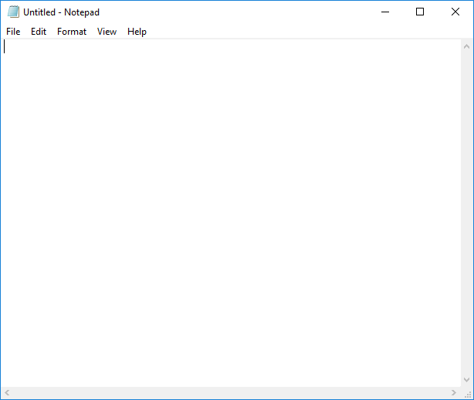

Figure 4 NotePad

Next, just type your java in the editor 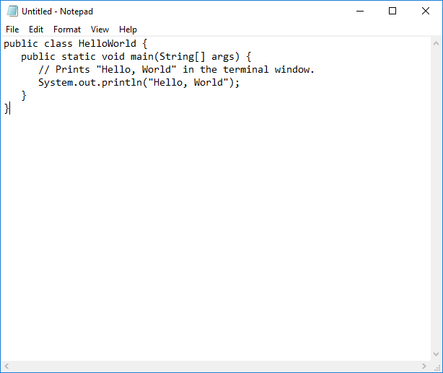

Select Save As under File, go to the directory in the Command Prompt. Mine was C:\Users\sparky. Save as type: All Files (*.*) and name it HelloWorld.java (this is important, it must be the same name you typed in the file after **class.**

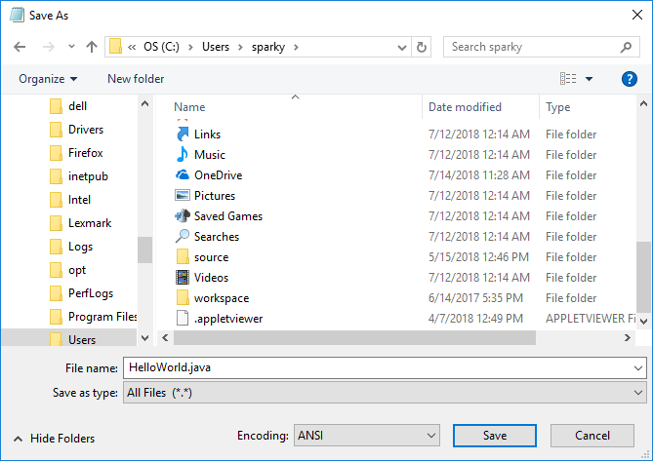

Figure 5 Save As ...

Next switch back to the Command Prompt and type

**javac HelloWord.java**

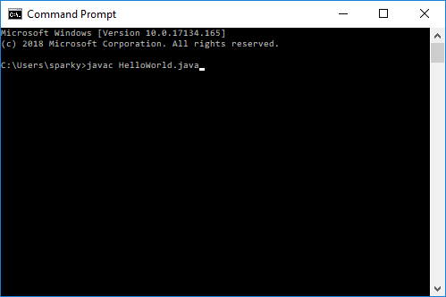

Figure 6 javac command

Press enter, to it appears nothing happened

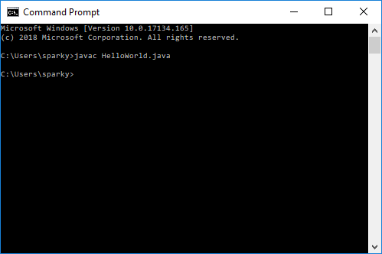

Figure 7 javac HelloWorld.java

Actually, an object file was created, looking in our file explorer, we see a **HelloWorld.class** file:

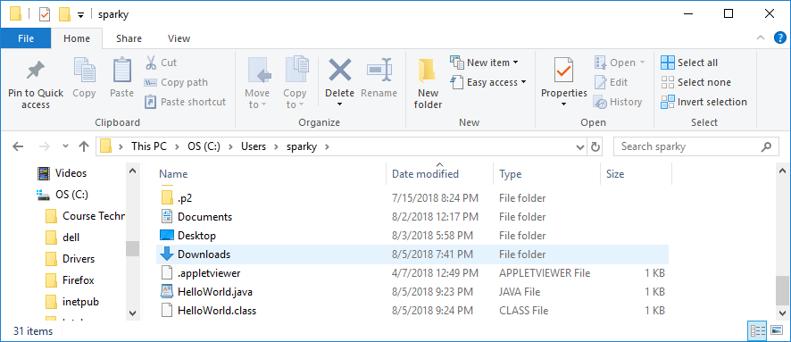

Figure 8 HelloWorld.class

Now we are ready to run our HelloWorld in the Command Prompt with the **java** command

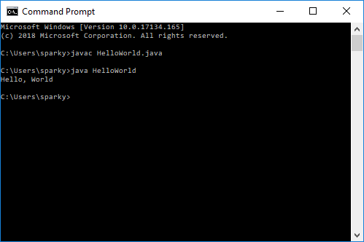

Figure 9 Excecuting java HelloWorld

Now you’re ready to write your own programs on the command line!