Submitting Assignments

Blackboard’s assignments feature allows the instructor to assign coursework for you to submit electronically. First, you need to locate the assignment. Your instructor will place assignments inside the respective week or unit folder in the Course Content area. Assignments have an icon that looks like a book over a sheet of paper. The requirements, instructions and other important information about the assignment will be displayed under the assignment title.

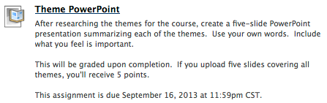

When you are ready to submit your assignment materials, open the assignment. Open it by clicking on the title of the assignment.

You are now in the upload assignment area where you attach and submit your materials. In section 1, you will see the assignment information again, which includes the name, instructions, due date and points possible.

Important: Once you’ve click on the assignment title and reached this screen, you must submit something. Do not use your browser’s back button to get out of the assignment. Most instructors only allow one attempt per assignment so submitting a blank assignment is something you want to avoid doing.

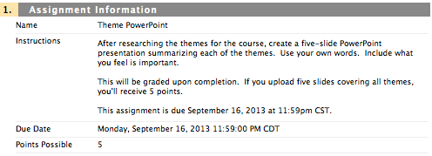

Blackboard provides two ways for you to give your instructor materials: attach a file or type in a submission box. Double check the assignment instructions, your syllabus or the course announcements before you type in the submission box. Most instructors will prefer or require that you attach a separate file rather than typing your paper in the submission box.

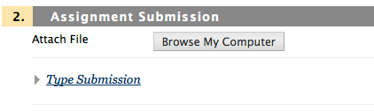

To attach a file, click the “Browse My Computer” button and locate the file on your computer.

Before you attach your file, make sure it is saved at a location where you can find it on your computer and that the file is closed. If your file name has a tilde at the beginning, your instructor will not be able to open it. Cancel the upload, minimize your browser window and close the file first.

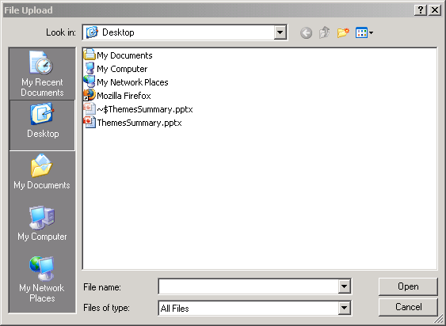

Also note that your file should not contain any special characters (~ , : ; “ + = % ‘ @ ! ? / { } [ ] \ ).

Select your file and click open.

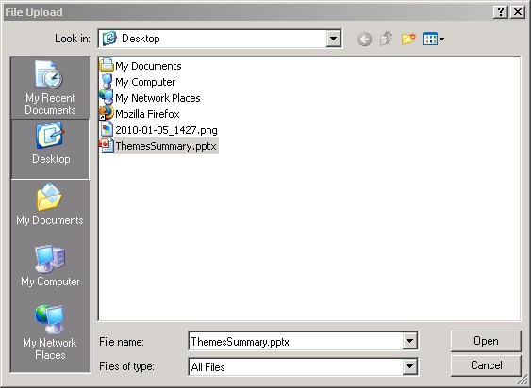

The file will be attached to the assignment. If the attached files line is blank, you have not attached a file for the assignment. You can add additional files by clicking the “Browse My Computer” button again. It will open the File Upload box again.

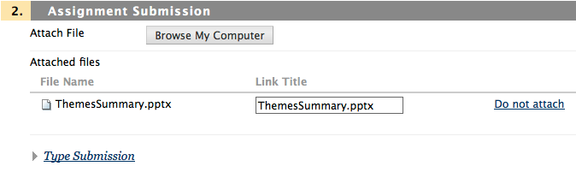

If you accidently attached the wrong file, click on the Do not attach link. You will receive a confirmation that you intended to delete the file.

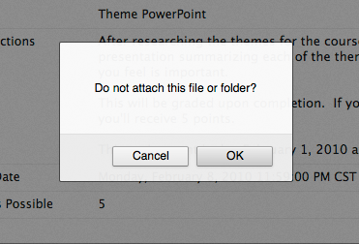

If your instructor asks you to type in the submission area, click the “Type Submission” line. This will extend the page and add a Text Editor for you to type in. The Text Editor has basic commands like Microsoft Office. Note that the button with “ABC” and a green checkmark provides spell check for your text entry. For ease of reading, do not change the font size, type or color unless necessary for your submission.

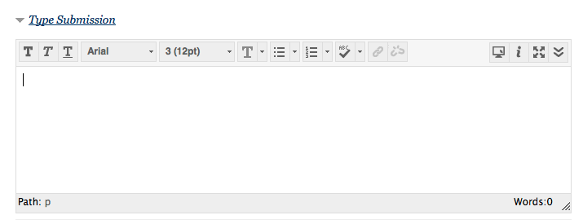

More editing options can be added, like subscript text, links, tables and other features by clicking the down arrows on the right of the text editor. It will add two more rows of buttons.

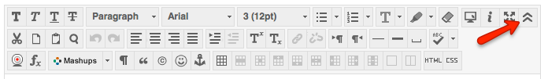

In section 3, you can add comments to your submission that you want your instructor to know. Note that this is not part of your submission.

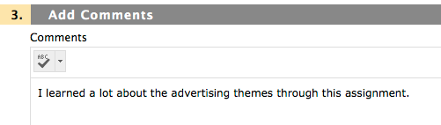

Once you have confirmed that the file(s) and text you want to submit is attached or included in the Type Submission area, click the Submit button.

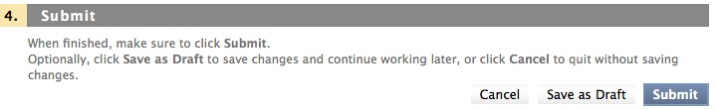

Blackboard will display a receipt showing the date and time you submitted your assignment. Under submission, you’ll also see any attached files or submission text provided.

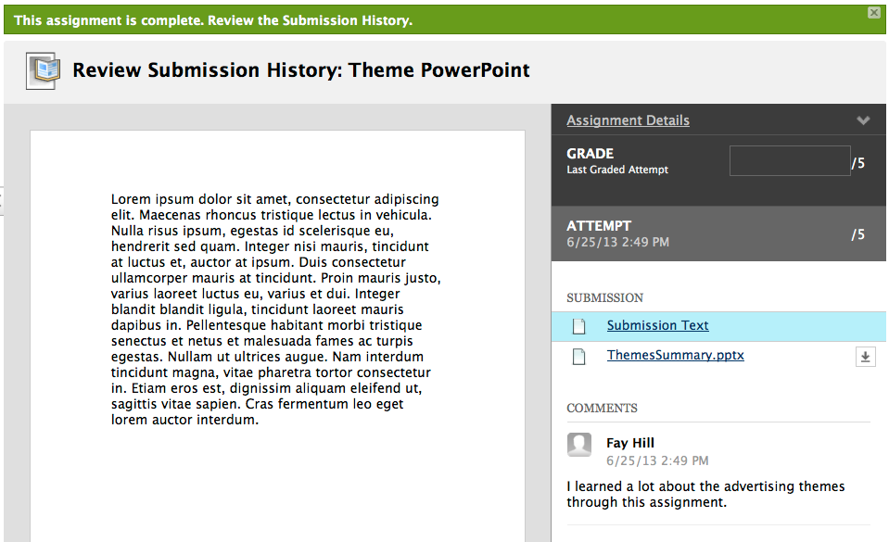

If the submission area is blank, this means that you did not include any submission items. Click on each of the submission items for a preview of the file or text. Click OK to close the receipt.

If you navigate to My Grades, you will now see that the assignment has been moved to a section called “Submitted”.

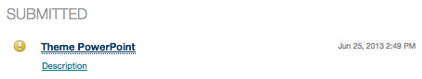

You can click on the title of the assignment to see your submission again. After your instructor grades your assignment, your score will be available in My Grades. Click Comments to view any feedback your instructor has left for this assignment.

