Creating a New Project  
Once you have Qt installed open Qt Creator.

Select File -> New File or Project... Then select Application -> Qt Console Application.

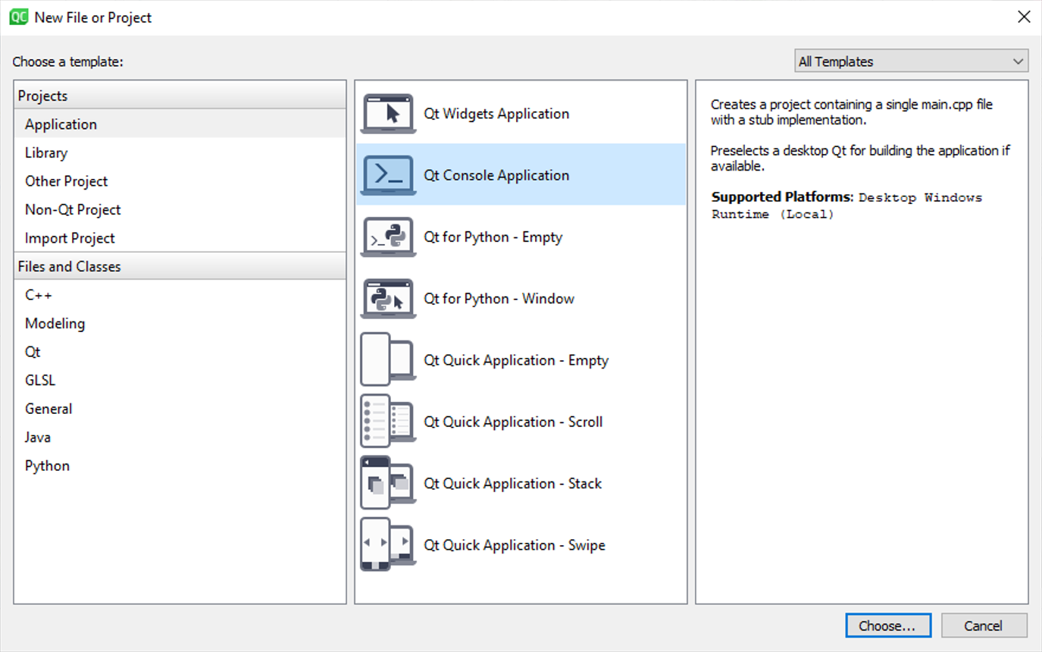

The new project will have a source code file called main.cpp that already contains some sample code, replace the sample code with the code shown below. Click on the green triangle "Run" button to compile and run the program. You should see a console window displaying the message "Hello, World!"

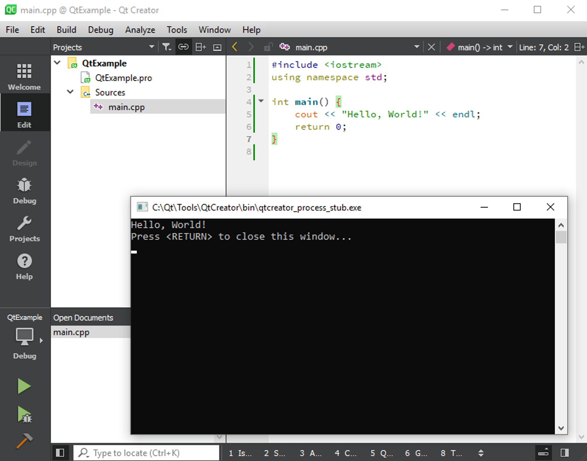

**What if there is no terminal?**

There have been some reports that the terminal does not show running an application. Here is how to fix that.

[https://forum.qt.io/topic/78732/run-os-console-instead-of-application-output-in-qt-creatorLinks to an external site.](https://forum.qt.io/topic/78732/run-os-console-instead-of-application-output-in-qt-creator)