Debugging Exercise – CIS 161  
Anthony Hamlin

Step 3 – locals window.  
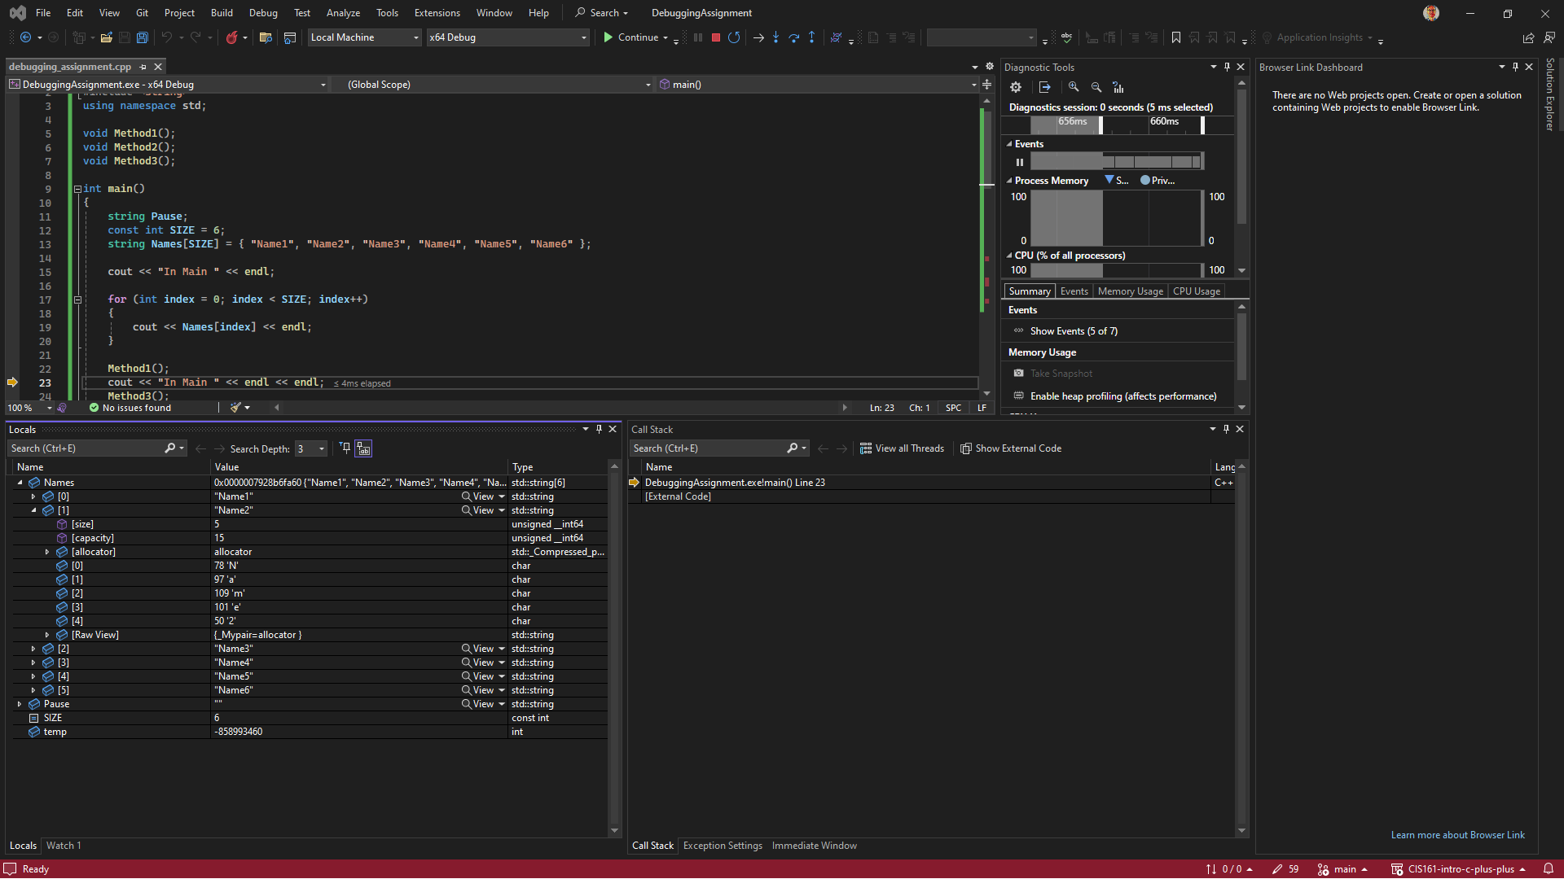

Step 4 – Pinned data item.  
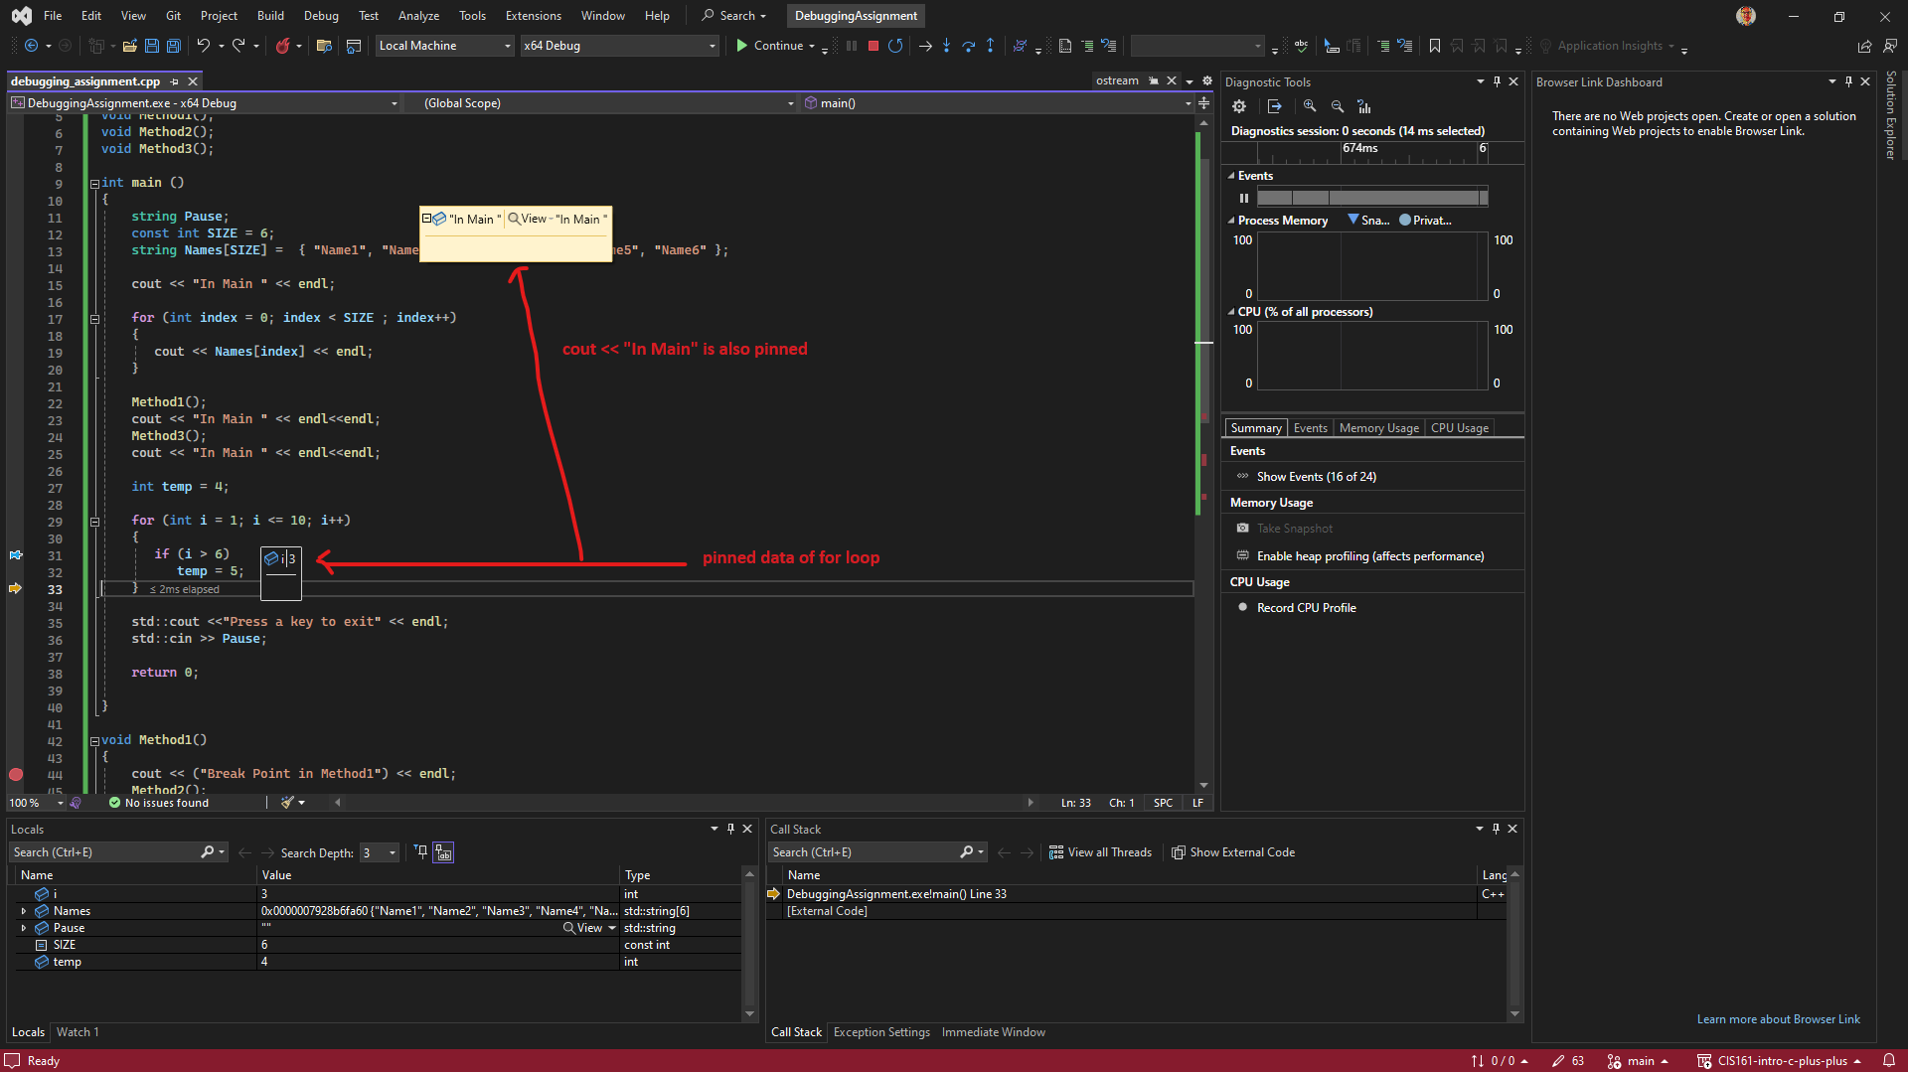  
  
Step 5 – Breakpoints  
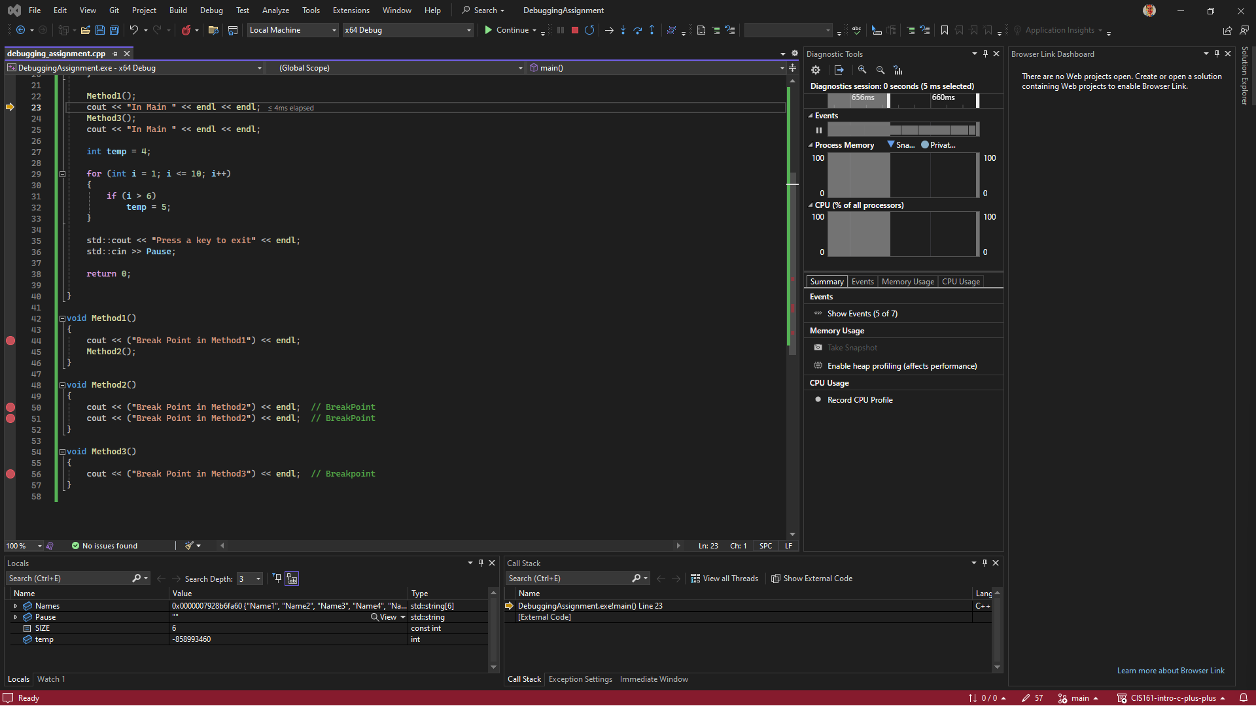

The most useful debugging strategy I will use will likely be a combination of breakpoints and the local/auto and watch windows.  
  
The difference of step into verses step over is that step into enters into the current line of code which can be your own code or other code being used within the code you are debugging and will require you to step out to get back “up” to the code you are actually debugging. Step over will execute the current line of code and move to the next line.