Debugging with Error Messages

**Due: Sun Feb 4, 2024 11:59pm**

Ungraded, 100 Possible Points100 Points Possible

**Details**

It is an important skill to be able to understand error messages. They may be intimidating at first but once you know the most common kinds of errors deciphering them becomes easier. Fix the code below and submit the following:

1. Submit the working code (only the .cpp file should be submitted). (50 points)
2. Explain what the following error messages mean, what kinds of mistakes in code cause them? Submit your answer as a separate file or as a comment in the code. (50 points)
   * expected unqualified-id
   * use of undeclared identifier 'xyz'
   * expected ';' after xyz

Here is a screen capture of the program.

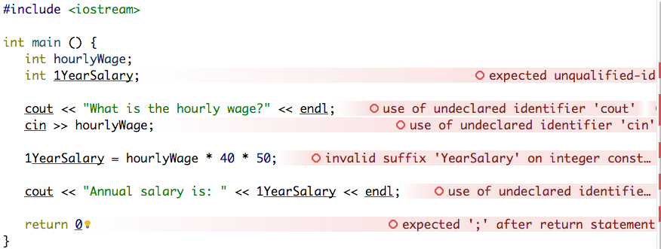

Here is the code that you can copy and paste.

#include <iostream>

int main () {

int hourlyWage;

int 1YearSalary;

cout << "What is the hourly wage?" << endl;

cin >> hourlyWage;

1YearSalary = hourlyWage * 40 * 50;

cout << "Annual salary is: " << 1YearSalary << endl;

return 0

}

**How to submit:**

Do not submit a zip file, do not submit all project files, only the .cpp file. It is easy! Just drag-and-drop from Qt Creator into the "Attach Files" panel as shown below. If you are unsure about this way of submitting files, now is a good time to ask for help, you will be doing this for the rest of the semester.

