Version Control

How do programmers all work on the same set of code? They can't email files back and forth. What if one of them deleted parts working code and wants to revert back the working version?

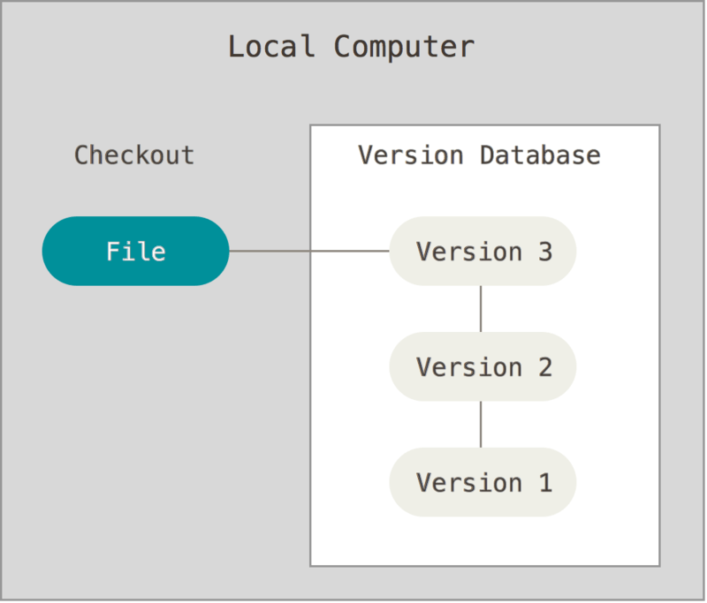

[Version controLinks to an external site.](https://g.co/kgs/F52Fyn)l is the answer! There are several version control opens. Two popular online ones with free versions include [githubLinks to an external site.](https://github.com/) and [bitbucketLinks to an external site.](https://bitbucket.org/?&aceid=&adposition=1t1&adgroup=55499736236&campaign=1407243035&creative=270062255977&device=c&keyword=bitbucket&matchtype=e&network=g&placement=&ds_kids=p33208860548&ds_e=GOOGLE&ds_eid=700000001551985&ds_e1=GOOGLE&gclid=EAIaIQobChMI0v-9_svZ3wIVhwFpCh3GKAu4EAAYASAAEgL5LfD_BwE&gclsrc=aw.ds). You will use github for this course and other DMACC CIS courses.

|  |  |
| --- | --- |
|  |  |

First, find your most professional personal email address (eg, michelle.ruse@gmail.com) and use it to create a [github Links to an external site.account  
Links to an external site.](https://github.com/profruse/)

Create your first repository, call it [CIS-161Links to an external site.](https://github.com/profruse/CIS-161/). 

