C/C++ Basic Arithmetic Operators

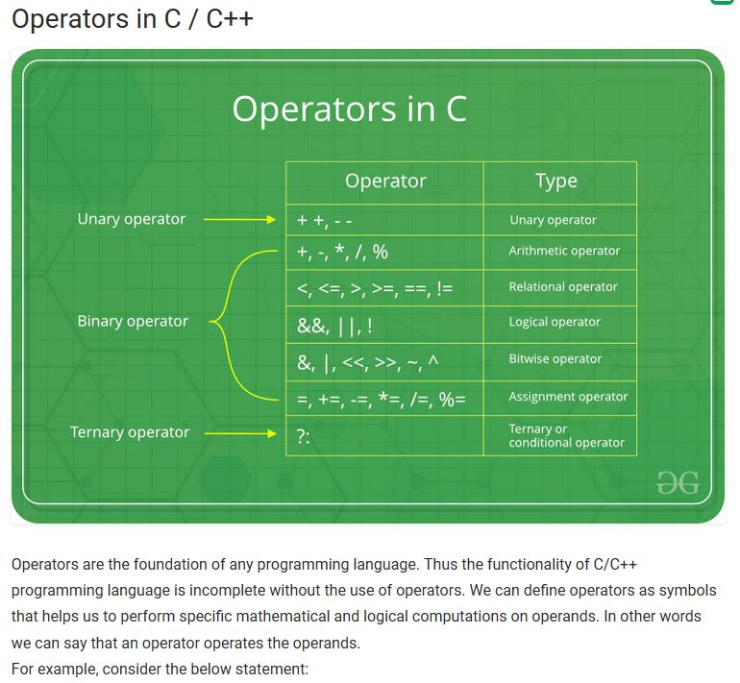

Unary operators require one operand. The increment and decrement operators are ++ and --.

|  |
| --- |
| int c = 5;  c++; // c is now 6 |

Binary operators require two operands.

|  |
| --- |
| int a = 5;  int b = -2;  int c;  c = a + b; // c is now 3 |

Ternary operators require three operands. (More the operation below when you learn **if** statements!)

|  |
| --- |
| int a = 7;  int b = -4;  int largest;  largest = ((a > b) ? a : b); // largest is 7 |