# Writing to the values of an array

We can assign values to the individual elements of an array by **indexing** the array.

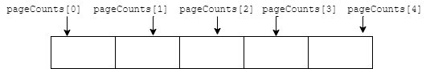

The first element of an array is located at index zero, here is how to assign a value to the first element of the array.

|  |
| --- |
| pageCounts[0] = 220; |

Here is a really powerful idea! Indexes don't have to be literal numbers like 10, we can also use a variable as an index.

|  |
| --- |
| int nextBook = 2;  pageCounts[nextBook] = 500; |

Also, we can use a mathematical expression as an index. Here is how to assign a value to the last element of an array by getting the size of the array using the size function. Think about why we have to subtract one from the size to get the last element of the array.

|  |
| --- |
| pageCounts[pageCounts.size() - 1] = 200; |

Now lets put what we learned in action with a complete code example that uses a variable as an index. The following code assigns every element of the array to the value 100.

|  |
| --- |
| #include <array>  using namespace std;  const int SIZE = 5;  int main() {    array<int, SIZE> pageCounts;    for (size_t nextBook = 0; nextBook < SIZE; nextBook++) {      pageCounts[nextBook] = 100;    }    return 0;  } |