# Multi-Dimensional Arrays

From the text:

C++ does not limit the number of dimensions that an array may have. It is possible to create arrays with multiple dimensions, to model data that occur in multiple sets.

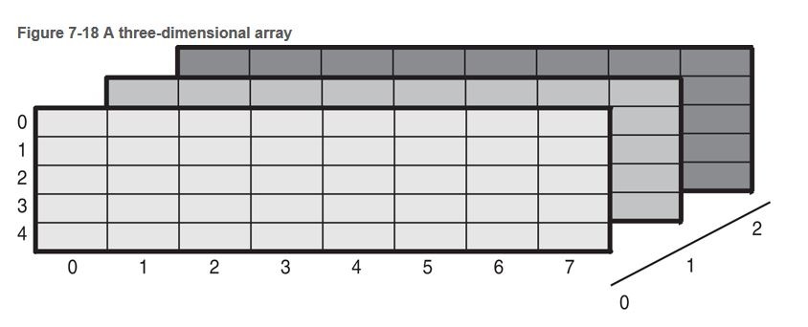

What might 4 or 5 dimensions be used to represent?