# Two-dimensional Arrays

Arrays can store a sequence of values, but what if we want a table of values? Introducing the two-dimensional array!

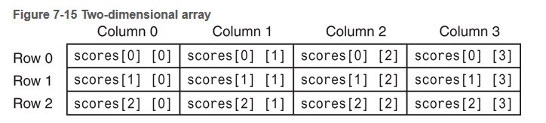

**Line 10** shows how a 2-dimensional array is declared, number of rows in the first bracket and number of columns in the second bracket