**Topic 2: Introduction to Programming**

Top of Form

Bottom of Form

**Content**

**Introductory Topics**

[Introductory Topics](https://dmacc.blackboard.com/webapps/blackboard/content/listContent.jsp?course_id=_102593_1&content_id=_7287063_1)

* + Four functions of a computer
  + Goal of a computer program
  + Console Application, Web Application, and Windows Forms Applications in C#
  + Components of an IDE (Integrated Development Environment)
  + Object-Oriented Programming
  + Software Development Process

**Four Functions of a Computer**

[Four Functions of a Computer](https://dmacc.blackboard.com/webapps/blackboard/content/listContent.jsp?course_id=_102593_1&content_id=_7287063_1)

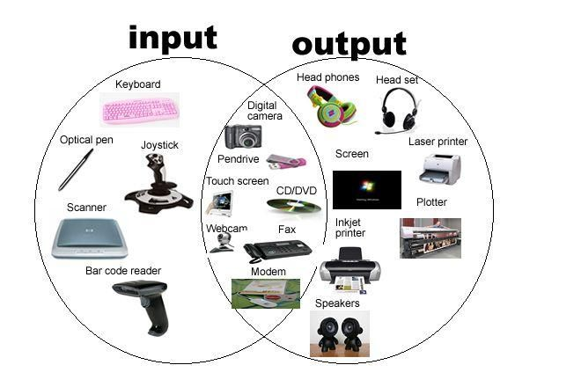

* + Input -- from a GUI, from a console, from a file, from a database query, a webpage, etc.
  + Store -- variables, file storage, save to a database, etc.
  + Process -- arithmetic operations, logic operations, decisions, etc.
  + Output -- to a GUI, to a console, to a file, to a database, to a webpage, etc.

Think of anything you can do with a mobile app on your phone (this is an application), a video game you may play, software you might use on a computer, the card reader at store checkout lines, or any other software application. Can you categorize that action into one of the 4 functions listed above?

Discussion: Can you think of Input, Storage, Processing, Output not listed? On the Weekly discussion board talk to your instructor and classmates about other possibilities. The easy ones are listed, be creative.

**Goal of a computer program**

[Goal of a computer program](https://dmacc.blackboard.com/webapps/blackboard/content/listContent.jsp?course_id=_102593_1&content_id=_7287063_1)

All computer programs written and any one you will write (and you will write many small programs in this course!) have one purpose. Can you guess?

***It is to solve a problem***.

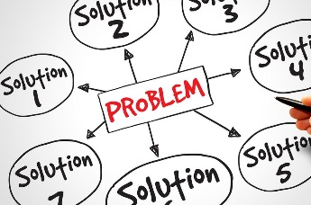Examples

* + An algorithm to solve a mathematical problem (compute the circumference of a circle, given its radius),
  + Make life easier (your calendar app on your phone)
  + Automate a business process (paperless billing)
  + ...
  + and many more!

The heart of it is solving a problem. In automating a business process, you may actually help find a more streamlined process, help in speed of the process or help in convenience of the process. There often different solutions for a problem. In writing a computer program, the "correct" solution will be the one the customer (end-user)wants and will use. Often it is a difficult process to figure out what exactly the end-user wants and what they will use. In this course, the instructor acts as the end-user/customer, providing "business requirements" and specifications for programs. This includes names, structures, desired input and output. Please pay attention to and follow the directions for each program as you are learning programming concepts. This is helping to prepare you for following the business requirements in a programming team one day!

**C# Console Applications**

[C# Console Applications](https://dmacc.blackboard.com/webapps/blackboard/content/listContent.jsp?course_id=_102593_1&content_id=_7287063_1)

***What is a Console App?***

Before you learn about a Console App, you need to know what an ***IDE*** is. It is an ***Integrated Development Environment***. It is a software that helps you write code. An IDE integrates, writing, debugging, testing and running your code.

* + - Detects syntax errors
    - Debugging code
    - Code execution (run) your code, allows you to debug your code
    - Connection to code repositories (such as [github](https://github.com/))
    - Create and run Unit Tests (more on that later!)
    - and many more exciting features!

In running and debugging your code in an IDE, you get access to the console. The console allows your code to output messages, results, prompts for user input, strings, numbers, etc. The console also allows for user input. The user in this case is you, since you are the developer testing and debugging your code. You might here it called a terminal or command line. See the image below for our Visual Studio Console, it pops up as a separate Console Window when you run the program:

**C# Web Application**

[C# Web Application](https://dmacc.blackboard.com/webapps/blackboard/content/listContent.jsp?course_id=_102593_1&content_id=_7287063_1)

***What is a Web App?***

A Web Application is type of software that uses Web browsers as its interface and Web servers for execution. Users access and use a Web App via the internet. More on Web Apps later in the semester and in Advanced C#!

Below is an image from Microsft's tutorial [NerdDinner](https://docs.microsoft.com/en-us/aspnet/mvc/overview/older-versions-1/nerddinner/introducing-the-nerddinner-tutorial).

**C# Windows Forms Applications**

[C# Windows Forms Applications](https://dmacc.blackboard.com/webapps/blackboard/content/listContent.jsp?course_id=_102593_1&content_id=_7287063_1)

***What is a Windows Forms App?***

Visual C# Windows Forms Applications provide an easy GUI building component. GUI stand for Graphical User Interface. This allows a graphical interface for a user to input, the program to output any information that might be stored or process by a computer program. Buttons, labels, text boxes, radio buttons, database connections are all available to drag and drop. Though this is an easy way to build an application, Console and Web Apps are more prevalent in industry. Windows Forms are reminiscent of Visual Basic Applications. For a small, stand alone App for personal use, a Windows Forms App might be the right tool for the job. You will not be covering Windows Forms in this class, but could teach yourself once you learn the basics of C#!

**NOTE: Planting seeds!**

[NOTE: Planting seeds!](https://dmacc.blackboard.com/webapps/blackboard/content/listContent.jsp?course_id=_102593_1&content_id=_7287063_1)

Some topics in the folder are for future learning, just an introduction, for example OOP (Object-Oriented Programming). Sometimes it's nice to see the big picture; sometimes it's nice to hear about concepts a few times before learning them. You do not need to understand in depth all about OOP and the SDLC presented here. These are seeds for future learning.

**Object-Oriented Principles**

[Object-Oriented Principles](https://dmacc.blackboard.com/webapps/blackboard/content/listContent.jsp?course_id=_102593_1&content_id=_7287063_1)

The goal of a computer program is solve a program. Solving problems in the real world means modeling the real world in code. The world is full of objects. Computers, houses, animals, people, plants, and so many more objects are found all around.

If you wanted to build a house, you would need a blueprint. If you wanted to make several houses, you could use the same blueprint if the houses were all going to be the same.

Source: [*https://docs.microsoft.com*](https://dmacc.blackboard.com/webapps/blackboard/content/%22https:/docs.microsoft.com/en-us/dotnet/csharp/programming-guide/classes-and-structs/classes)

The idea behind Object-Oriented Programming (OOP) is just as it sounds. Create programs based on objects. That blueprint you had could be consider a class and the actual house could be considered an object. All the houses you build with that blueprint are also objects.

You will learn to program using objects later in this course. You will first create your class, then utilize that class to create objects.

The four pillars of OOP

* + Encapsulation
  + Polymorphism
  + Inheritance
  + Abstraction

You do not need to worry about these concepts just yet, but a sneak peek is always fun.

**Software Development Life Cycle**

[Software Development Life Cycle](https://dmacc.blackboard.com/webapps/blackboard/content/listContent.jsp?course_id=_102593_1&content_id=_7287063_1)

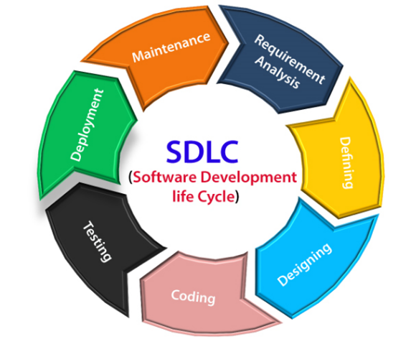The Software Development Life Cycle (SDLC) describes the steps in designing, developing, testing, deploying and maintaining software. It covers the proposal (requirements analysis) to the end of life (sunsetting) of the software. There are a variety of methodologies than can be incorporated into the SDLC of a software. Different companies may adjust this process to meet the needs of the their culture and the type of software application being developed.

Reading:

* + [SDLC tutorialspoint.com](https://www.tutorialspoint.com/sdlc/index.htm)
  + [SDLC geeksforgeeks.com](https://www.geeksforgeeks.org/software-development-life-cycle-sdlc/)
  + [Mobile SDLC docs.microsoft.com](https://docs.microsoft.com/en-us/xamarin/cross-platform/get-started/introduction-to-mobile-sdlc)

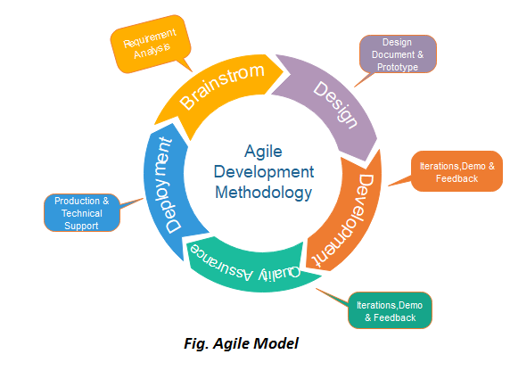

Agile is one type of Methodology used in industry, particularly newer companies and starts. Established companies often adopt Agile methodologies as well.

**What types of Applications will you write?**

[What types of Applications will you write?](https://dmacc.blackboard.com/webapps/blackboard/content/listContent.jsp?course_id=_102593_1&content_id=_7287063_1)

In C#, when using your IDE Visual Studio, you will see many choices for the type of applications you may want to build. There are Console Applications, Web Forms Applications, Window Forms Applications, among others. In this course you will be creating Console Applications mainly and and an introduction Web Applications to create a GUI. Your final project will be a Web App. The advanced course, CIS 174 Advanced C# uses Web Forms.

Additional topics you will be introduced in your IDE as project options include ASP.NET Core and .NET Core MVC. These you will learn more about after mid-way through the semester and will serve as a launch point into Advanced C#, where you will use .NET Core to build Web Forms Applications in a team-based environment. In this course it is important to do all your own projects, including our final project at the end of the semester, and learn the foundations. It is okay to study in groups, ask questions in the discussion boards, but when it is time to write code you will need to be writing it on your own.

You will learn Unit Testing and discuss the idea of Test-Driven Development. As a computer programming part of coding is also testing your code, Unit Tests provide coded tests to minimize manual testing and help catch edges cases in testing. More on that later, but you can do an Internet search at any time on anything interests you.

**How can you be successful in this course?**

[How can you be successful in this course?](https://dmacc.blackboard.com/webapps/blackboard/content/listContent.jsp?course_id=_102593_1&content_id=_7287063_1)

Be sure to check Blackboard and your dmacc.edu email for announcemnts. When you have questions, reach out on the discussion board or via email. Also, check out the Course Success Toolkit folder under Course Content. It has importmant information, such as requirements for assignments, how to turn in assignments (what files should you turn in?), and various tips that useful throughout the semester. The Academic Honesty Header that you will be asked to copy and personalize in the quiz below can be found in Course Success Toolkit.

[**Introduction to C#**](https://dmacc.blackboard.com/webapps/blackboard/content/launchAssessment.jsp?course_id=_102593_1&content_id=_7287093_1&mode=view)

This quiz has 2 attempts, it is not timed.

**Learning to Code with your Best Friends**

[Learning to Code with your Best Friends](https://dmacc.blackboard.com/webapps/blackboard/content/listContent.jsp?course_id=_102593_1&content_id=_7287063_1)

As a programmer your two best friends are Google (<http://lmgtfy.com/>) and stackoverflow ([https://stackoverflow.com](https://stackoverflow.com/)/) Be careful on stackoverflow, the first code snippet you see is the question, non-working code and the subsequent snippets are ***possible*** answers.

For example, if you Google "How to Install Visual Studio" the first link might take you to Microsoft's instructions:

<https://docs.microsoft.com/en-us/visualstudio/install/install-visual-studio>

Or, if you Google, "How do I print the contents of an array in C#?" you may see stackoverflow.com as a result

[https://stackoverflow.com/questions/16265247/printing-all-contents-of-array-in-c-sharp](https://stackoverflow.com/questions/30413683/console-writeline-basics)

The first snippet is the question, not a ***possible*** answer:



You can scroll for one or more ***possible*** answers:

|  |  |
| --- | --- |
| Don't worry, you don't need to know about arrays, foreach loops or the => operator this week! You will see them later so  ... keep reading. Move on to the next topics to install your necessary software and write your first program. |  |